Name: |  |  |  |  |  |  |  |  | Date:
Is the service user able to use a tooth brush? |  |  | Yes |  |  | No | If “No” what is the reason?
Is the service user able to press the toothpaste alone? |  |  | Yes |  | No |  | If “No” what is the reason?
Favourite brand of toothpaste:
Preferred type of toothbrush |  |  |  |  |  |  |  | Manual Battery
How many times does the service user wish to have their teeth cleaned a day?* Brushing twice a day is recommended
Does the service user have dentures? |  |  | Yes | No |  |  | Additional Information:
Are dentures clean? |  |  | Yes | No
Are dentures plastic? |  |  | Yes | No
Are dentures metal |  |  | Yes | No
Does the service user have: |  | None Full set Bottom Top
When are the dentures worn? |  | All day Meal times only Not worn
Are the dentures kept in a pot? |  | Yes No
Are the lips |  | Soft Dry Cracked
Does the service user have cold sores? |  | Yes No
Is there any halitosis breath (bad breath)? |  | Yes No
Does the tongue look pink? |  | Yes No
Does the tongue move freely? |  | Yes No
Are the gums |  | Pink Red Bleeding when brushed
Overall oral condition |  | Healthy Mild dysfunction  Moderate dysfunction Severe dysfunction
Are there any mouth ulcers, lumps or white patches? Please detail
Does the service user require a referral to dentist? |  | Yes No
When was the last known visit to the dentist? |  | Date……………………………………………..
Does the service user have a preferred dentist?  (If yes, give details) |  | Yes No
Any other relevant information
Date to be reviewed:
Completed by ; Name

Name: |  | Date:
Teeth Missing:
Dentures:
Upper

Lower

Part_____________
_________________
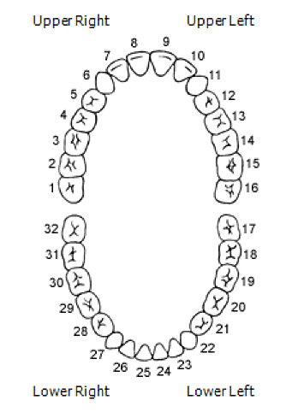
Date |  |  |  |  |  |  |  | Signed
Brushing
Upper teeth
Lower teeth
Dentures
Cleaned | Yes  No | Yes  No | Yes  No | Yes  No | Yes  No | Yes  No | Yes  No
 | Yes  No | Yes  No | Yes  No | Yes  No | Yes  No | Yes  No | Yes  No
Other
any ulcers or bleeding (include placement)
Any other comments
Signed

