OUTCOME MEASURE – Manual handling of People
This is designed to be used with the person being transferred to identify their comfort level.
CURRENT METHOD OF TRANSFER:

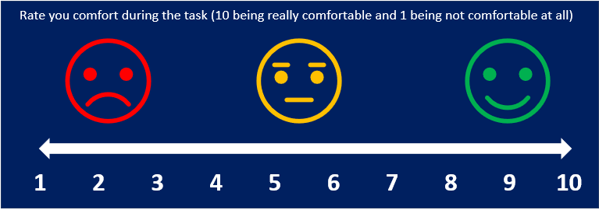
Date:
SCORE:

AFTER ACTION TAKEN (IF REQUIRED):

Date:
SCORE:

