My urinary catheter passport

Please take your urinary catheter passport with you to all your healthcare appointments, on hospital admissions and when you travel.

|  |
| --- |
| Emergency contact details:  Special instructions in the event of an emergency: |

Contents

|  |  |
| --- | --- |
| Personal Information | Page 3 |
| Purpose of Catheter Passport | Page 3 |
| Patient Information | Page 3 & 4 |
| Why do I need a Catheter? | Page 4 |
| Daily Catheter Care | Pages 5 & 6 |
| Securing your Catheter | Pages 7-10 |
| Healthy Bladder, Healthy Bowel | Page 10 |
| Self-Help | Pages 10-11 |
| Urinary Tract Infections | Pages 11-12 |
| Proper use of antibiotics | Page 12 |
| Useful Contact Details and supplies | Page 13 |

Ask your health practitioner how long your catheter will be in. If temporary, ask your health practitioner to remove your catheter as soon as possible.

References can be found at https://improvement.nhs.uk

|  |
| --- |
| Name:  DOB: **ADD STICKER**  NHS number: |

**Important contact details**

|  |  |
| --- | --- |
| GP | Name:  Phone: |
| Community nurse | Name:  Phone: |
| Consultant/other health professional | Name:  Phone: |
| Reason for catheterisation: |  |
| Date first catheterised: |  |
| Urethral | Supra-pubic |
| Date of passport issue: |  |
| Supplies: | Name:  Phone: |
| Place of catheter changes: |  |
| Known allergies: |  |

## 

## Purpose of the catheter passport

This passport is for you and/or anyone else involved in the care of your catheter. The information in it will help you care for your catheter at home and ensure your carer/healthcare professional has the right information.

Good management of your catheter could improve your quality of life. Catheters significantly increase the risk of urinary tract infections (UTIs) and these can seriously affect your general health and wellbeing. Catheters are only inserted if there is a medical need. They must not be inserted at the request of a patient/family member alone. Follow the guidelines contained in this booklet to help minimise the risk of developing a UTI.

**Patient Information**

A catheter is a thin, hollow, flexible tube inserted

into your bladder to drain urine. You will have a drainage bag attached to your leg or around your waist, or a catheter valve and no bag. There are two types of catheters; urethral and supra-pubic.

**Why do I need a catheter?**

You may need a catheter for many reasons, including:

* to let urine drain if you have an obstruction in the tube that carries it out of the bladder
* to allow you to urinate if you have bladder weakness or nerve damage that affects your ability to pass urine
* to drain your bladder before, during and/or after some types of surgery.

**A urinary catheter is only put in when necessary as it carries significant risk of developing UTIs which can be serious or even life threatening.**

The information in this passport will help you avoid infections.

**If you need more help around caring for your catheter or have any health concerns, contact your GP or community nurse.**

**Urethral catheter**

The catheter is put into your urethra, the tube that carries urine from the bladder to the outside of the body (the opening is at the tip of your penis or just above your vagina). The catheter is put into your bladder, and a small balloon near the end of the catheter is inflated with sterile water to keep it in place.

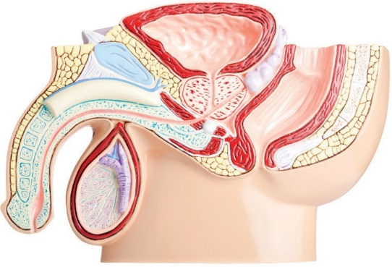

Bladder

ethra

Catheter

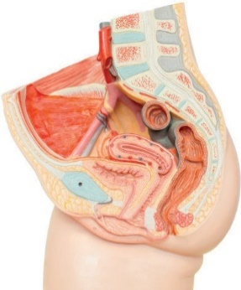

adder

rethra

Catheter

**Supra-pubic catheter**

The catheter is put in via a small cut made in the abdomen. This is done in hospital by a doctor, during a short operation using either local or general anaesthetic.

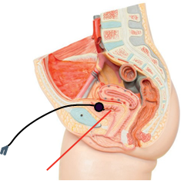

**Daily catheter care**

**Washing**

* Wash your hands with soap and water before and after touching your catheter using the method on page 7.
* If possible, have a daily shower (preferably) or bath. Do this with your leg bag or valve attached.
* Wash the skin in the area where the catheter enters the body with unperfumed or mild soap and water at least daily and after using the toilet if possible. Use a clean flannel or cloth for this purpose only.
* Wash the catheter tubing away from the body.
* Avoid using talcum powder.

**If you have a urethral catheter:**

* Men should be careful to wash under their foreskin, replacing afterwards, unless you have been circumcised.
* Women should always wash the genitals from front to back, to avoid moving faeces from your bottom to the catheter.

**If you have a suprapubic catheter:**

* Some people may experience a slight discharge from around the catheter site. If this happens then contact your nurse who will tell you the best way to treat it.
* Avoid pulling or restricting your catheter by wearing loose comfortable clothing. Tight clothing can cut off the flow of urine and cause skin irritations.

**Correct method of hand washing**

It’s important to wash your hands before and after touching your catheter or drainage bag.



4. Backs of 5. Rotational 6. Rotational

fingers to rubbing of rubbing

opposing palms with right thumb backwards and

fingers interlocked. clasped in left palm, forwards with

then vice versa. clasped hand in left

palm then vice versa

Adapted from the World Health Organisation *Clean hands protect against infection*

## Securing your catheter

A catheter securement device should be used to stop your catheter tube moving around. This might be a cloth and Velcro® G-strap or a device resembling a dressing that is stuck to your skin. Your healthcare professional will advise you when and how to change this.

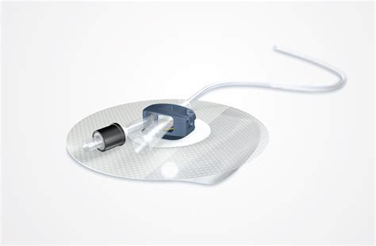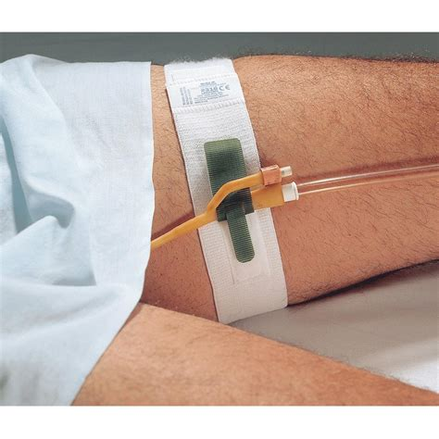

**Leg bag**

Your catheter bag should always be below your bladder unless you are using a belly bag. The leg bag is attached to your calf or thigh by a pair of straps, a sleeve, fixation device or a special holster. How you wear the bag depends on what feels comfortable for you.

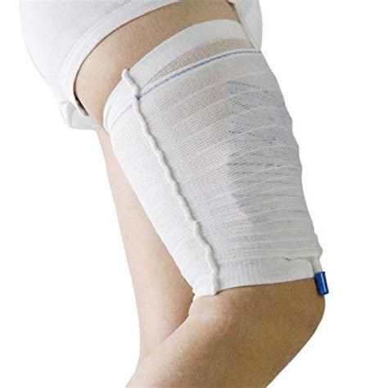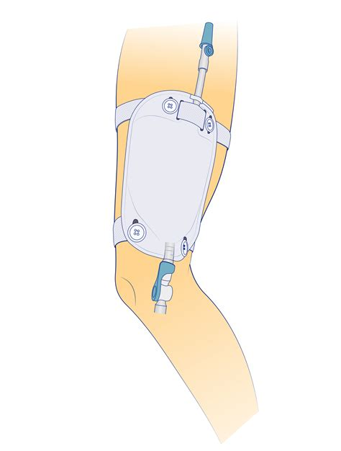

The choice and size of the bag and the length of tubing depend on where you want to wear it and how much urine you pass. When wearing trousers, a long tube bag may be more convenient as it is possible to roll up the bottom of the trouser leg and access the tap at the base of the bag for emptying urine. Short tube leg bags can be worn on the thigh and are discreet under skirts, shorts and dresses.

Men should try to change the position of the leg bag frequently to avoid damage to the penis from the catheter rubbing in one position.

**Caring for your leg bag**

* Wash your hands before and after touching your catheter.
* Empty the leg bag when it is 2/3 full, into the toilet or a dedicated container for transport to the toilet.
* To help prevent infection, only disconnect the leg bag when it is replaced with a new one.

**How to change my leg bag**

Most leg bags are changed on a weekly basis; it is best to change your leg bag on the same day of the week. Empty the attached leg bag before changing to your new one.

* Wash your hands before and after.
* Open the new leg bag, but don’t remove the protective cap.
* Remove the attached leg bag carefully. Don’t pull or use excessive force.
* Point the end of the catheter upwards as you detach the leg bag to prevent leakage. Dispose of old leg bag into a plastic bag (follow your local council’s policy for disposal).
* Carefully remove the protective cap from the new leg bag. Do not touch the nozzle once you have removed the cap.
* Gently insert the new leg bag connector to the catheter. Take care not to touch the plastic nozzle.

**Using a valve instead of a drainage bag**

If you have a valve attached to your catheter instead of a leg bag, you should open the valve to empty your bladder:

* every three to four hours during the day
* when you feel your bladder is full
* before opening your bowels.

A valve may not be recommended for certain conditions. You will be advised by your healthcare professional. To help prevent infection, only disconnect the valve weekly when it is replaced with a new one. Attaching a night bag to a valve is optional. If you do use a night bag, remember to open the valve to allow urine to drain into the night bag.

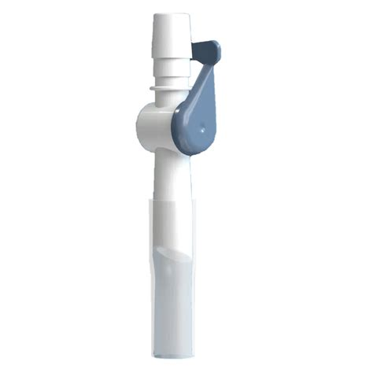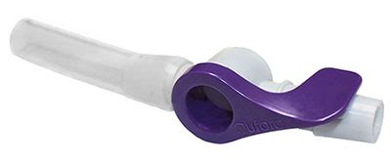

**The night bag**

Night bags allow free drainage of urine when in bed.

* Attach a night bag to the leg bag or valve.
* Open the tap from your leg bag.
* In the morning close the leg bag or valve.
* Remove the night bag and empty the urine into the toilet.
* Dispose of empty night bag into a plastic bag (follow your local council’s policy for disposal).

**Is it possible to have sexual intercourse with a catheter inserted?**

Yes, it is possible. A suprapubic catheter may make it easier, speak to your healthcare professional for more information.

If during intercourse you experience any pain or discomfort, you should stop. Talk to a healthcare professional about any concerns you have.

**Before:**

* Wash your hands before and after touching your catheter
* Empty your bag.

**Advice for men**

* Once erect fold back your catheter along the length of the penis, leaving a loop. This will stop the catheter pulling.
* Apply a condom to help secure the catheter.
* If you need a lubricant use a water-based gel.

**Advice for women**

* Secure or tape your catheter out of the way.
* After intercourse clean your genital area thoroughly with warm water and unperfumed soap.

**Healthy bladder and bowel**

Maintaining a healthy bladder and bowel is very important. A full, constipated bowel can press on the bladder and stop the catheter draining freely.

* Drink about 1.6 to 2 litres (about 7 – 8 full mugs or 11 – 14 full teacups) of

fluid in 24 hours, unless clinically advised not to do so. This keeps you hydrated and will help soften your stool and aid easier bowel movements.

* Drinks containing caffeine are not dehydrating so only limit intake if you find they irritate your bladder. Weak alcoholic drinks of up to 4% alcohol by volume (ABV) are hydrating but NHS recommendations to drink no more than 14 units of alcohol a week, spread across 3 days or more should be followed.
* Eat a balanced diet that is healthy for your age.
* Fibre can improve your bowel habit. Eat five portions of

fruit and vegetables every day and choose whole grain foods.

* Don’t strain on the toilet. Relax and allow yourself enough

time and privacy to empty the bowel fully.

* The colour of your urine may vary as some food or medication can cause discolouration.

**In younger people, darker urine may indicate dehydration, if your urine gets darker then drinking more fluids can help prevent infection. In older adults (age 65 and over) pale coloured urine does not signify good hydration so should not be used as an indicator.**



**For adults aged under 65, aim for light coloured urine.**

**For adults aged 65 and over it can be hard to spot dehydration because there are no easy-to-use tests that tell us whether someone is dehydrated or not. Signs (such as urine colour, thirst and a dry mouth) that may be suggested as showing dehydration do not actually work in older adults.**

**Troubleshooting**

**If you are worried about your urine, or that your catheter is leaking/not draining, here are some checks.**

**Self Help:**

* Are your food and fluid intake adequate?
* Are you constipated?
* Is the drainage bag below the level of the bladder, particularly when sitting in a low or reclining chair?
* Is the tubing twisted, or restricted by tight clothing?
* Is the tubing extended or pulled tight towards the bag?
* Is the catheter tube connected to the drainage bag correctly?
* Are the leg straps stopping urine flowing into the bag?
* Is the bag too full? If in doubt empty the bag.
* Change your position and walk around if you are able and it is safe.
* If your catheter is leaking but still draining some urine, this may be due to bladder spasms—where the bladder contracts as a result of irritation from the catheter. Sometimes patients who have bladder spasms can be treated with medication, speak with your healthcare professional.

**Seek help if:**

* Your catheter is draining little/no urine despite adequate fluid intake and following the troubleshooting guide
* You feel warm, flushed or shivery, as you may have an infection
* your urine has a strong smell, is dark in colour or becomes thick and/or cloudy and does not improve with taking more fluid (if able or advised)
* you experience lower stomach or back pain
* you have increased stomach swelling with no other cause
* there is bright red blood in your urine
* the catheter entry site becomes red and sore
* you have bleeding into or around the catheter
* you have enough urine leaking around the catheter to make your clothing wet and you have already followed these self-help measures
* your catheter falls out.

## Urinary tract infections

**How will I know if I have a UTI?**

Having a catheter in your urinary tract significantly increases your chances of getting a UTI, which is why it is so important to care for it following the advice in this passport.

**Signs and symptoms associated with a UTI:**

* feeling unwell
* fever with or without uncontrollable shaking
* new pain at lower tummy or back
* becoming agitated or newly confused
* pain around the area where the catheter is put in and/or pus like discharge in the urine
* unusual tiredness

**How is my UTI treated?**

* A urine sample should be taken from your catheter sampling port and sent to microbiology.
* You may be started on an antibiotic.
* Your catheter should be changed.
* You should make sure you are drinking plenty of fluids.

**Proper use of antibiotics**

* Make sure you follow the instructions given with the

antibiotic and finish the course.

* Using antibiotics only when we need to helps reduce the chances of bugs causing the infection becoming resistant to them.
* This helps protect our antibiotics so we can rely on them to work when we really need them.

**Where can I get further supplies?**

* You can order supplies from a home delivery service. You can request the items you need and they will be delivered to your door free of charge. Please note that new patients will need to register for home delivery. Your healthcare professional can advise you on what you need to order.
* Please always ensure you have a minimum of two weeks’ worth of supply when plac ing future orders as the delivery service will have to request the prescription from your doctor.
* You can also choose to take your prescription to your local chemist.

**Contact details**

**Hertfordshire**

District nursing service central number: 03000 200 656

*(choose option 1 for patient enquiries, then option 1 again for district nurses)*

Dacorum [clcht.dacorumspoc@nhs.net](mailto:clcht.dacorumspoc@nhs.net)

Hertsmere [clcht.hertsmerespoc@nhs.net](mailto:clcht.hertsmerespoc@nhs.net)

St Albans & Harpenden [clcht.stalbansandharpendenspoc@nhs.net](mailto:clcht.stalbansandharpendenspoc@nhs.net) Watford & Three Rivers [clcht.watfordspoc@nhs.net](mailto:clcht.watfordspoc@nhs.net)

**East & North Hertfordshire**

Integrated Community Team central number: 0300 123 7571

Upper Lea Valley [hct.upperleavalleyspoc@nhs.net](mailto:hct.upperleavalleyspoc@nhs.net) Lower Lea Valley [hct.lowerleavalleyspoc@nhs.net](mailto:hct.lowerleavalleyspoc@nhs.net) North Herts [hct.northhertsspoc1@nhs.net](mailto:hct.northhertsspoc1@nhs.net)

Royston [hct.roystonspoc1@nhs.net](mailto:hct.roystonspoc1@nhs.net)

Stevenage [hct.stevenagespoc@nhs.net](mailto:hct.stevenagespoc@nhs.net)

Welwyn & Hatfield [hct.welhatspoc@nhs.net](mailto:hct.welhatspoc@nhs.net)

**West Essex**Care Coordinating Centre:  0300 123 5433 choose option 1 for district nurses 

Email:[epunft.carecoordinationcentre.west.2023@nhs.net](mailto:epunft.carecoordinationcentre.west.2023@nhs.net)