

Social Value Case Study
Contract Name: | Essex Renewal Fund (Asset Management)
Provider Name: | Montagu Evans LLP
Date: | Date of case study – 4 September 2026

Background
The Contractor shall submit to the Council an annual case study report, no later than [insert date, e.g. 31st March] each Contract Year, detailing the activities undertaken to deliver social value in connection with this Contract.

Requirement
Each case study shall include:

- A description of the initiative or activity undertaken
- The intended and actual outcomes achieved
- Detail linking the delivery against the respective Social Value Themes, Outcomes and Measures (TOMs)
- Quantitative and qualitative evidence of impact (e.g. metrics, testimonials, community feedback)
- Any challenges encountered and lessons learned
- Future plans or commitments related to social value

The case study shall be submitted in a format agreed with the Council and may be used by the Council for internal reporting, public communications, or best practice sharing.

Social Value Case Study Template
Your Case Study should include:

- Briefly describe an overview of the initiative.
- Outline the objectives that the project aimed to achieve.
- Detail how it applied the Social Value Themes, Outcomes and Measures (TOMs).
- Describe actions taken including steps implemented and resources used.
- Identify tangible results using quantitative and qualitative data.
- Include stakeholder feedback from employees, partners, community groups etc, including quotes/testimonials, and how feedback informed future planning.
- Detail challenges and lessons learned, including barriers faced during implementation, adjustments main and insights gained.

As part of our work with Essex Country Council, we are contracted to deliver a number of social value commitments. One such commitment relates to:

ECC ref: ECC16
TOMs Measure: No. of hours dedicated to support young people into work (e.g. CV advice, mock interviews, careers guidance) - (under 24 y.o.)
Intended Outcome: 300 hours
Outcome achieved: 787.5 hours

Delivery:

In Q1 2026/27 we reported that 5 x Montagu Evans staff supported students at The Billericay School with CV advice and mock interviews over the course of two days (on 26 and 27 February 2026). We committed 13.5 hours and there were 25 beneficiaries. In accordance with the calculation (and sense checked by Craig Johnson, Procurement Support Officer at ECC), we delivered 337.5 hours of the 300 hours commitment.

In Q2 2026/27 we reported that 2 x Montagu Evans staff supported students at The Billericay School as part of a speed networking careers insight session (7 July 2026). We committed 4.5 hours and there were 100 beneficiaries. In accordance with the calculation, we delivered 450 hours.

The above was co-ordinated by the Sarah Dewell at the School.

Feedback received:

“Thank you for attending our Year 12 Speed Networking Event and supporting our practise interview skills day in February. Your presence provided an invaluable experience for our students, especially having the opportunity to speak to one of your apprentices. They thoroughly enjoyed speaking with you both, learning about your company's opportunities, and practising vital communication skills. Your support and insights have greatly inspired their future career paths. We truly appreciate your time”.
Sarah Dewell
Sixth Form Admin/Student Support – The Billericay School
01277 655191 ext 157

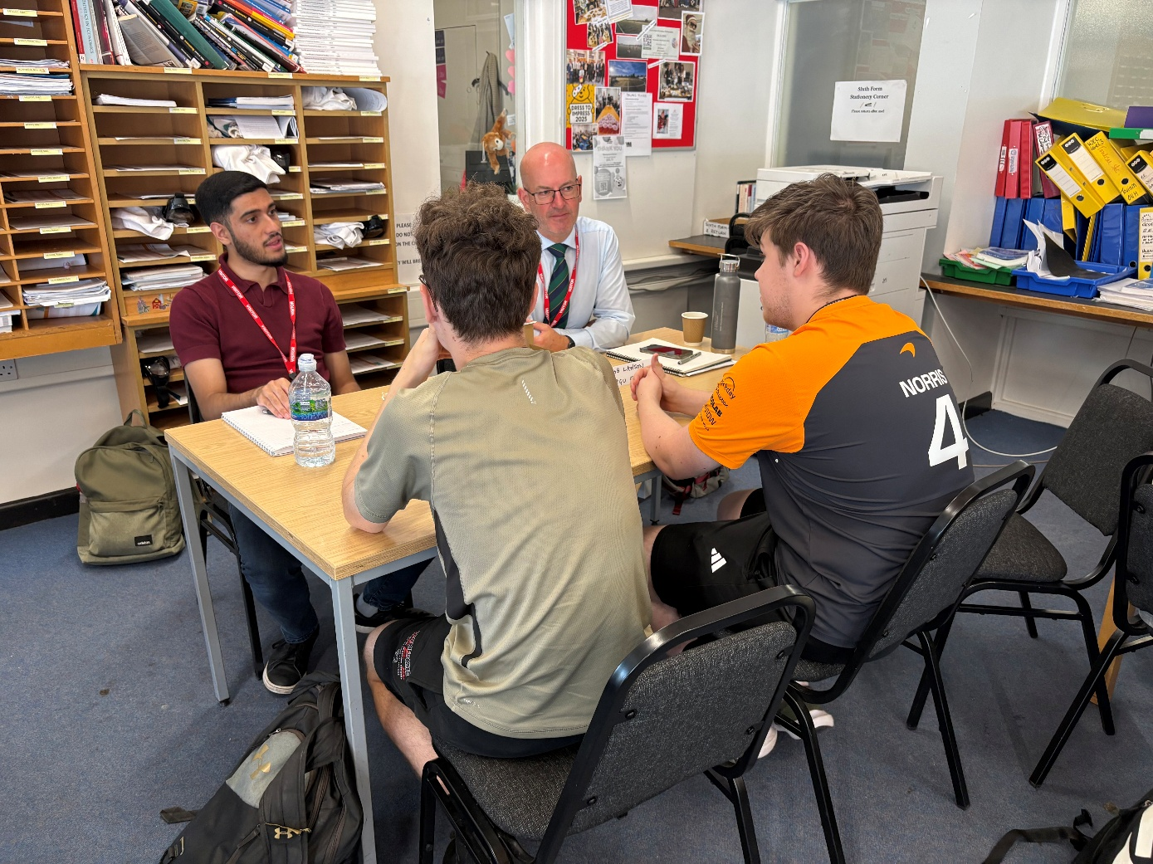
Image from 7 July session

Future plans or commitments:
Your response should:

- Detail planned initiatives and targets for the next period.
- Describe opportunities for collaboration and innovation.

As we have completed delivery of this commitment we have no activity currently planned but will continue to support the School as per another of our commitments (ECC17 (No. of weeks spent on meaningful work placements or pre-employment course; from 1 to 9 weeks unpaid student placements (e.g. T-Level unpaid work experience, work experience for students)).

For ECC17 we are currently arranging work experience for October 2026.

Subject to availability, we will continue to support the School with commitment ECC16.

We await a response from the Council in relation to commitment ECC45 (Activities to influence staff, suppliers, customers and communities to support environmental protection and improvement).

We will soon complete delivery of commitment ECC32 (In-kind contributions to local community projects (materials)) and will report back to ECC when this occurs.

Finally, we continue to report on commitment ECC23a (Car miles saved on the project as a result of a green transport programme or equivalent (e.g. cycle to work programmes, public transport or car pooling programmes, etc.)

We will report back to ECC on delivery of these commitments through the quarterly reporting and submit case studies when the commitments have been delivered and outcomes achieved.

