**Payment Schedules Tab**

1. **What it is used for?**

This is the page where you access the invoices that need to be checked before submitting them to be processed for payments.

1. **How do I find it?**

* Login into Provider Portal
* At the top centre of the page there are three options – select Payments
* Then select Non-Residential
* Then select Payment Schedules

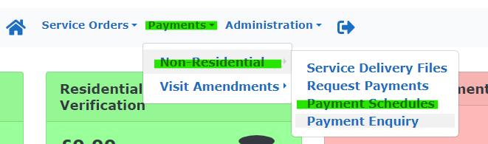

1. **Where are my invoices?**

When you first get to the Payment Schedules page make sure your company name is in the Provider field and that the Period From date on the left-hand side of the screen has been highlighted and then deleted. Then click the green Filter button (highlighted in blue below).

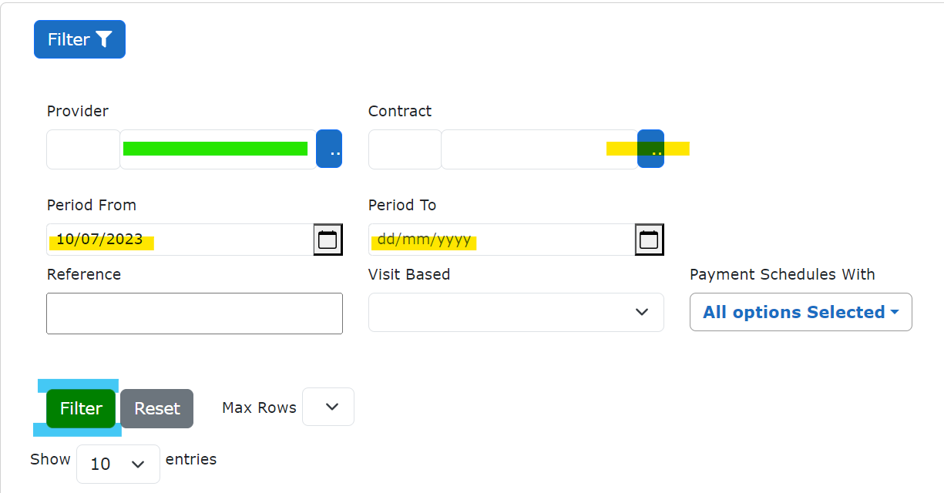

If you scroll down the page a list of all contracts will appear, to get them into descending order so that the newest invoicing periods are first, click the down arrow twice on the Date To column as highlighted below in yellow.



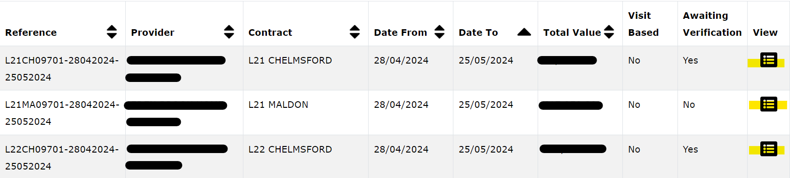

Once you have located the correct contract for the correct period double click on the icon on the far right hand side of the contract line it to open it. The icon looks like a table and is highlighted in yellow above.

1. **How do I submit an invoice?**

Once you have opened the contract there is a summary section at the top, confirming contract and invoicing period. Beneath that are two sections, Unprocessed Provisional Invoices and Payment Invoice.

* Unprocessed Provisional Invoices is where invoices wait until they are submitted for payment.
* Invoices Awaiting Verification shows how many invoices are waiting to be submitted
* Once submitted they will appear as a Verified Invoice beneath
* Click on the blue List button to see all the invoices waiting to be submitted for payment

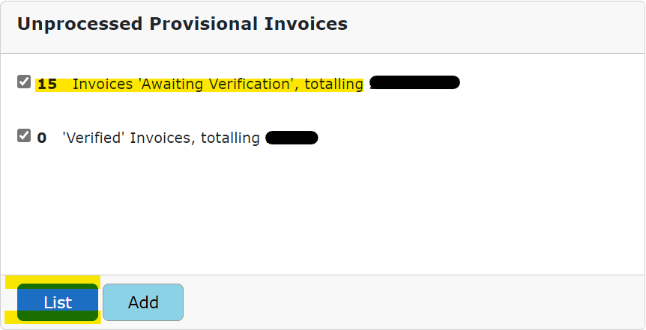

You will then see an alphabetical list of all the invoices that need to be checked and then submitted for payment, if they are correct and care was provided. Click on the Service Users name to open the invoice.

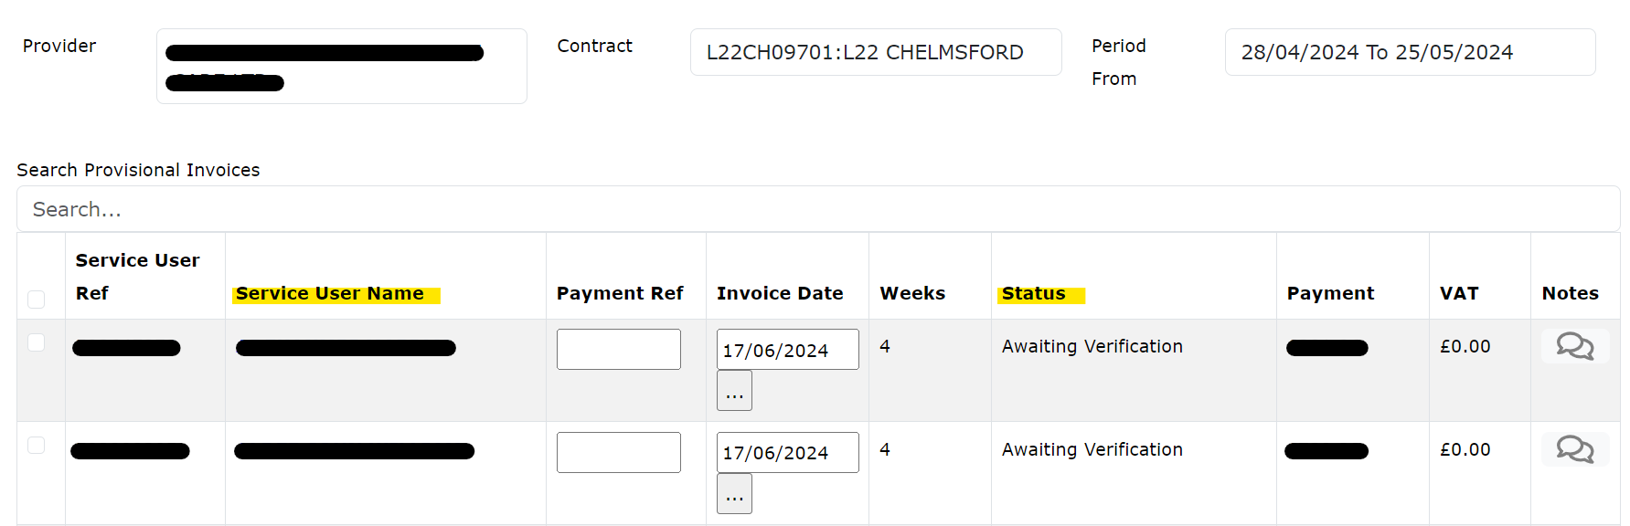

Once opened you will have up to 4 weeks per invoice to check. **Here is what you need to check when going through the invoice:**

* **Check all needed weeks are showing.** They are shown in the first column by their week ending date, if care starts mid invoicing period there will not be 4 weeks showing.
* **Check the type of care is correct.** This is the second column. If different types of care are provided each week then there will be several individual lines per week for each care type.
* **Check the planned hours are visible and match PO** – this is the third column and is presented in either hours or days depending on care type.
* **Check and amend if needed the amount of hours/days provided** – this is the Delivered/fourth column this can be adjusted by you if less care or no care was provided for one or multiple weeks. Simply type in the box in the Delivered column how much care you actually delivered that week. If entering incomplete hours, it must be entered in quarterly increments i.e. 12.75, 4.25, 7.50, 5.00 please round up or down to the closest quarterly amount.
* **Enter any hours where you tried but could not provide care i.e. a Frustrated visit** – this is the Non-Delivery column please go to the 5th page of this manual to see how to use it.
* **Check the rate is correct** – this is the Unit Cost column and is the agreed upon rate, showing on PO. Do not try to override the unit cost.
* **Check the total** – the final column is the amount you will be paid for each week, please check your paperwork to ensure this is what you were expecting. Do not try to override the total cost.
* **Extra week** – if there is a week showing where you didn’t provide care, i.e if there are 4 weeks but you only provided care for 3 of the weeks, either enter 0 hours for that week or click the X in the delete column on the far-right end of the relevant line to remove the week.
* 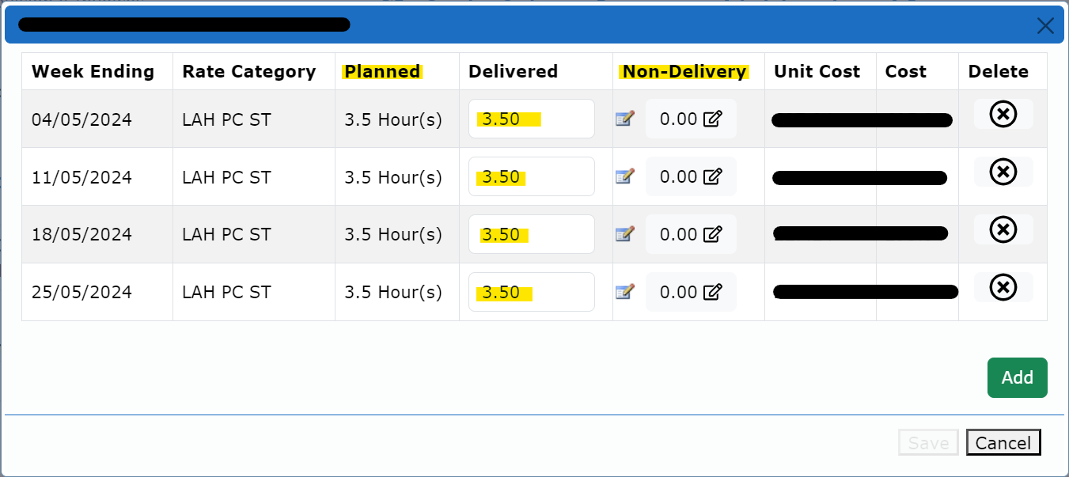

Once you have checked the invoice and happy with hours/rates, and no amendments were needed click on the X in the top right-hand corner. If you had to adjust and change the hours in the Delivered column please click the Save button in the bottom right hand corner – if changes are made this button will not be greyed out.

Once out of the invoice we are then back to our invoice list. For the invoice we just checked/amended we now need to:

* **Provide a Payment Ref** – this column has a blank box for each invoice (highlighted blue below) this is where you enter your unique invoice number. **It needs to be different for every person, every month, every invoice.**
* **Check Invoice Date** – this date needs to be the date that you checked and submitted your invoice.
* **Check Payment** – this is the total amount that will be paid for that invoice, check it is in line with what you were expecting.
* **Submit Invoice** – on the far left hand side of each invoice line is a box, when you are ready to submit, click the box, then go to the bottom of the page and click the green Verify button.

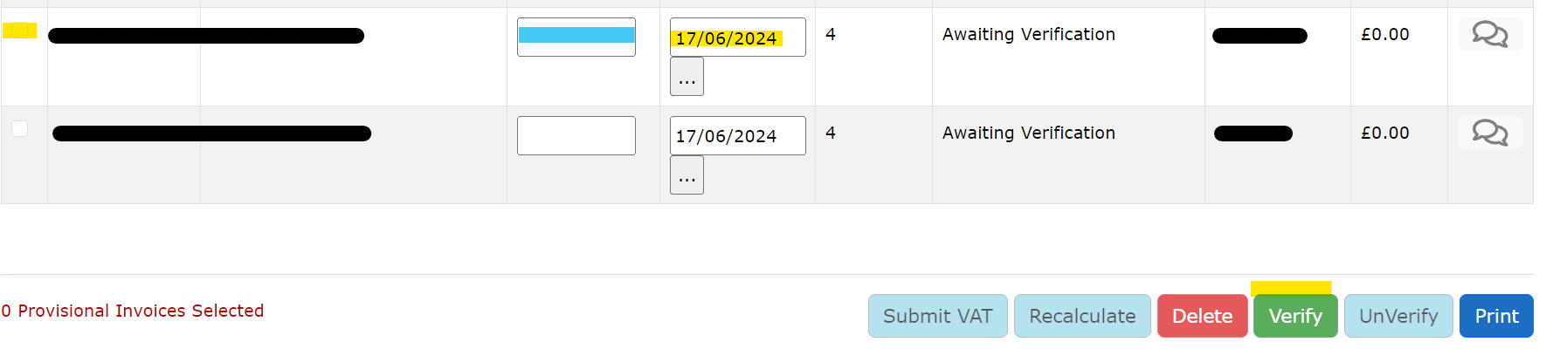

**I Was Unable To Provide Care**

**Frustrated Visits**

1. **What is a Frustrated Visit**

A Frustrated Visit is where you either attempted to provide someone care but couldn’t i.e. the Service User wouldn’t let the carers in, they had gone out and not advised the carers. Or the care was not cancelled with enough notice and stated in your contract.

For these situations the care can still be claimed for as it was not properly cancelled but it needs to be submitted as a Frustrated Visit to avoid a charge going out to the Service User for care they did not receive.

**If care is cancelled within the appropriate notice period, this cannot be claimed as a Frustrated visit. If the amount of care the Service User receives decreases but this is not reflected on the system advise the relevant Social Worker.**

1. **How to Submit Frustrated Hours**

When submitting an invoice that has Frustrated visits you find it in the same place as any other invoice, by going to Payment Schedules and finding the relevant contract and invoice period.

Once the invoice is located open it up to show the rows of weeks for that invoice.

Frustrated hours/visits are submitted in the Non-delivery column, by default every row for every invoice has 0.00 entered. To submit hours into this column, click on the 0.00 of the relevant week row.

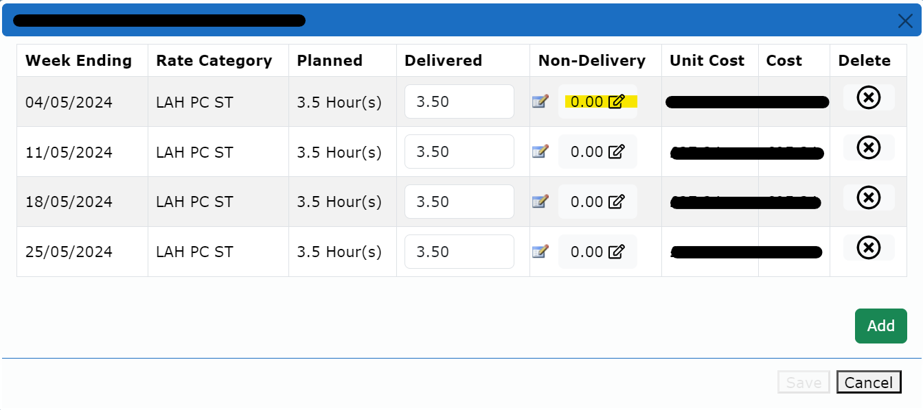

When the below dialogue box appears, click the green Add button.

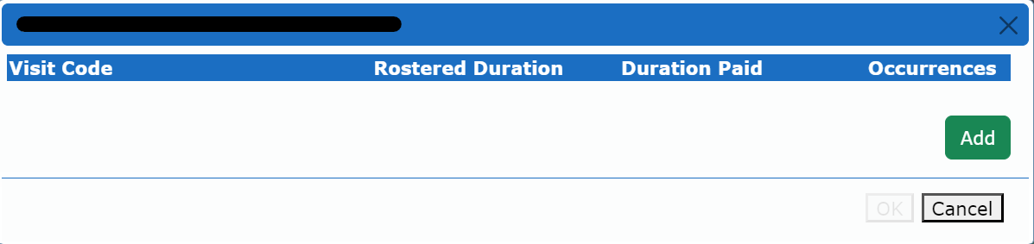

Once clicked the below dialogue box will appear. Leave the visit code as Frustrated Visit, there are other options but they result in a non payment of visit to yourselves. **Frustrated Visit ensures you get paid but the Service User isn’t charged.**

**Unless it is a Spot Contract (and starts with S0) in which case change the Visit Code will need to be changed to Doorstep Refusal. Please click the down arrow in the Visit Code bar to change the reason otherwise you will not be paid for this care.**

The next drop down option is Rostered Duration, in here you select how many hours and or minutes could not be provided. **Normally when entering minutes they are shown as .25 or .75, in this section the minutes need to be entered as exact minutes i.e 15, 30, 45.** Once the amount of time has been entered click Ok.

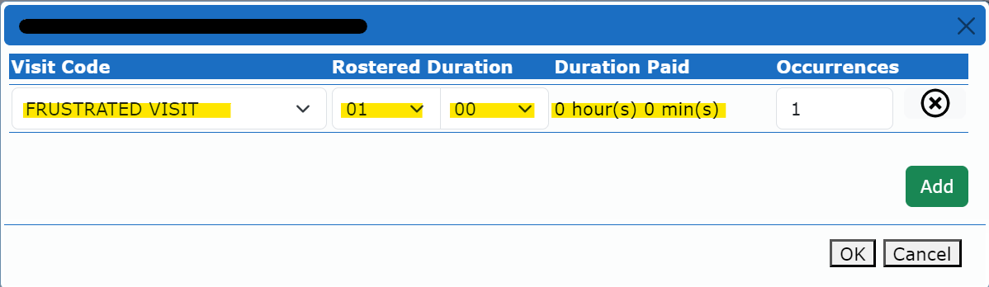

Now we can see that the Non Delivery column for the selected week now shows 1 Frustrated hour. **However, the cost column for this week is showing in Red, this means if the invoice is submitted in its current state it will Suspend.**

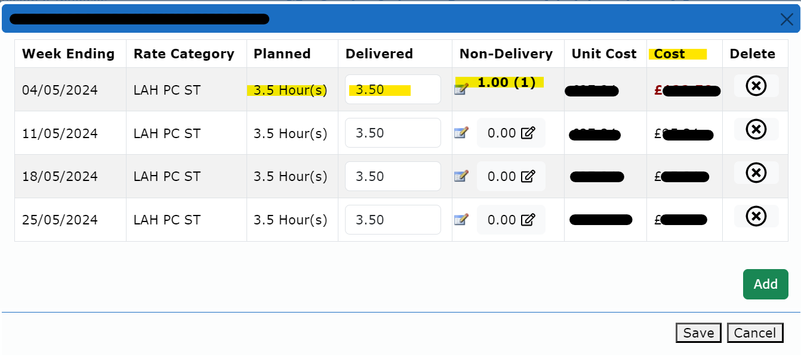

**The Delivered columns also needs to be amended. Whatever hours are put in the Non Delivery column they need to be removed from the Delivered column.**

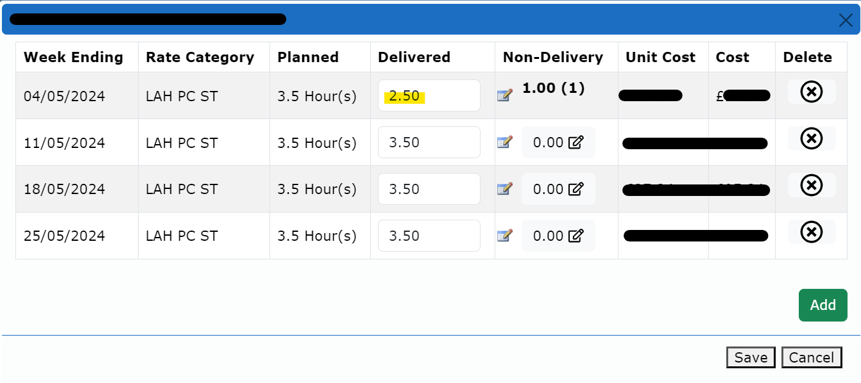

Now check all other weeks, or repeat process if needed, click Save and submit invoice in the standard way as mentioned previously in this manual.