Retracting a Paid Invoice

- When do I retract an invoice?

There are several reasons why a retraction needs to be carried out. These are as follows: -

- You have received an email from the Non-residential Payments Team as there has been a query from the Service User regarding hours they have been charged.
- If hours have been submitted after the care ended or during a period of suspension. As to be expected there is a delay between the action taking place and the relevant paperwork being uploaded onto the system. Therefore, care and attention when submitting actual care hours is required.
- Double payment, if a contract changes half through an invoicing cycle half the hours need to be claimed on the original and then the new, not all hours, across both contracts this will result in 8 weeks’ worth of charges.

- How do I retract an invoice?

- Login to Provider Portal
- At the top centre of the page there are three options – select Payments
- Select Non-residential
- Select Provider Payment Enquiry
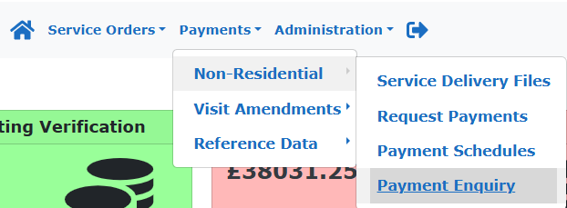

- Selecting the correct invoice to retract

When you first reach the Payment Enquiry screen make sure your company name is in the Provider field.

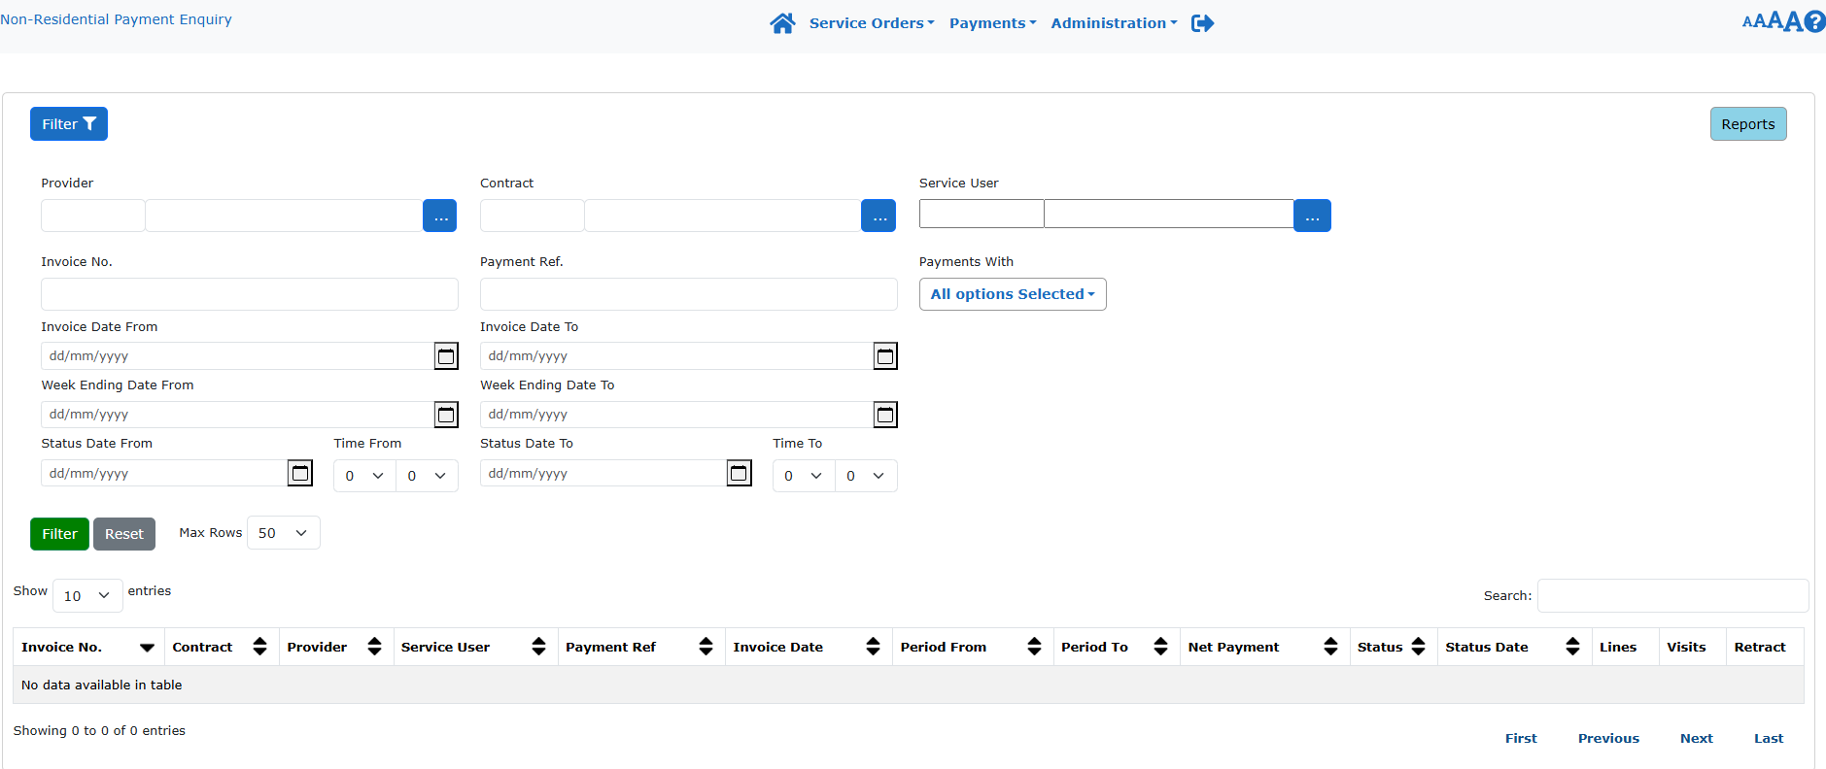

Use the Service User filter to select the Service Users Name from the picklist.

If you know the dates for the invoice period of the retracted invoice, please enter these into the Week Ending Date From and Week Ending Date To.

Click on the down arrow of the Payments With to open a selection of invoice statuses. Untick Hide Retracted and Retraction Invoices.
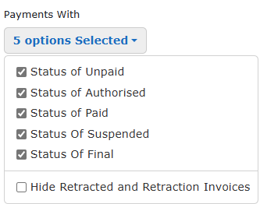
By selecting the above, it will ensure that you have a full list of transactions for the adult in question, both payments and credits, and for the period of the required retraction. This assures you that the invoice has not already been retracted previously.

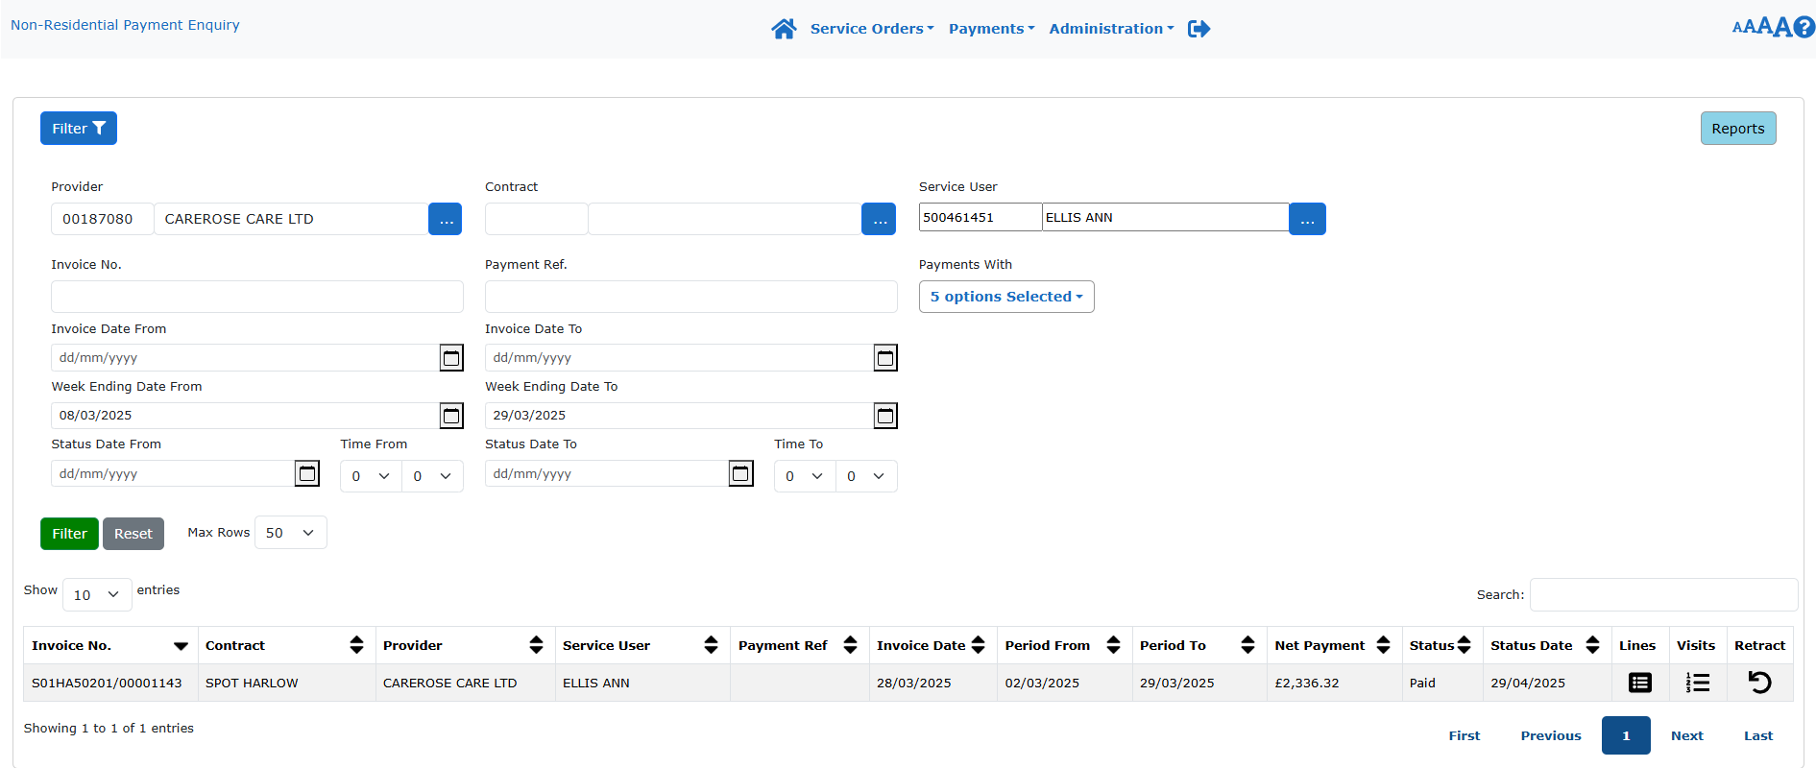

Before retracting the invoice. Check the invoice by clicking on the Lines entry to the right of the Status Date.

If ok and correct return to the above screen and select Retract on the right-hand side of the invoice entry.

This retracts the entire previously paid invoice, for the same amount of money, which can be added back into the payment schedule again for amendment of all hours delivered during the period in question. When re-verifying the amended invoice entry always ensure you use the same date as the original invoice and use the original invoice number but put an A at the end, this will make reconciling the remittances easier. The system will confirm at this stage if you have already used the same invoice number by confirming a duplicate on a pop-up box on screen.

When you receive your remittance advice you will see the retraction for the original paid invoice and the amended amount due.

