Aspiration Pneumonia & Dysphagia (swallowing problems)
The leading cause of death among people with a learning disability is aspiration pneumonia. (LeDeR 2022)
Dysphagia is the umbrella term for swallowing difficulties and signs of dysphagia can be coughing or choking when eating or drinking, bringing food back up, (sometimes through the nose) or a sensation that food is stuck in your throat or chest. It can also cause persistent drooling of saliva.
Pneumonia is a serious infection causing inflammation and swelling of the lungs that will restrict breathing and ultimately can result in death. Symptoms include breathlessness, chest pain and coughing which can be accompanied by dark, thick mucus.
Aspiration Pneumonia occurs when the individual breathes in a foreign matter such as food, vomit, smoke, chemicals and in some cases faecal matter that has been regurgitated by someone who has chronic constipation.
Individuals with swallowing problems are at risk of inhaling food and drink which can sit in the lungs and create infection which, if left untreated, can become life threatening.
It is crucial that any swallowing difficulties are promptly referred to a Speech and Language Therapist (SALT) in order to get a swallowing assessment completed.
The assessment may include a videofluoroscopy to look at swallowing ability. It takes place in the X-ray department and provides a moving image of your swallowing in real time. You'll be asked to swallow different types of food and drink of different consistencies, mixed with a non-toxic liquid called barium that shows up on X-rays.
Once this is done the SALT will prescribe certain products that will thicken fluids without altering taste/flavour. They will also identify a certain thickness or consistency of food that enables the individual to eat food without choking or coughing.

International Dysphagia Diet Standardisation Initiative (IDDSI)
The thicknesses of food are described in the IDDSI framework which consists of a continuum of 8 levels (0 - 7), where drinks are measured from Levels 0 – 4, while foods are measured from Levels 3 – 7. The IDDSI Framework provides a common terminology to describe food textures and drink thickness.
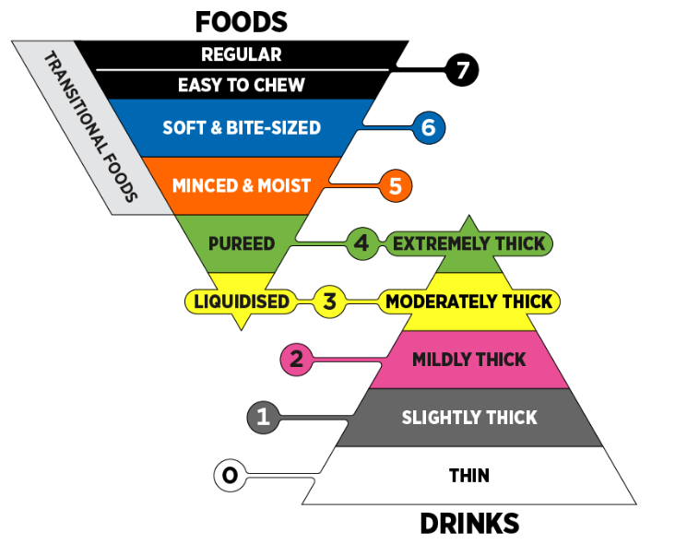

As previously mentioned there are other causes of aspiration pneumonia which include smoking or smoke inhalation as well as inhalation of vomit and foreign objects so it is imperative that incidents such as this are monitored closely to ensure they don’t lead to aspiration pneumonia.
LINKS for referrals:
https://www.nelft.nhs.uk/services-bsbwtk-salt/
https://www.provide.org.uk/service/speech-language-therapy-adult/
https://www.nhs.uk/Services/clinics/Services/Service/DefaultView.aspx?id=315860

