Providers Guide to Provider Portal:
By Essex County Council

Contents

Notifications 3
Emails 3
Provider Portal Homepage 4
Residential enquiries 5
By home 5
By service user 6
Security 8
Forgot password 8
Reset Password in Provider Portal 8
Help 10
Useful Contacts 10

Notifications
Emails
Remittance Notifications
When the Council has published a remittance for a home, the user associated with that home will receive an email notifying them of the publication. The user/home will then be able to logon to Provider Portal to review the remittance.
The email will come from: no-reply@abacus.essex.gov.uk
it will contain the link to provider portal: https://abacus.essex.gov.uk/AbacusExtranet/Apps/Security/Login.aspx

Provider Portal looks like this:

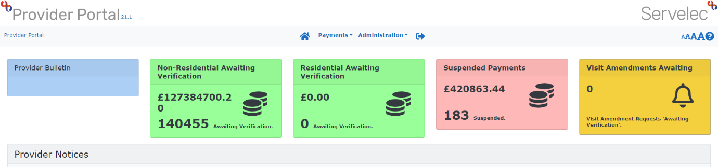
The Provider Portal homepage looks like this.

Remittance enquires can be found under ‘Payments’

Any enquires about your password and your account can be found under ‘Administration’.
To log out of the homepage click on the arrow icon on the top bar.
Provider Notices

This section will have notifications of planned system downtime and information on monthly payment dates and other useful information regarding Adult Social Care payments.

Residential Enquiries
Payment Enquiry by Home
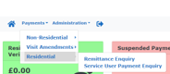
On the menu tab click ‘Payments’ – ‘Residential – ‘Remittance Enquiry’

Select the home you wish to view remittances for, by clicking the ‘Provider’ select an item box and a pop up box will appear. Click on the home you would like to view.
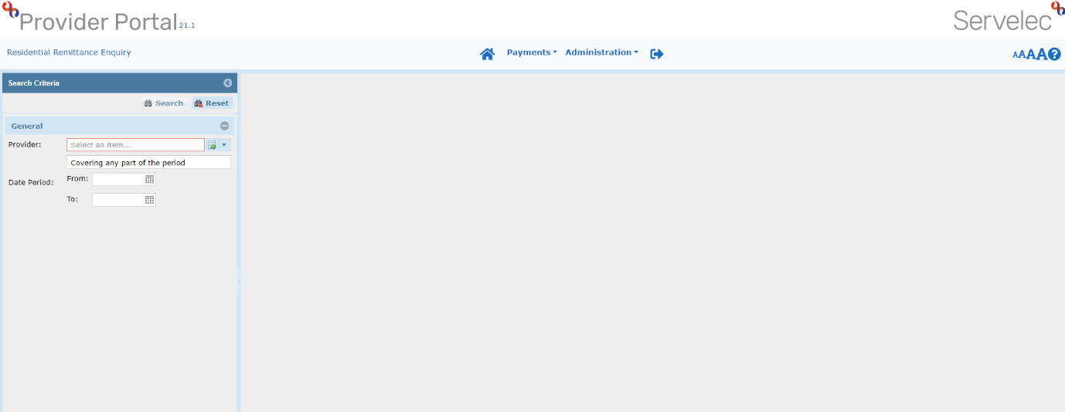
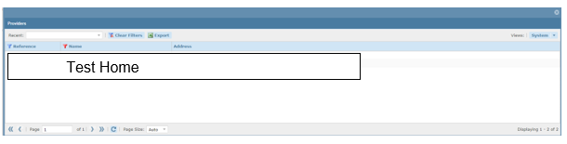
At this stage you can either enter a date range of remittances OR click ‘Search’ to view all remittances for the home you previously selected.

If you choose to enter that date range:

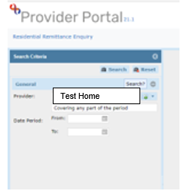
You would like to view by clicking on the calendar icon.
Click the ‘Search’ button in the right had corner.
A list will be produced with the results of your enquiry on the right hand side:
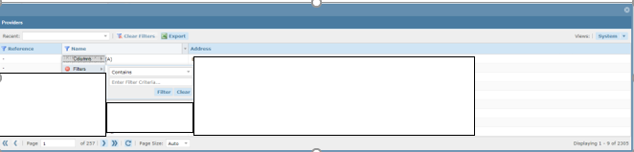
Select the Remittance you would like to view by right clicking on it.
A new window will open with a preview of the selected remittance.

Payment Enquiry by Service User
Residential Service User Payment Enquiry
Click ‘Payments’ – ‘Residential’ – ‘Service User Payment Enquiry’
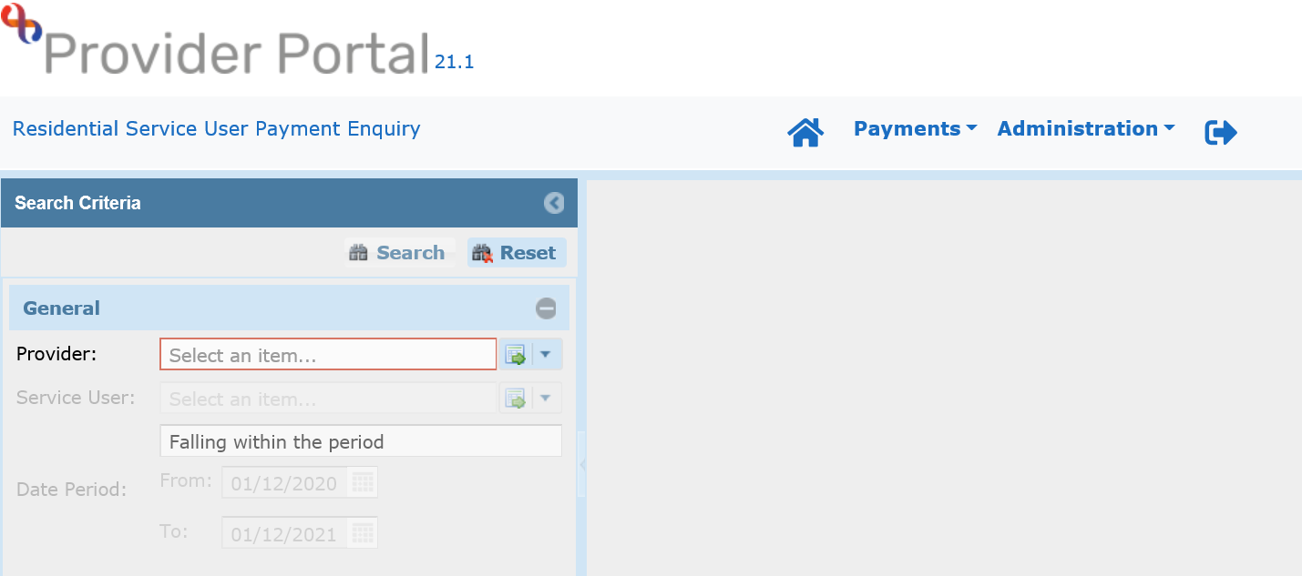
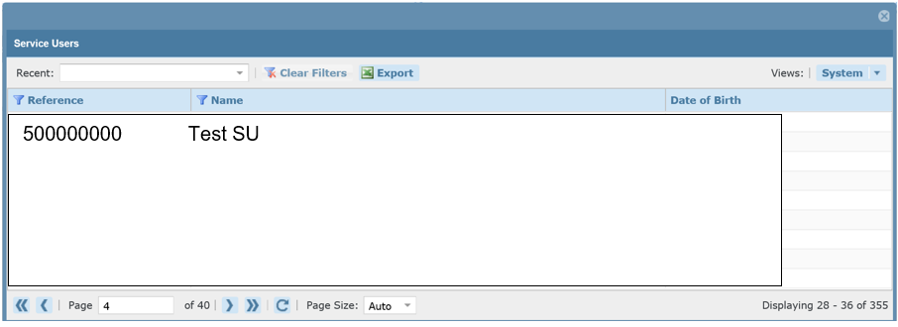
Select the home you would like to view clients for by clicking the ‘Provider’ select an item box and then select the appropriate Service User on the drop down
At this stage, you can either click enter a date range OR click ‘Search’ to view all statements for the relevant Service User.

Enter the relevant date ranges.
Then click the ‘Search’ button on the right hand side.
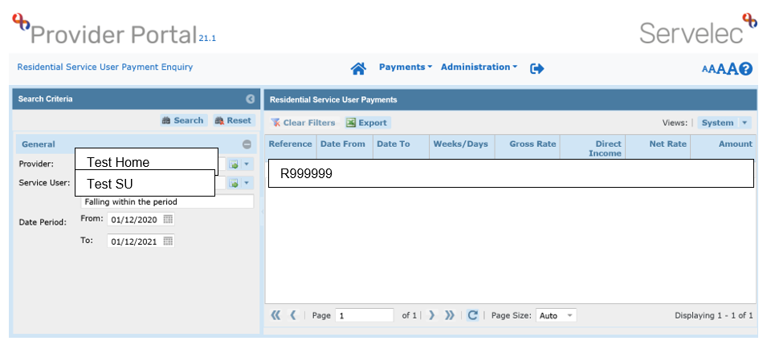
This results screen displays a list of payment lines for the selected home, service user and date range. To view these payment lines in the form of a Service User statement, right click on a payment line and select View/Print Statement.
You can export the remittance to Excel by clicking on the ‘Export’ icon.

Security
Forgotten Password
If a user has forgotten their password, they can reset it themselves by clicking on the ‘Forgotten Your Password?’ hyperlink on the login page.

Enter your email address in the ‘Email’ field.

Then click ‘Submit’

You will then receive an email, follow the link in the email.
Complete all fields shown and click ‘Submit’. The security question is the one you set up upon Account Activation.
Note: Your password must be a minimum of 8 characters (containing at least one upper case letter and one number).

You will then be taken back to the original login page and asked to login with the password you just created:

Resetting password when already in Provider Portal
If you are already logged into Provider Portal you can reset your password by going to ‘Administration’ – ‘My Details’ – ‘Change Password’.
You will be taken to this screen:
Follow the instructions on the page.
Help
Getting Help
Each and every page within the website displays a If you need help on any page click on the icon and a popup will be displayed with context-sensitive help information relevant to the current page.

Useful Contacts
Login Issues: Essex Service Desk: 03330 135588 TS.Servicedesk@essex.gov.uk
Payment Queries: in a first instance should be sent to cdsooprcaqueries@essex.gov.uk
Procurement: for issues regarding fee uplifts or contractual agreements procurement.adults@essex.gov.uk
All queries related to the IRN refresh can be emailed to IRN.ProjectTeam@essex.gov.uk

Useful Links
Provider Hub: https://www.essexproviderhub.org/
Essex Care Search (Bedfinder): https://www.essexcaresearch.org

