EASY READ LeDeR letter to GP surgeries for distribution to adults on the LD register.
Dear

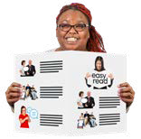
We are writing to you because you are registered with your doctor
as someone who has learning disabilities.

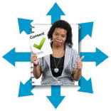
We want to ask your consent to share your health information.

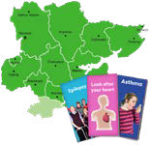
Across Essex people with learning disabilities often have more health problems and don’t always get the right help. This can make a difference to their life
T

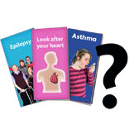
We want to understand why this happens and to stop it from happening.

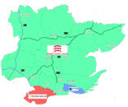
To do this there is a Health Equality Team.

They work across Southend, Essex and Thurrock.

Some of these people are called LeDeR Reviewers.

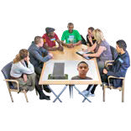
LeDeR Reviewers might ask to find out about you and your life. But they will not look at your records during your lifetime.

To do that they will talk to doctors, social workers, carers and people who supported you.

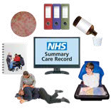
Your doctor writes down everything they need to know about your health on a computer system.

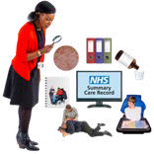
The LeDeR Reviewer will ask to see this information. We must share it unless you tell us not to.

They will also talk to family and friends.

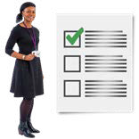
The LeDeR Reviewer will then say what should happen to prevent any difficulties in the future.

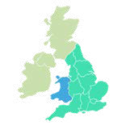
They do this for everyone with a learning disability in England and Wales.

To make it easier to access your health information, the Health Equality Team and LeDeR Reviewers will start to use the same computer system as your doctor.

They will only look at your health record to complete a LeDeR review

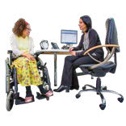

Without accessing your record, using your name or personal details, the system can also be used to find out

- total numbers of how many people have had their Annual Health Checks
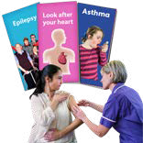
- how many people have a specific condition, like diabetes or a heart condition,

- how many people have had a treatment like a flu jab or a special medication.

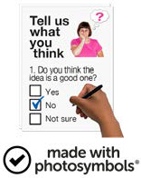

Please answer the questions on the next page to give your consent to the LeDeR Reviewers to access your health information.

I am happy to share my health information with the new LeDeR team.
Yes
No
I am happy to share some of my health information, but I want to keep some information private.
Yes
No
Please keep this information private:

Please send your answers back to us by the 4th January 2022

Please send your answer to:

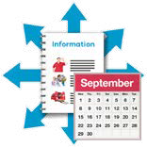
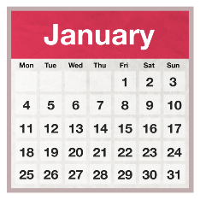

If we do not receive your answer we will share your health information with the new Unit

If you are finding it difficult to know what this all means, please talk to someone you know and trust – a family member or a good friend. Or if you have any questions you can contact the LeDeR coordinator at:
Rebekah.bailie@essex.gov.uk

