

Live at Home 2025
Mobilisation Pack

Introduction to Essex County Council – Adult Social Care
Our skilled workforce, working with our partners, supports 16,000 people to live independently.
Our vision in Adult Social Care (ASC) is for people in Essex living their lives to the fullest, supported by a community-based model of social care that is preventative and local.
Everyone should be able to live freely without fear, to make the choices they wish, and to be treated with respect.
Each year we support about 16,000 (sixteen thousand) people who need help to look after themselves and manage everyday tasks. We help them and their carers to live as independently as possible and to exercise control over their lives.
Our workforce has a range of skills including social work, occupational therapy, mental health and specialist disability practitioners, as well as highly skilled support staff. We work creatively to maximise the strengths of each individual we support and help them to achieve positive outcomes.
We commission care and support from a strong, diverse care market across Essex which provides a range of services including:
- home care
- residential and nursing care
- intermediate care
- day opportunities
- supported housing options
We work closely with the care market to ensure there is sufficient capacity to meet demand, and to improve the quality of care provision.
In order to meet the needs of adults throughout the county and to achieve desired outcomes, we work collaboratively with partners in health, and the public, private and voluntary sectors. We commission and design services together to best support our communities.
As part of mobilisation and throughout the life of the Live at Home (LAH) contract we will support you, as key providers of care, to identify health and social care partners within your service delivery area. We will make introductions and explore opportunities for collaborative working to better support you as providers, and to improve coordination of care for the Adults that you are supporting.

Service Development and Improvements
As part of ongoing delivery of the new LAH contract, we are committed to implementing a programme of service development and service improvement. We will share additional details about this at initial locality events late in 2025/early 2026 which you will be required to attend so please look out for invites to these.
The service development and service improvement plan includes a number of exciting pilot projects for providers as well as a plan for introduction and integration of providers into local health and social care systems. We look forward to working with you to ensure that you are supported in delivering care, and that LAH services are delivered to the highest possible standard.

Key Information and ways in which the Council communicates with the market
Locality Teams
Essex County Council’s operational Adult Social Care Teams operate on a locality basis. The locality teams consist of North East Essex, West Essex, Mid Essex, South West Essex and South East Essex. For more information on the locality teams/contact details please use the links below –
North East Essex – Locality Team Contacts
Mid Essex – Locality Team Contacts
South Essex – Locality Team Contacts
West Essex – to be added to the provider hub
Provider Hub
If you are new to working with Essex County Council, there is a large amount of relevant information contained on the Council’s Provider Hub, which you can access by clicking here. Please ensure that you familiarise yourself with the information contained on the website site as early as possible.
Provider Bulletin
The Council sends out a weekly Provider Bulletin. The bulletin is a collation of the latest news across social care in the county and is a valuable tool for those working in the sector to keep up to date. To sign up to receive it please click here.
Provider Newsletter
Sign up to receive the monthly Provider Newsletter from Essex County Council. The newsletter is also a collation of the latest news across social care in the county. To register to receive it please click here.
Quality Improvement Newsletters
To find out the support and free training you can get from the Council’s Provider Quality Improvement Team please see the two different newsletters available here.
Council Contacts
For key equipment service, finance or operational teams contact details please click here.
Live at Home Team – Procurement Services
If you have been notified that you are a Tier 1 provider via the Assessment Summary Letter and Schedule 13, you will have a named contract manager within the team to contact and meet with. This manager will get in touch with you during the contract mobilisation phase to share contact details and arrange a meeting.
If you are a Tier 2 provider, for the majority of providers you will not have a named contract manager. However, if you have a contractual query you may email liveathome@essex.gov.uk in the first instance. Your email will be triaged and one of the Live at Home team will be in contact with you.
Contacting Adult Social Care
For Providers (and all professionals) we no longer accept telephone calls or email referrals - providers should use the Portal - click here.
Only in a very urgent situation should Providers telephone during daytime hours.
Safeguarding Contacts
If you are unsure if your concern is a safeguard please click here for further information.
Published on the Essex Safeguarding Adults Board (ESAB) website – our Essex Decision Support Framework will help advise you on what is a reportable concern.
**A new improved version will be issued in early 2026 which will be accessible from the ESAB website and Provider Hub Safeguarding Pages**
Alternatively, you can call the Organisational Safeguarding Duty line on 033301 39032 for advice or email org.safeguards@essex.gov.uk (please note: we do not accept referrals this way – and you will be advised to use the portal should this be required).
If you need to raise an Adult Safeguard referral, professionals should notify the Council by completing an online form via the Adult Safeguarding Portal
If the matter is urgent and in or out of hours you can contact us on:
Essex - 0345 6037630 (out of hours 0345 606 1212)
There is a demo video as to how to use ECC’s Safeguarding Portal accessible on the ESAB website – click here to view it.
To raise adult safeguarding concerns – where the alleged harm or abuse occurred in Southend or Thurrock areas – contact;
Southend
Telephone: 01702 215008 (Out of hours: 0345 606 1212) | Adult Social Care online reporting: https://www.livewellsouthend.com/care-support-adults
Thurrock
Telephone: 01375 511000 | email: Thurrock.First@thurrock.gov.uk
If the adult is experiencing a mental health crisis please contact NHS 111 option 2.
You can also speak to the Adult's allocated social worker if known.
To raise safeguarding concerns relating to children – please click here.
Where a alleged crime has occurred; please also report via Essex Police.
Service Placement Team/Sourcing Process
Please refer to Appendix 1 of this document for contact details and sourcing processes used by the Council. Part 3 of the framework contract, sections 1, 8, 9 and 10 also provide further detail in terms of sourcing processes.
Payments and the payments system (Provider Portal)
For information on the Council’s Provider Portal, ‘how to’ guides and training videos click here. For Live at Home Services, ensure you click on the hyperlinks under the Non-residential heading. Schedule 3 of the framework contract, provides further detail in terms of payments.
Please note – we have recently written to providers new to working with Essex via ProContract to request bank details and the completion of the Extranet Security Form (as well as other information). If you have not responded to the message on ProContract, please can you do so as a matter of urgency. If you have already responded, you do not need to take any action.
Provider Quality
For further details on the support available or to find out some of the ways in which the Council will assess the quality of your service please click here. For further detail on the contractual Performance Standards please refer to Schedule 2 of the contract.
Provider Forums
These are a networking opportunity for Adult Social Care Providers and Essex County Council to meet both in-person and on-line at a local level. They are free to attend and provide the opportunity to discuss operational issues, system and council updates, have topical discussions, Q&A sessions and for providers to have their say. Representatives from system partners, including Health, attend the forums for a whole system approach to issues raised. For more information on the forums click here.
Sensory services in Essex
Essex County Council commissions Essex Cares Ltd (ECL) and six Voluntary Sector partners to deliver a comprehensive Sensory Service for residents with sight and/or hearing loss. ECL provides a triage service that acts as the front door for referrals, ensuring individuals are directed to the most appropriate support. They also deliver specialist sensory rehabilitation, develop in-house apprenticeships to grow local expertise, and coordinate initiatives such as the Sensory Action Alliance and sensory champions training. For more information in relation to sensory services click here.
Access to community equipment
The current Integrated Community Equipment Loan Service (ICELS) provider for Essex County Council is Medequip Assistive Technology Limited.
Once a provider has accepted a care package, individual carers will have the opportunity to express interest in Essex County Council’s Community Equipment Approved Assessor Programme. The MS Forms should be used to submit an Expression of Interest for individuals(s) within the organisation who will be able to access low-value equipment (please note that only company email addresses should be used, submissions from personal email addresses will not be accepted)
Requests will be reviewed by the ICELS Team and if approved, candidates will be sent information on how to enrol on the Approved Assessor E-Learning programme. Approved Assessor training equips participants with the skills to conduct functional assessments, identify people’s needs, and order simple equipment and minor adaptations through the ICELS. This enables professionals across health, social care, and allied services to contribute to wellbeing, prevention, enablement, and long-term community support.
More detail can be found on the information sheet attached as Appendix 2.
Care Technology
Care Technology (sometimes referred to as Telecare or Assistive Technology) is a range of monitoring and alert equipment designed to help individuals remain independent at home and within the community.
Our current care technology offer includes
- Personal alarms and pendants
- Fall detectors
- Monitored Smoke and carbon monoxide detectors
- Medication dispensers
- GPS trackers
For more information on the Council’s Care Technology offer click here.
For information on training your staff, following which they will be able to access various pieces of tec enabled care click here.
The East of England Displaced Worker Platform
The East of England Displaced Worker Platform is a free digital service designed to connect social care providers with displaced care workers seeking employment in the region. For more information in relation to this please click here.
ECA
Essex County Council works alongside the Essex Care Association. This is an organisation that providers can chose to belong to if required. For more information, see below or to visit their website click here.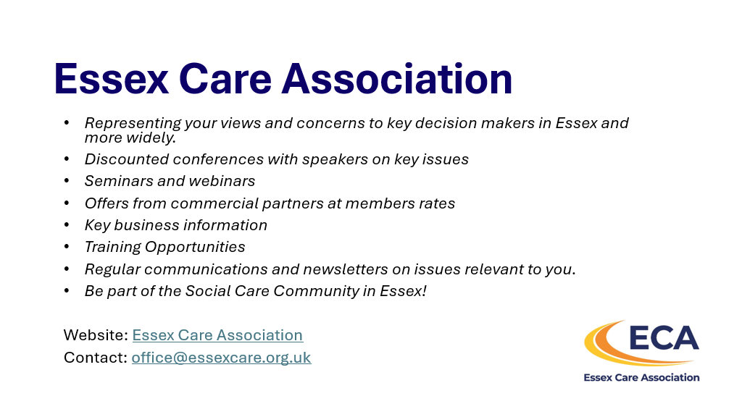
The information above is accurate as of November 2025. Updates are made to the Provider Hub information links above, so please ensure you regularly visit the pages for the latest information.

Appendices
Appendix 1
Sourcing Process Overview – please open the document below.
For information about the Specialist Views of Others (SVO) process please open the document below.
For information about the batching process please open the document below.

Appendix 2

