**Service Orders Tab**

1. **How To Locate Page**

The Service Orders page can be accessed from the top panel of the page, which is available on every page of the Portal:

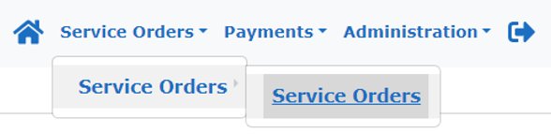

1. **What is it Used For**

The Service Orders page shows what contracts a service user has been under, i.e. they could have started on a Reablement contract and then moved onto a Spot contract. It shows every contract history even those that have ended.

**Contracts that have ended will have a date in the Date To column, ongoing care will not have a date.**



**If a Contract has an end date the Service Username will also be removed and instead it will say Name Redacted. However, you will still be able to see their ID reference number, which will match the reference on their purchase orders so you can still identify them. This is the Mosaic ID reference.**

**Some contracts may be added to the system before the start date, so it may be showing in Service Orders but there may not be an invoice to submit in Payment Schedules, it is important to check the Date From column.**

To look for a specific service user and their contracts you can filter the contracts using the panel at the top section of screen. Make sure your Provider name is showing, remove any dates in the From or To boxes and then click on the Service User filter. **Even for a Service User whose name will be showing as Name Redacted you can still search by their name and then just check for the correct ID reference.**

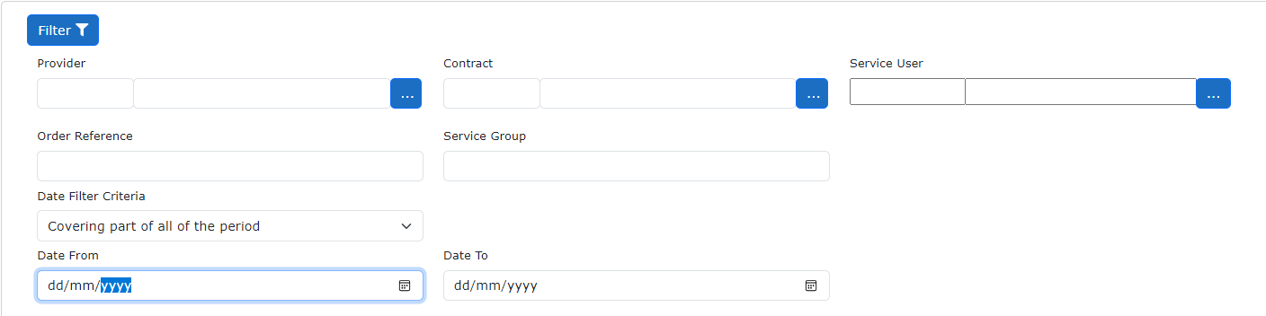



Once you click Service User a dialogue box will open;

* Click Name
* Hover over Filter
* Then type Service Name in Filter box, last name first
* Click on Apply
* Click on Select. This takes you back to the main screen
* Then click green Filter button

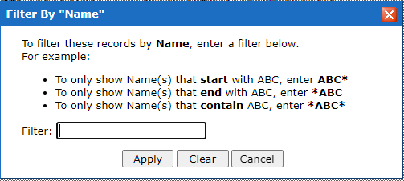

* Click on Select. This takes you back to the main screen
* Then click green Filter button

Click on the Details line at the end of the line to open up the service order to view the details.



This is a good way of checking what hours and rates are on the system for that service user without having to go through Payment Schedules.



Once you double click a contract a dialogue box appears with the above headings.

**Details** – this page shows when the care started, what type of care it is and how many Units are available as per the PO. Units will either be hours or day depending on type of care.

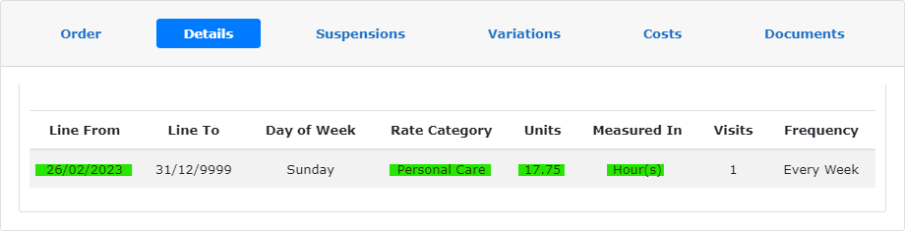

**Costs** – this page shows what rate is currently on the system. It will again show the Units per week and give a weekly total of how much full care will be, and if there are multiple care elements per week it shows a total at the bottom of how much everything would come to per week.

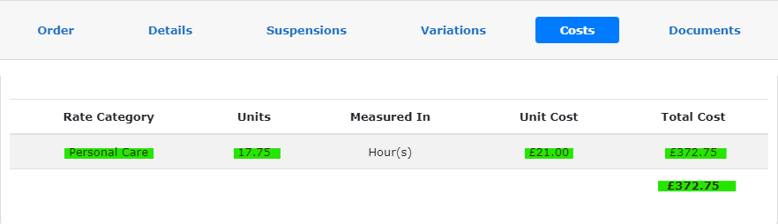

1. **When to Use Service Orders**

**If an invoice is not showing on Payment Schedules as you expected check Service Orders first. It may be that the contract has changed, and the invoice is now somewhere different. Or it may be that the PO has ended.**

1. **Who to Contact and When**

If you have provided care but the **care is showing as ended on Service Orders and you don’t have an ongoing PO** please contact [Service.Placementteam@essex.gov.uk](mailto:Service.Placementteam@essex.gov.uk)

If you **have a relevant PO but the information is not showing on Service Orders and the PO is dated more the 4 weeks ago** please send to [Panel.Team@essex.gov.uk](mailto:Panel.Team@essex.gov.uk) with the subject title Missing PO – 4 weeks old

**If the Service Orders page matches your PO but there is no invoice to submit please try using the Add button**, **with the Payment Schedule Option** hold Ctrl and click here to be taken to the relevant page on how to do that.