Provider Payment Enquiry

1. What is this used for?

This process allows you to be able to review payments against your provider account either paid or suspended by individual service user, or when reconciling remittance advices received from ECC for multiple service users.

1. How do I find it?

Log into the Provider Portal

At the top centre of the page there are three options – Select Payments

Then select Non-Residential

Then select Payment Enquiry

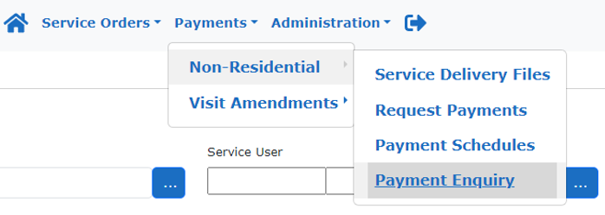

1. How do I find out if an invoice has been paid against an individual adult?

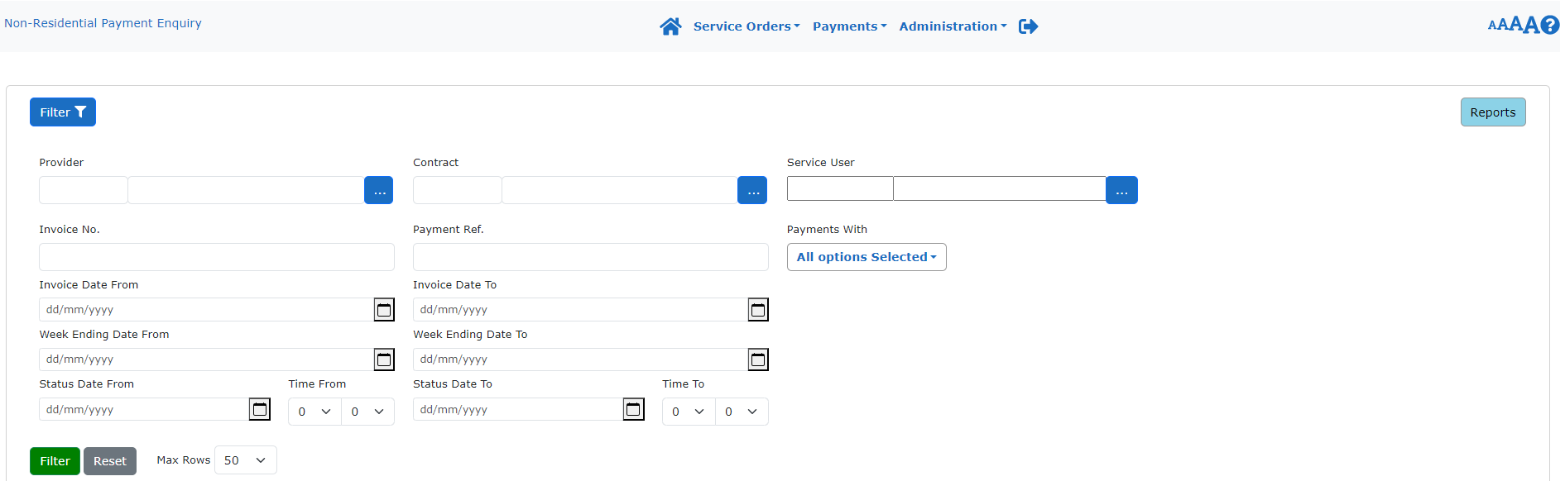



* Ensure that your Provider Name is visible in the ‘Provider’ field.
* Delete the ‘Week Ending Date From’ and leave blank.
* Click on ‘Service User’ to produce the list of clients to select from.
* Enter in either your service username, surname first, or Mosaic ID provided on the PO provided by Service Placement Team in the filter functionality
* Click Select

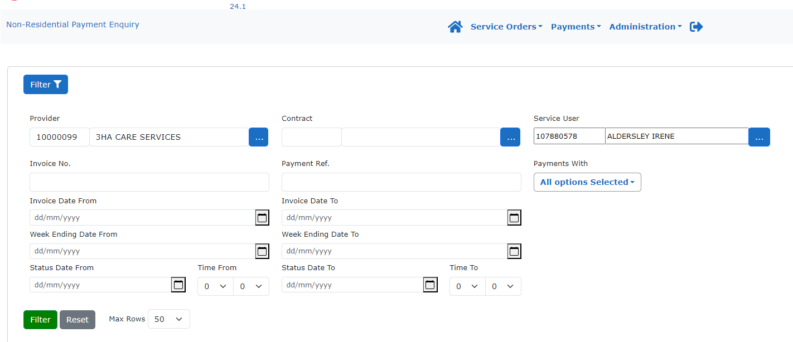



* Change ‘Max Rows’ to the maximum of 200 or accordingly if you have a lot of invoices to review against the client.
* Click on the Green ‘Filter’ button and wait for the invoices to show in the grid on the lower part of the screen.

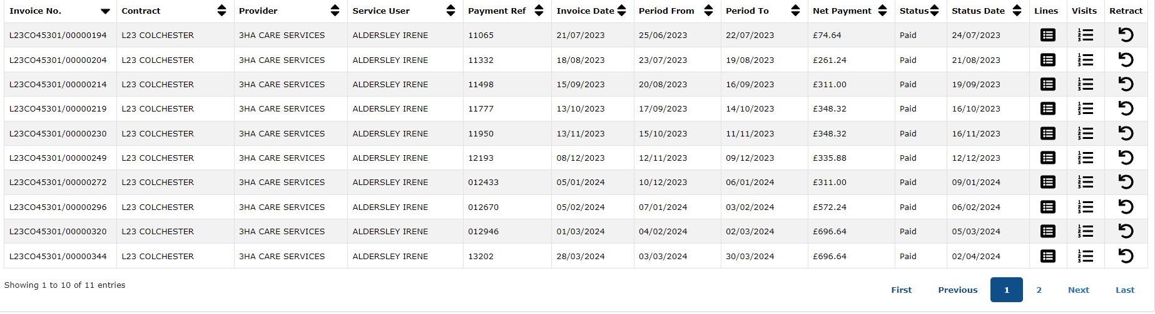



* To get invoices into a descending order so that the newest invoicing periods are first, click the down arrow twice on the ‘Period To’ column as highlighted. The manual invoice reference you have free typed in will show under column header ‘Payment Reference’ and the system generated invoice number if no manual invoice number is entered will be shown under column header ‘Invoice No.’ This process can be repeated for each individual adult requiring an enquiry.

1. When would I need to run a report and how?

Running a system report is advisable if you are wanting to reconcile a number of payments for various clients, or see how many suspended invoices you have currently in dispute within the Provider Portal. This can be achieved using the following process.

Ensure that your Provider Name is visible in the ‘Provider’ field.





Click on the top right-hand corner, blue box 

The below list of reports will appear: -

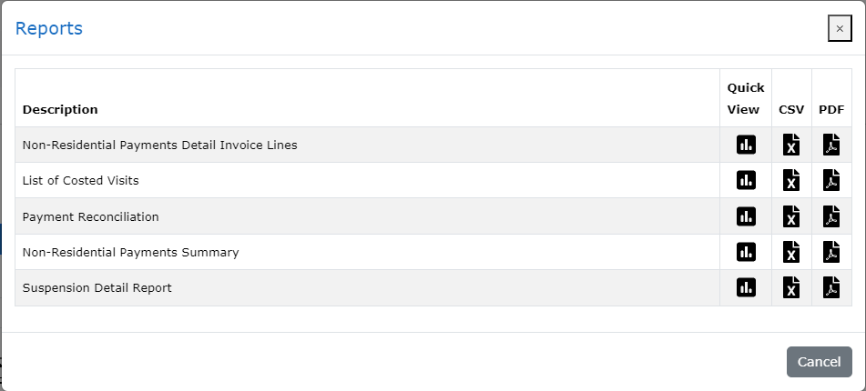

* Select ‘Payment Reconciliation’.
* Select ‘CSV’ option. This is the equivalent of an Excel report and once outputted you can apply filters across the headers to apply your own criteria to the task you are wishing to undertake.

This process can be also used for a suspension detail report by following the above instruction but selecting the option ‘Suspension Detail Report’. All reports contain both systems generated invoice number and manually inputted invoice numbers to allow you to reconcile remittances more easily.