


How to vote on 7 May 2026

For people with disabilities and those with support needs who may require help at the polling station

 | On Tuesday 7 May 2026 there will be local elections in Essex.
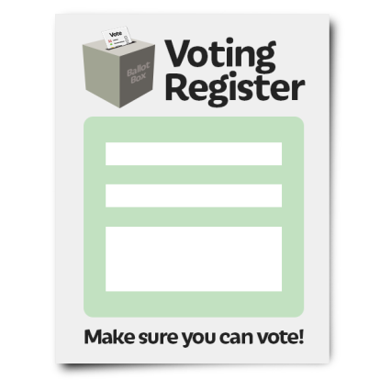 | You must register to vote before you can vote in an election.
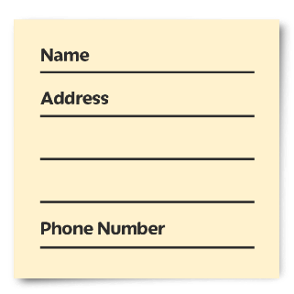 | If you are registered to vote you must update your details if you have:  - Moved to a new address  - Changed your name
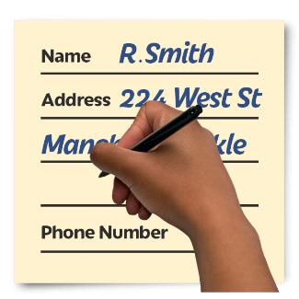   | You can register or update your details:  - on the government website  https://www.gov.uk/register-to-vote  - on a paper application form
 | If you:  - need help to register to vote  - need help to update your details  - want a paper application form
 | Contact:  [Add District Council Contact Details]
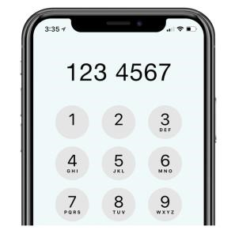     | Phone: xxxx  Email: xxxx  Website: xxxxx
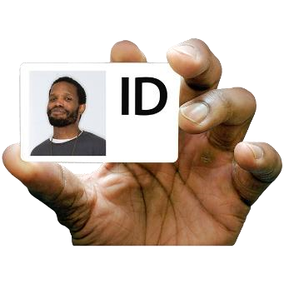 | Photo ID  You will need to take photo ID with you when you vote at a polling station.
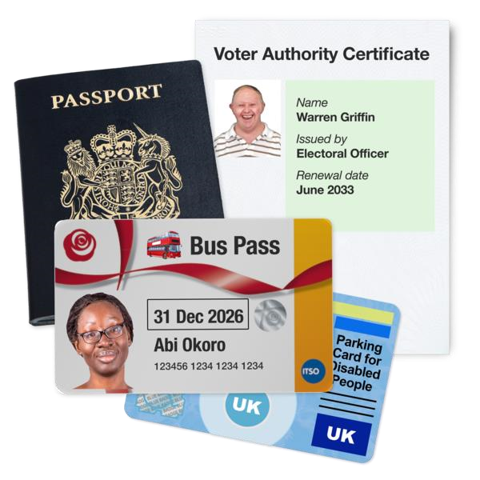 | You will need to take one of these photo IDs from this list:  • passport  • driving licence or provisional licence  • identity card with PASS mark  • biometric immigration document  • defence identity card
 | Some travel cards are ok.  Some national identity cards are ok.  You can use an out of date photo ID if the photo still looks like you.
 | For more information you can  - go to this website https://www.electoralcommission.org.uk/voterID  - phone the Electoral Commission helpline 0800 328 0280
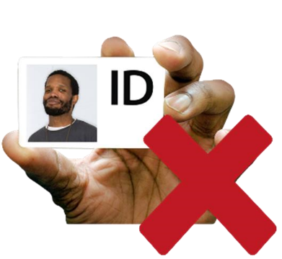 | If you don’t have photo ID
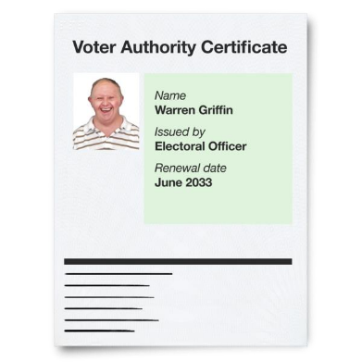 | You can get a voter authority certificate to use when you vote.  To apply for a certificate, you must be registered to vote.
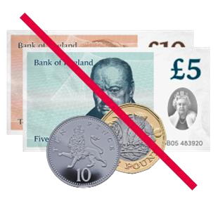 | A voter authority certificate is free.
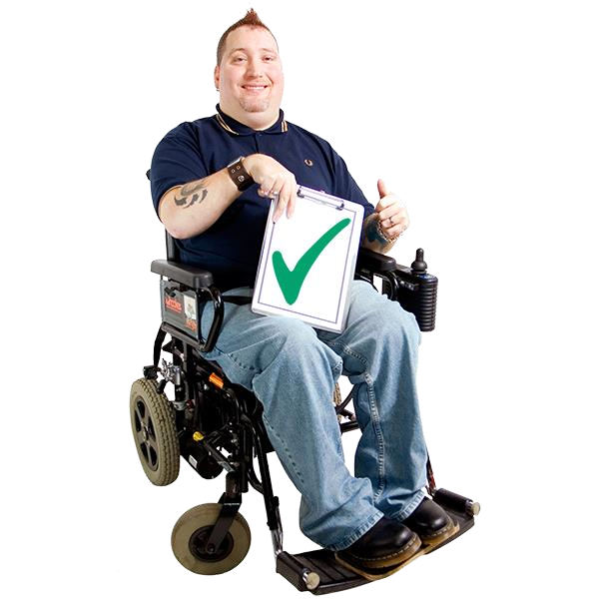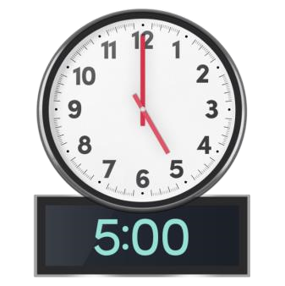 | You must apply for a certificate before 5pm on Tuesday 28 April.
You can apply for a certificate:

- on the government website https://www.gov.uk/apply-for-photo-id-voter-authority-certificate

- on a paper application form

If you:

- need help to apply
- want a paper application form

Contact:
Add District Council details
Phone: xxxx
Email: xxxx
Website: xxxx
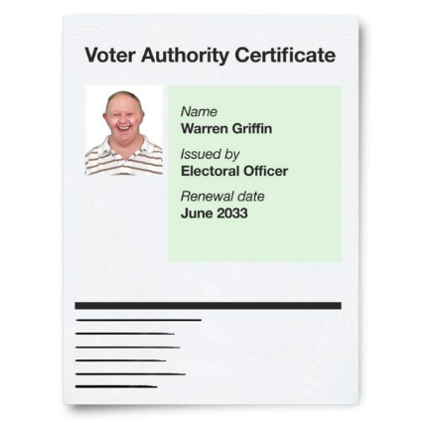 | When you apply for a certificate you need to know your:  - name  - address  - date of birth  - national insurance number
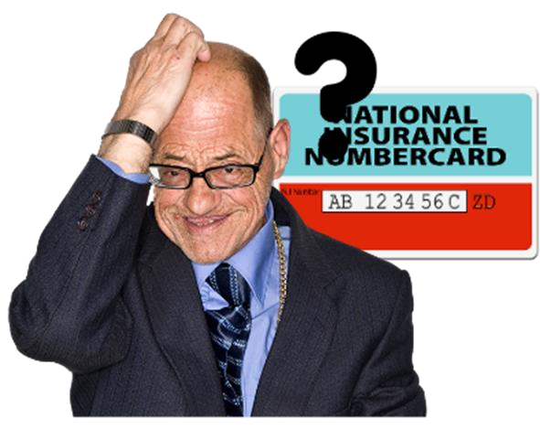 | If you don’t know your national insurance number, you can still apply.  If you don’t know your national insurance number, [Add District Council] will ask you for something else to check who you are.
 | When you apply for a certificate, you need to send a photo.  If you don’t have a photo the council can take one for you.
 | You need to follow some rules for the photo. The rules are like the rules for a passport photo.  You can read about the rules here https://www.electoralcommission.org.uk/voterID
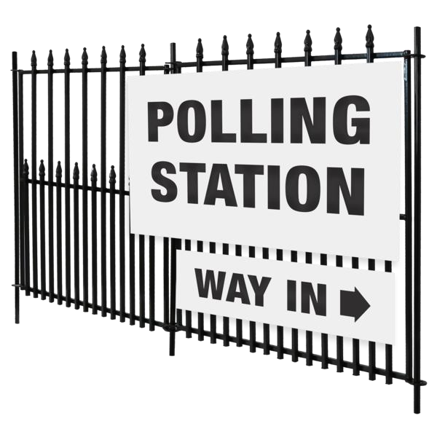   | You can vote by going to the polling station.  When you get to the polling station to vote a member of staff will ask you for your:  - name  - address  - photo ID
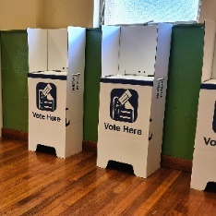 | There will be a private area at the polling station where staff can look at your ID.  Let staff know if you want them to look at your ID in the private area when you arrive at the polling station.
 | They will look for you on the voting register.  If they are happy with your ID they will give you a ballot paper to vote on.  They will show you where you can fill it in.
 | If you need any help at the polling station, please ask the staff.
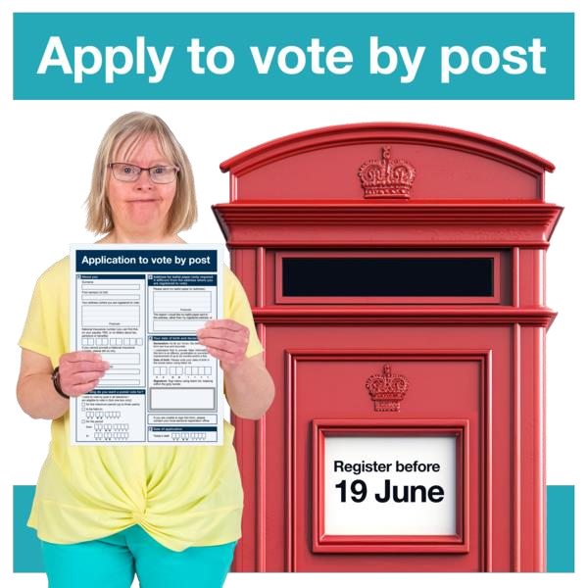 | You can vote by post.  To vote by post you need to fill in an application form.  You must be registered to vote.  You do not need photo ID.
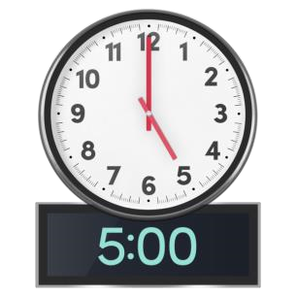 | You must apply to vote by post  before 5pm on Friday 20 April.
You need to get a form on this website

https://www.gov.uk/government/publications/apply-for-a-postal-vote

and send it to [Add District Council]
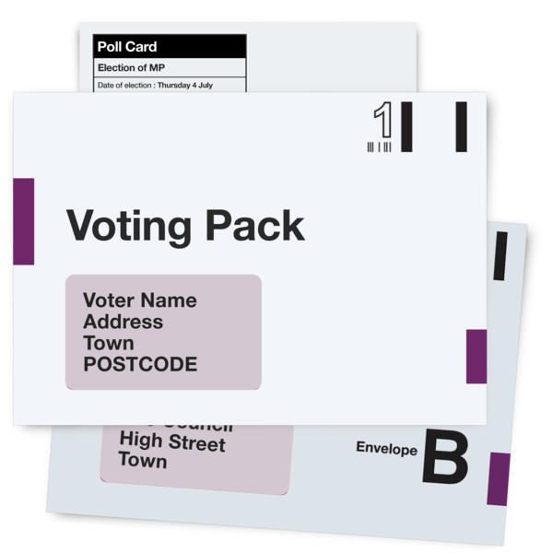 | The [Add District Council] will send your ballot paper to vote in the post.  [Add District Council] will tell you what date and time they need your vote by.
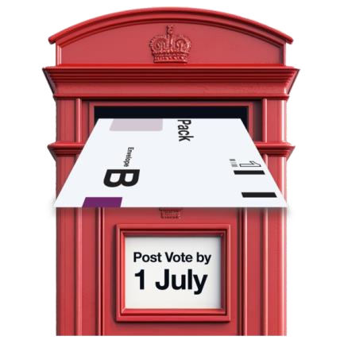 | Fill in your ballot paper and post it back to [Add district Council] before the deadline.
If you miss the deadline you can take your ballot paper:

- to your polling station before 10pm on Tuesday 7 May
- to Elections and Electoral Registration

[Add address]
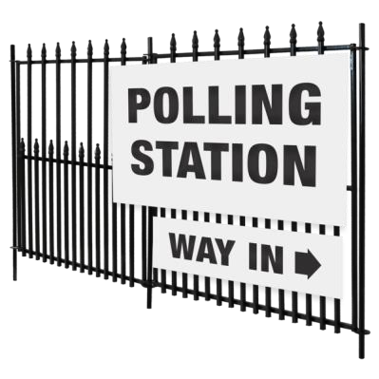   | You can vote by proxy.  Proxy means you choose someone to go to the polling station to vote for you.  You must be registered to vote.  You do not need photo ID.  The person you choose to vote for you must be registered to vote.
You will need:
- your national insurance number or something else to prove who you are
- permission from the person you want to vote for you
- their address and contact details

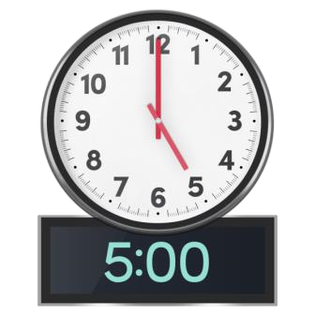 | You must apply for a proxy vote  before 5pm on Tuesday 28 April.
The person you choose to be your proxy will go to the polling station and vote for you.

They will need to take their own photo ID.
 | If you have any questions about  - registering to vote  - photo ID  - applying for a voter authority certificate
 | Go to this website  https://www.electoralcommission.org.uk/voter  Or phone the electoral commission on 0800 328 0280

