Provider Portal
Processing Non-Residential Invoices

*Links have been set up for all the below section headings to their relevant page. To quickly get to a section hold Ctrl and click on the relevant underlined heading in the Contents section below. To get back to this page do the same by clicking on the heading at the start of the section you read in the manual*
Contents
- Getting Started – Logging in / setting up – Page 2
- Payment Schedules tab – Submitting invoice for payment – Pages 3 – 6
- The Homepage – System updates/downtime PLEASE READ – Page 7
- Service Orders tab – Checking a contract – Pages 8 - 10
- Payment Enquiry tab – Online remit – Pages 11 - 15
- My Invoice is Suspended – Page 16
- I Need to Retract/Amend an Invoice – Pages 17 - 19
- I Was Unable to Provide Care - Frustrated visit – Pages 20 - 21
- Submitting VAT Invoices – DOES NOT APPLY TO ALL – Page 22
- Adding a Note to an Invoice – Page 23
- Creating an Excel Report of Invoices - Pages 24 - 25

Useful Contacts and When to Use Them
- Purchase Order (PO) issues:
  - PO has incorrect dates/hours/rates – Service.Placementteam@essex.gov.uk
  - PO is not showing on Service Orders tab – Panel.Team@essex.gov.uk
  - PO ended, should be ongoing – Service.Placementteam@essex.gov.uk
- Contract Issues/changes:
  - Change of details i.e. name/bank account – Procurement.Adults@essex.gov.uk
  - Rate Issues – Service.Placementteam@essex.gov.uk
- Payment Issues:
  - When will an invoice be paid – AP.Servicecentre@essex.gov.uk

Getting Started
- What do I do?
Once you have signed your contract you need to be granted access to the system Provider Portal, this is the system where the electronic invoices are submitted. Below is a checklist and contact information of what you need to do to gain access:
- Contact Mosaic.Helpdesk@essex.gov.uk advise you are a new company and need system access.
- You will then complete a security form – Every person who will use the Provider Portal needs their own login details accessed via their own work email address
- Once the form is completed you will be emailed a link to verify your Provider Portal account – activate the link and create new password
- Once you have access to the Provider Portal contact NRPayments@essex.gov.uk advising you require system training. Please confirm if you have Microsoft Teams

- No Purchase Orders No Training
If you are still waiting for hours/rates to be confirmed and have not yet received a purchase order for care, please bear in mind we will have to wait until this is completed before training can commence. Without a PO there are no invoices on the system.

- New Starters
Every time someone new joins your team who needs access to the Provider Portal please advise them to complete the security form and send over to NRPayments@essex.gov.uk , we will then provide them with training.

- Leavers
Please also contact NRPayments@essex.gov.uk whenever someone leaves your company or no longer needs access to the Provider Portal so that we can terminate their access. This can always be reinstated later if needed.

Payment Schedules Tab
- What it is used for?
In short, this is the page where you access the invoices to check them and submit them to go through to be processed for payments.

- How do I find it?
- Login into Provider Portal
- At the top centre of the page there are three options – select Payments
- Then select Non Residential
- Then select Payment Schedules
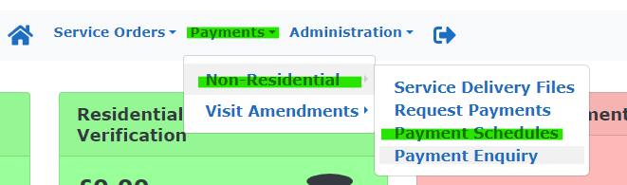

- Where are my invoices?
When you first get to the Payment Schedules page make sure your company name is in the Provider field and that the date From in the top left hand side of the screen has been removed.
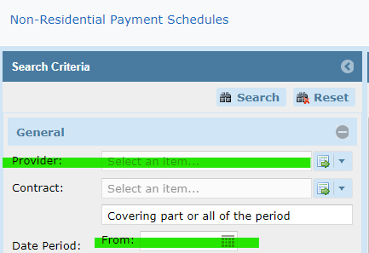

On the main part of the screen is where the Contracts are, they are grouped by invoicing period, they run top to bottom newest to oldest. The invoices are held in the contracts depending on care type.
Quick overview of the main page:
- Reference – the contract, always look at first 3 digits; S12 (Reablement) LAH (Live at Home) SL1 (Supported Living) etc the next two letters represent the area; CO (Colchester_ BR (Braintree)
- Date From / To column – shows you the invoicing period covered in that contract
- Click on Reference column heading and a filter option appears. Type in first 5 digits of a contract and it will only show that contract across every period
- Or you filter the Date Period and just bring up one invoicing period and every contract active in that period
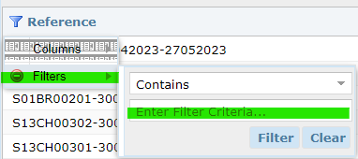

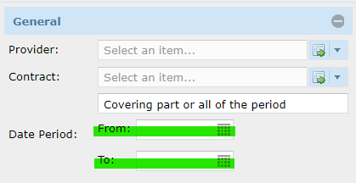

Once you have located the correct contract for the correct period double click on it to open it.

- How do I submit an invoice?
Once you have opened the contract there is a summary section at the top, confirming contract and invoicing period. Beneath that are two sections, Unprocessed Provisional Invoices and Payment Invoice.

- Unprocessed Provisional Invoices is where invoices wait until they are submitted for payment.
- Invoices Awaiting Verification shows how many invoices are waiting to be submitted
- Once submitted they will appear as a Verified Invoice beneath
- Click on the blue List button to see all the invoices
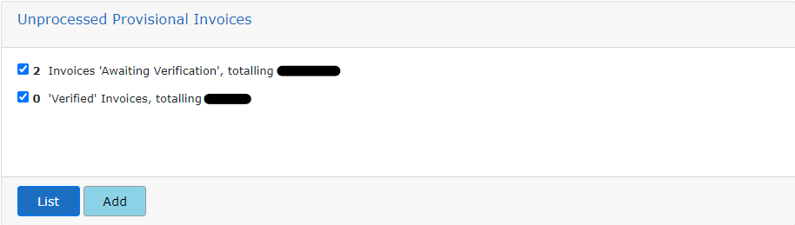

You will then see an alphabetical list of all the invoices that need to be checked and the submitted for payment if correct and care was provided. Click on the Service Users name to open the invoice.
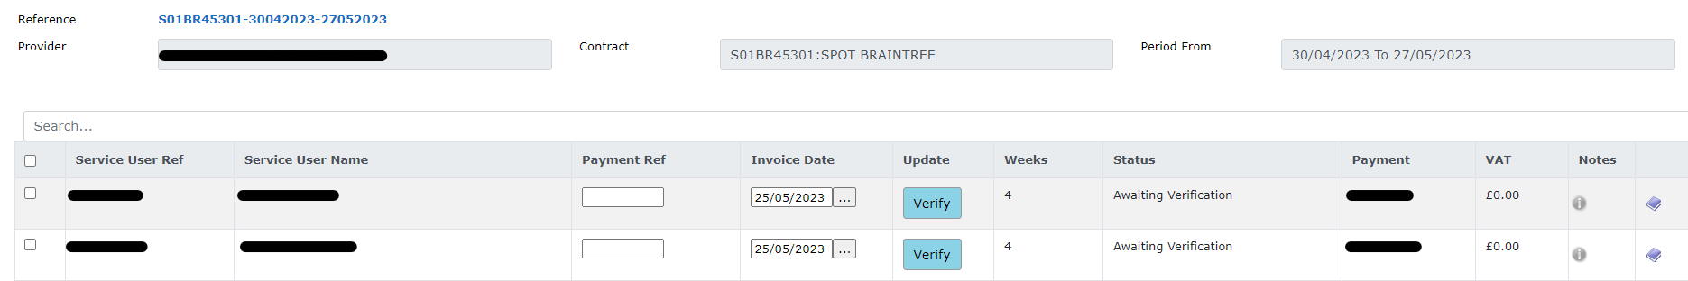

Once opened you will have up to 4 weeks per invoice to check. Here is what you need to check when going through the invoice:
- Check all needed weeks are showing. They are shown in the first column by their week ending date, if care starts mid invoicing period there will not be 4 weeks showing.
- Check the type of care is correct. This is the second column. If different types of care are provided each week then there will be several individual lines per week for each care type.
- Check the planned hours are visible and match PO – this is the third column and is presented in either hours or days depending on care type.
- Check and amend if needed the amount of hours/days provided – this is the Delivered/fourth column this can be adjusted by you if less care or no care was provided for one or multiple weeks. Simply type in the box in the Delivered column how much care you provided that week. If entering incomplete hours it must be entered in quarterly increments i.e 12.75, 4.25, 7.50, 5.00 please round up or down to the closest quarterly amount.
- Enter any hours where you tried but could not provide care i.e. a Frustrated visit – hold Ctrl and click here to be taken to the relevant page on how to do this.
- Check the rate is correct – this is the Unit Cost column and is the agreed upon rate, showing on PO
- Check the total – the final column is the amount you will be paid for each week, please check your paperwork to ensure this is what you were expecting.
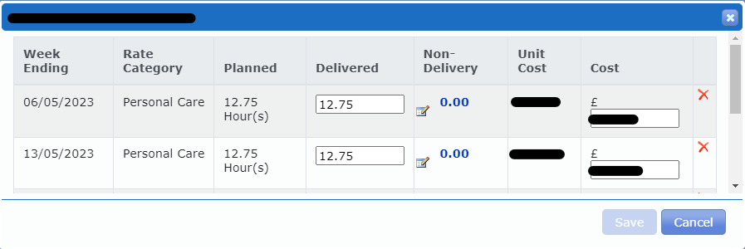
Once you have checked the invoice and happy with hours/rates, and no amendments were needed click on the X in the top right-hand corner.

If you had to adjust and change the hours in the Delivered column please click the Save button in the bottom right hand corner – if changes aren’t made this button won’t be greyed out.

Once out of the invoice we are then back to our invoice list. For the invoice we just checked/amended we now need to:
- Provide a Payment Ref – this column has a blank box for each invoice, this is where you enter your unique invoice number. It needs to be different for every person, every month, every invoice.
- Check Invoice Date – this date needs to be the date that you checked and submitted your invoice.
- Check Payment – this is the total amount that will be paid for that invoice, check it is in line with what you were expecting.
- Submit Invoice – the fifth column says Update and every line will have a blue Verify box. Once you are happy with an invoice click Verify, click Ok on the dialogue box that appears and that invoice is now going into the payment process.
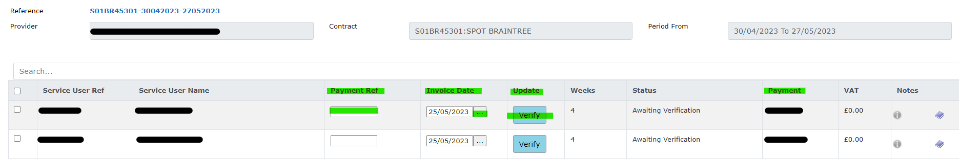

The Homepage
- System Updates
When you first login to the Portal and are taken to the homepage one of the main features to pay attention to is the Provider Notices section.
This will advise you when the system will be offline and therefore you will not be able to login or when updates are happening and the system shouldn’t be used otherwise any changes made, i.e invoices you submit, may not be saved once the update is complete.
Therefore, if you use the system during Downtime you may think you have submitted an invoice but actually once the update is complete its still waiting to be submitted again.
Also if you try to login during downtime it may say your system is blocked, it says this for everyone that’s because we are not allowed to be logging on during that time.
Take note of downtime and only try to login after the estimated completion time.
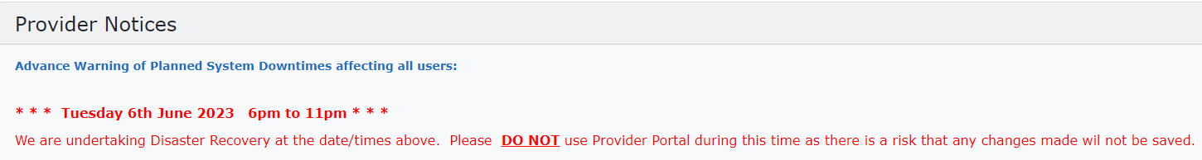

- Navigation
The homepage is also where you can access all other pages and features of the Portal. Below is a list of where you can go, what information is held there and how to find that page:
- Service Orders – List of all contracts, ongoing and closed, for every service user.
- Payment Schedules – Where all the contracts are held, where the invoices are submitted from.
- Payment Enquiry – Online remittance, list of every invoice processed, those that are paid, retracted and suspended.
- House Icon – This takes you back to the main page.
- Arrow – This is how you log out of the system

Service Orders Tab
- How To Locate Page
The Service Orders page can be accessed from the top panel of the page, which is available on every page of the Portal:
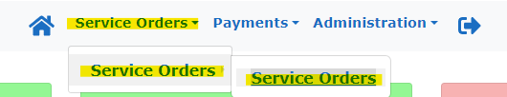

- What is it Used For
The Service Orders page shows what contracts a service user has been under, i.e. they could have started on a Reablement contract and then moved onto a Spot contract. It shows every contract even those that have ended.
Contracts that have ended will have a date in the Date To column, ongoing care will not have a date.
Some contracts may be added to the system before the start date, so it may be showing in Service Orders but there may not be an invoice to submit in Payment Schedules, its important to check the Date From column too.
To look for a specific service user and their contracts you can filter the contracts using the panel on the left-hand side of the screen. Make sure your name is showing, remove any dates in the From or To boxes and then click on the Service User.
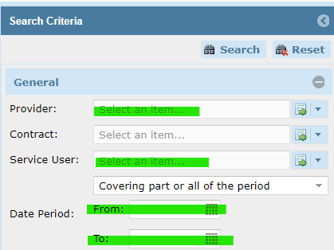
Once you click Service User a dialogue box will open;
- Click Name
- Hover over Filter
- Then type Service Name in Filter box, last name first
- Then click Filter
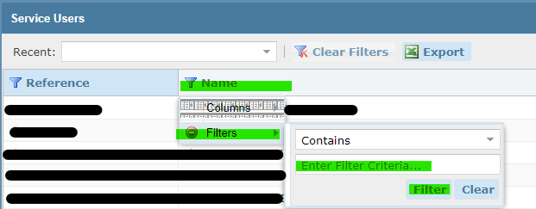

If a contract does not have an end date and is ongoing you can double click on it to open the contract. This is a good way of checking what hours and rates are on the system for that service user without having to go through Payment Schedules.

Once you double click a contract a dialogue box appears with the above headings.
Details – this page shows when the care started, what type of care it is and how many Units are available as per the PO. Units will either be hours or day depending on type of care.
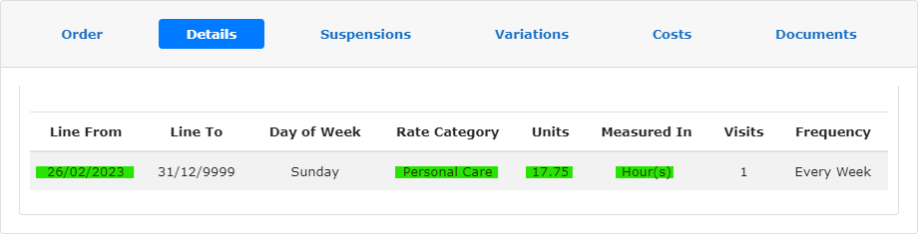

Costs – this page shows what rate is currently on the system. It will again show the Units per week and give a weekly total of how much full care will be, and if there are multiple care elements per week it shows a total at the bottom of how much everything would come to per week.
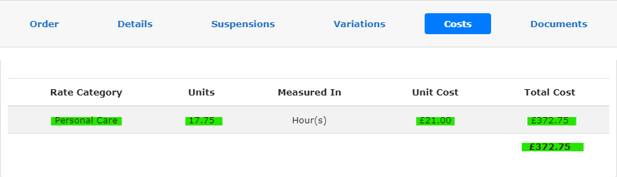

- When to Use Service Orders
If an invoice is not showing on Payment Schedules as you expected check Service Orders first. It may be that the contract has changed and the invoice is now somewhere different. Or it may be that the PO has ended.

- Who to Contact and When
If you have provided care but the care is showing as ended on Service Orders and you don’t have an ongoing PO please contact Service.Placementteam@essex.gov.uk
If you have a relevant PO but the information is not showing on Service Orders and the PO is dated more the 4 weeks ago please send to Panel.Team@essex.gov.uk with the subject title Missing PO – 4 weeks old
If the Service Orders page matches your PO but there is no invoice to submit please try using the Add button, hold Ctrl and click here to be taken to the relevant page on how to do that.

Payment Enquiry Tab
- How To Locate Page
The Payment Enquiry page can be accessed from the top panel of the page, which is available on every page of the Portal:
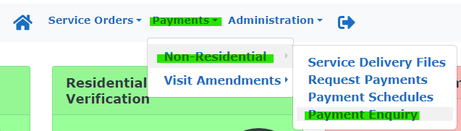
- What is it Used For
The Payment Enquiry page is used to check the status of an invoice; you can see which invoices are suspended, which have been paid, if an invoice payment is missing and which invoices have been retracted.
To check what invoices are Suspended go to the left hand panel;
- Make sure your name is in the Provider box
- Untick every Status box except Suspended
- Remove the From date in the Invoice Date box
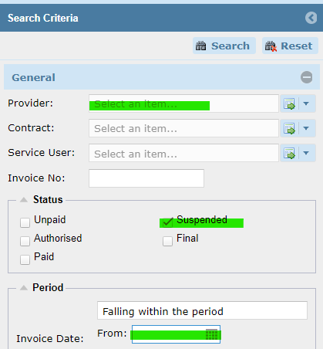
The right hand side of the screen will now show every invoice that is Suspended, these invoices have exceeded the allocated hours/days stated on the PO therefore they are stuck in the system and cannot be processed for payment. To know what to do with these invoices, hold Ctrl and click here to be taken to the relevant page.
You can see that instead of having a status of Paid they say Suspended. It also tells you the Payment Ref (the invoice number) which Service User the invoice is for, and which invoicing period it relates to.
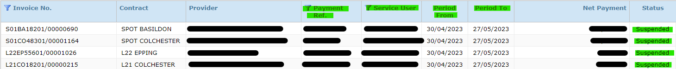

To check what invoices have been Paid, you can filter the invoices to show a specific invoicing period using the left hand panel;
- Make sure your name is in the Provider box
- Untick every Status box except Paid
- Remove the From date in the Invoice Date box
- In the Week Ending section put the invoicing period start date in From and the end date in To
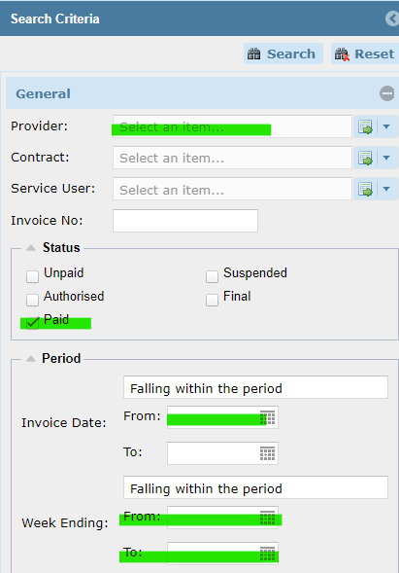
This will bring up all invoices that have been Paid for this period, for every service user and under every contract.
Or you can filter the invoices to just show one service user’s invoices, this is helpful if you think there is an invoice period that hasn’t been processed or paid yet.
- Make sure your name is in the Provider box
- Put the relevant name in the Service User box
- Untick every Status box except Paid
- Remove the From date in the Invoice Date box
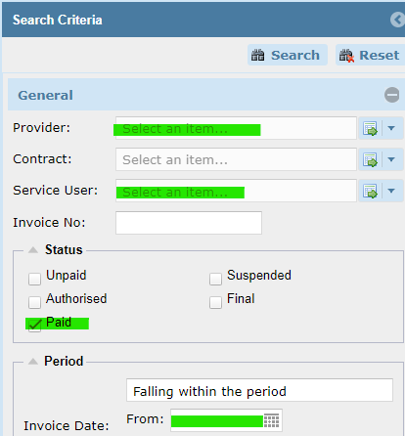
Once you click Service User a dialogue box will open.
- Click Name
- Hover over Filter
- Then type Service Name in Filter box, last name first
- Then click Filter
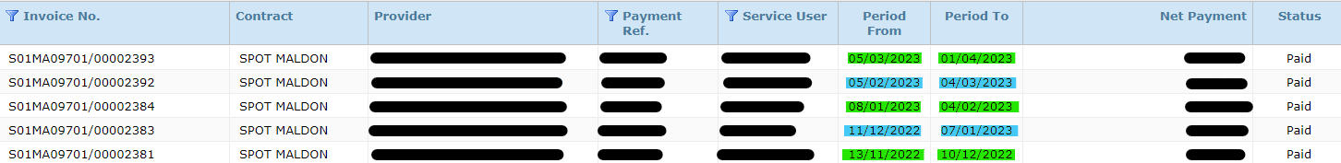
Once you have a list of all the invoices processed for that service user you can look down the list and see if any invoicing periods are missing, this can be done by simply checking the start dates follow on from the end date of the previous period.
Finally, you can also use Payment Enquiry to see if an invoice has been retracted, this could be if you think an invoice has been submitted but you cannot see it, or you want to check if an invoice was retracted and or resubmitted.
To see any retracted invoices, you need to untick the Hide Retracted and Retraction Invoices box at the bottom of the left-hand panel.
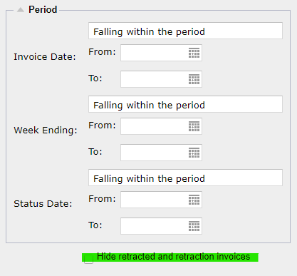
Again, you can filter this by invoicing periods or by a specific service user.
For the below example the invoices have been filtered by service user.
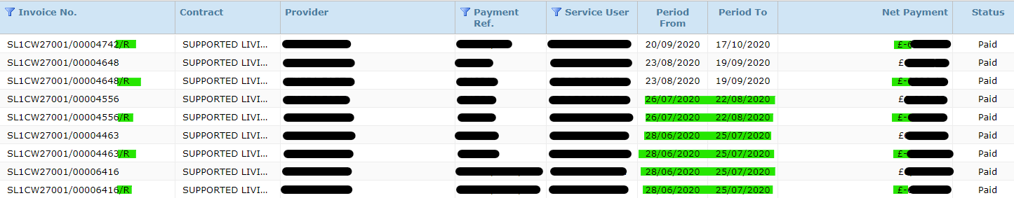
As you can see from above when an invoice is submitted and then retracted there are two entries for an invoicing period (period 26/07/20 to 22/08/20). However, if an invoice needs to be retracted and resubmitted again there could be multiple entries as can be seen for period 28/06/20 to 25/07/20.
The first entry will always be at the top of the list for that period, the next entry below it will be its retraction, the one below that will be the resubmitted invoice etc.
Invoices that are retracted have an /R at the end of the Invoice Number, and also for the Net Payment there will be a pound sign then a minus figure before the invoice amount indicating that amount has been removed not paid. It will look like; £-1,000.00 for a retraction and £1,000.00 for a payment.

- When to Use Payment Enquiry
If you receive a remittance but you think there as an invoice, or several invoices, missing you can quickly look them up on Payment Enquiry.
You can either use the invoicing period filter and then check the total of that compared to the remittance. To easily convert this information into an Excel document, hold Ctrl and click here to be taken to the relevant page.
Or if you know specifically which invoice is missing you can look for that using the unique invoice number you provided when the invoice was submitted.
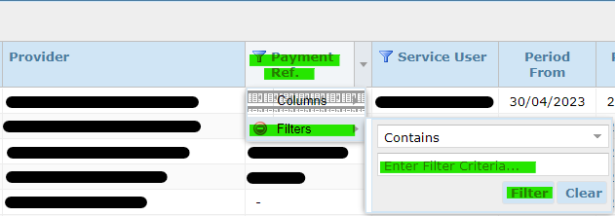
- Click Payment Ref
- Hover over Filter
- Then type the invoice number in the Filter box, if you did not enter one when you submitted the invoice this isn’t an option.
- Then click Filter
Then you can see just that one invoice and see what Status it has; whether its, Paid, Suspended or it cannot be found.
If nothing comes up when the invoice number is entered you will need to go into Payment Schedules and look up the invoice under its relevant contract and period. Remember this will now be showing under the paid section. Hold Ctrl and click here to see what this section looks like.
You can also use Payment Enquiry to see what invoices are Suspended as these will need amending in some way as they cannot be paid in their current form, please go to the next page to see what needs to happen.
Payment Enquiry should be used as an online remit, it’s the quickest way to check what has been Paid, what hasn’t been submitted and is missing, and what’s Suspended. All you have to change is the information on the left hand side panel to change what is viewed on the main screen.
All the information can also be captured onto an Excel spreadsheet, hold Ctrl and click here to view this page.
- Who to Contact and When
If you receive a remittance that doesn’t have a payment you’re expecting on it but it is showing as Paid on Payment Enquiry contact AP.Servicecentre@essex.gov.uk with the invoice number.
My Invoice Is Suspended
- Why is Your Invoice Suspended
Once you have found the invoices that are Suspended on Payment Enquiry if you double click anywhere on the row, it will open the invoice up so it can be read.
Once the invoice is open you need to look at the Units column, this is the number of hours/days that have been agreed per week and are on the PO, compared to the Delivered column, this is the number of hours/days you are saying were provided per week.
If the Delivered column is greater then the Units column, the invoice will Suspend.
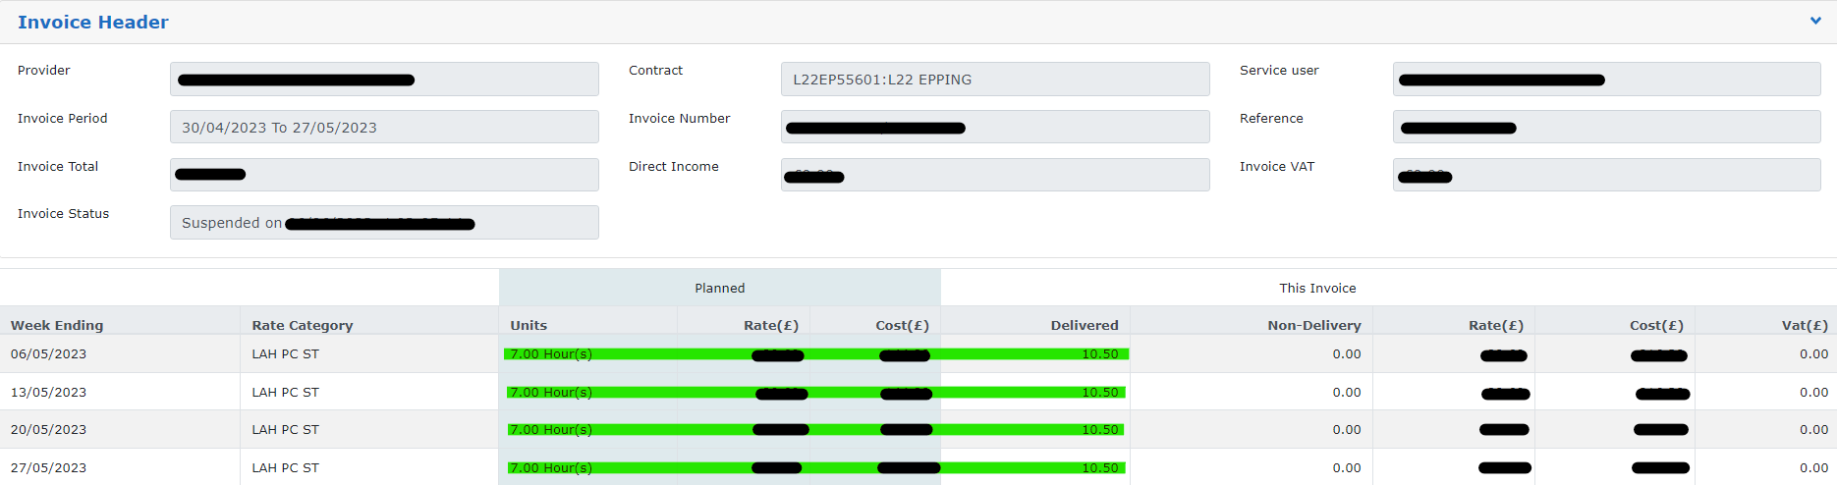
As can be seen from above 7.5 hours is what has been allocated per week, but 10.5 hours have been entered, so it will become Suspended.

- How to Unsuspend an Invoice
Once you can see why the invoice is Suspended you need to ask yourself the following questions;
- Are the hours in the Delivered column correct and the system/PO is wrong
- Are the hours in the Delivered column wrong and just need amending
If the invoice is correct and the Delivered hours are as they should be, but the Units column is incorrect this needs to be reflected onto a purchase order. If you don’t have a PO that shows the correct number of Units you need to contact Service.Placementteam@essex.gov.uk to request they amend the PO.
If you already have an amended PO but the Units showing on the system are still incorrect, please send the PO over to Panel.Team@essex.gov.uk if the date on the PO is older the 4 weeks and the system is still wrong.
Once the PO and the system have been amended or if the invoice was submitted incorrectly and the hours entered in the Delivered column are wrong the invoice will need to be retracted to remove it from its Suspended state and then resubmitted. Either in line with the new PO hours or in line with the original hours and just not exceeding them.
Please read on to the next chapter to learn how to retract and resubmit an invoice

I Need to Retract/Amend an Invoice
- Why Would I Need to Retract an Invoice
An invoice will need retracting if the original submission is incorrect in some way and or needs to be amended. The invoice needs to firstly be removed from the system and then resubmitted with the amendments or left removed from the system if it shouldn’t have been submitted at all. The amendments could be hours needing to be changed, invoice submitted at the wrong rate, invoice submitted under old contract etc.

- How Do I Retract An Invoice
Firstly, locate the relevant invoice by going through Payment Schedules and finding the correct contract and relevant invoicing period and double clicking it to open.
Next to where the invoices needing to be submitted are held is a section where the processed invoices are kept. At the bottom of this section is another List button, click this to view all of the submitted/processed invoices.
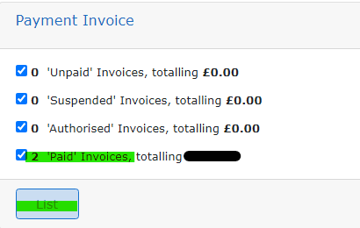
All the invoices will be shown in rows in the same format as when they are new and waiting to be submitted. Once you have located the relevant invoice click the circle at the far-left hand end of the invoice row, the circle will then turn blue.
In the bottom right hand corner, the red Retract button can now be selected, click this button.
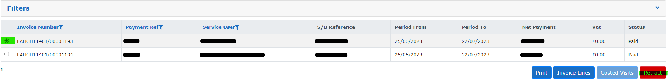
A dialogue box will then appear just confirming that you wish to retract the selected invoice and that by doing so it will create a credit. Click OK.
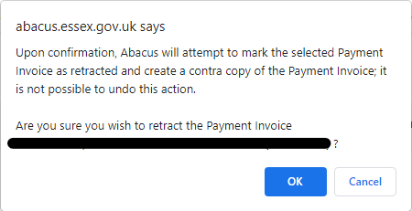
Next another dialogue box will appear confirming the invoice has been retracted, if this does not appear please double check whether the invoice is still showing in the Payment Invoice section, see previous page. If it is repeat the retraction process.
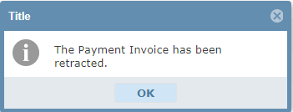
Once you click Ok on the above dialogue box the invoice has been retracted. If the whole invoice needed to be removed and not resubmitted there is nothing more that needs doing, if you need to resubmit an invoice with adjustments please continue reading.
If once you have clicked Ok on the above box and you need to resubmit the invoice, please go back one page using the back button in the top left hand corner of the screen.
Once there in the section where the new invoices wait to be submitted you can see it says there are 0 Invoice Awaiting Verification. That is because when an invoice is retracted/manually removed we need to manually add it back onto the system.
This can be done by clicking the Add button as seen below.
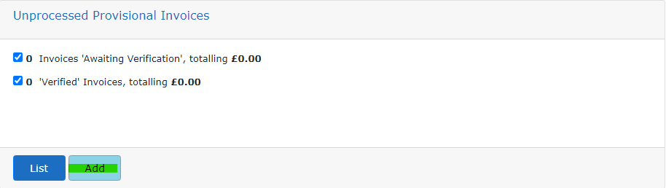
Once you click Add it will bring up a list of invoices that can be added onto that contract for submission. The invoice you have just retracted will be there.
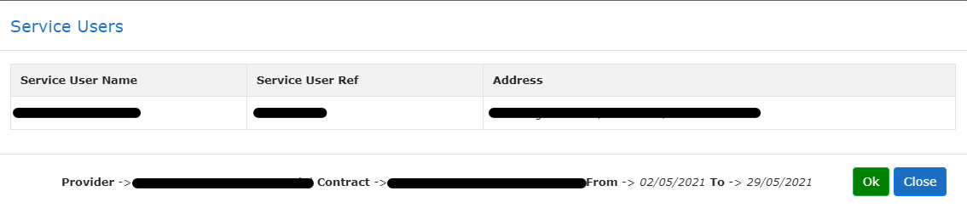
Click Ok to add the invoice back onto the system, you don’t need to tick a box or select anything just clicking Ok will add it.
Once you click Ok the green ribbon in the below image will appear confirming the invoices is being added back. To come off this screen you need to now click the close button.
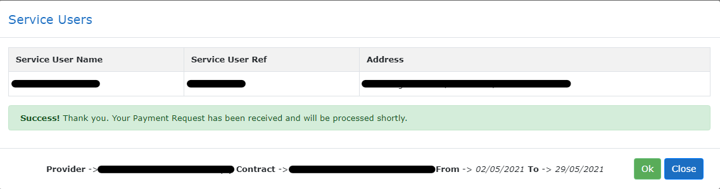
Once back on the main screen refresh the page and you can now see that it says there is 1 Invoice Awaiting Verification.
From here you just submit the invoice like you would do if it was the start of a new invoicing cycle.

I Was Unable To Provide Care
Frustrated Visits
- What is a Frustrated Visit
A Frustrated Visit is where you either attempted to provide someone care but couldn’t i.e., the Service User wouldn’t let the carers in, they had gone out and not advised the carers. Or the care was not cancelled with enough notice and stated in your contract.
For these situations the care can still not be claimed for as it was not properly cancelled but it needs to be submitted as a Frustrated Visit to avoid a charge going out to the Service User for care they did not receive.
If care is cancelled within the appropriate notice period, this cannot be claimed as a Frustrated visit. If the amount of care the Service User receives decreases but this is not reflected on the system advise the relevant Social Worker.

- How to Submit Frustrated Hours
When submitting an invoice that has Frustrated visits you find it in the same place as any other invoice, by going to Payment Schedules and finding the relevant contract and invoice period.
Once the invoice is located open it up to show the rows of weeks for that invoice.
Frustrated hours/visits are submitted in the Non-Delivery column, by default every row for every invoice has 0.00 entered. To submit hours into this column, click on the 0.00 of the relevant week row.
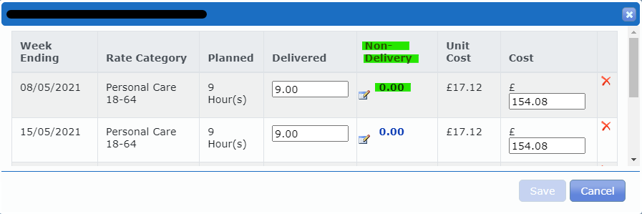
Once clicked the below dialogue box will appear. Leave the visit code as Doorstep Refusal, there are other options but they result in a non-payment of visit to yourselves. Doorstep refusal ensures you get paid but the Service User isn’t charged.
The next drop-down option is Rostered Duration, in here you select how many hours and or minutes could not be provided. Normally when entering minutes they are shown as .25 or .75, in this section the minutes need to be entered as exact minutes i.e 15, 30, 45. Once the amount of time has been entered click Ok.
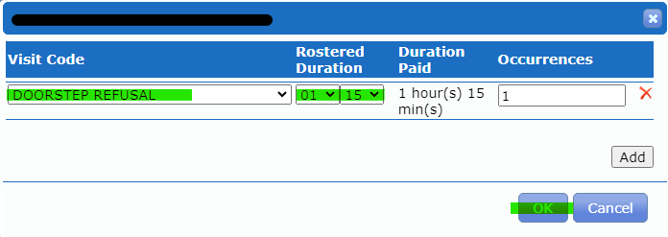
Now we can see that the Non-Delivery column for the selected week now shows 1.25 Frustrated hours. However, the cost column for this week is showing in Red, this means if the invoice is submitted in its current state it will Suspend.
The Delivered columns also needs to be amended. Whatever hours are put in the Non Delivery column they need to be removed from the Delivered column.
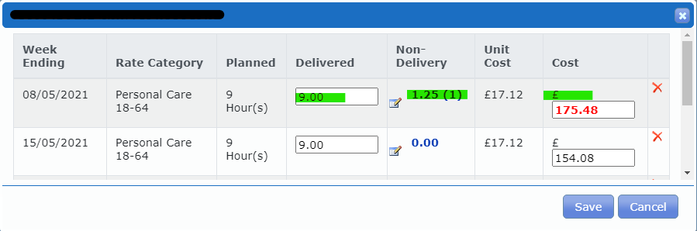
As can be seen below, 1.25 hours have been removed from the full allocated 9 hours, leaving 7.45 hours in the Delivered column and the Cost column is no longer showing in red. This invoice will not Suspend if submitted.
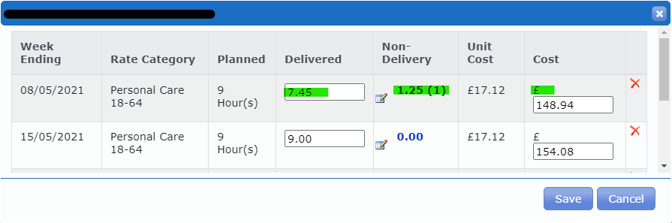

Submitting VAT Invoices
- Do I Need to Submit VAT Separately
If you need to separately claim for the VAT when submitting an invoice this will have been discussed when setting up your contract, if in doubt check your contract or contact: Procurement.Adults@essex.gov.uk

- How to Submit VAT Invoices
The invoice still needs to go through the same procedure as outlined in the second section titled Payment Schedules tab, hold Ctrl and click here to be taken to that page.
Once the invoice hours have been checked, a reference number added, and the invoice date entered and before clicking verify you need to click the box and the far left end of the invoice row so that it turns blue and there is a tick in it.
Next go to the bottom of the page and click Submit VAT.
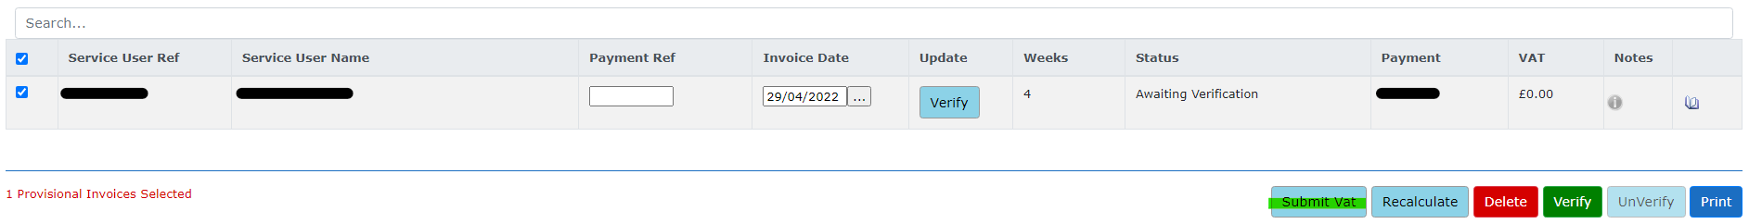
The below screen will appear, and you need to enter the VAT amount for that invoice and then click save.
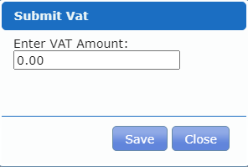
This needs to be repeated for every invoice.
The VAT cannot be submitted if the Verify button has already been clicked. If this is done accidentally refresh the page until the button is showing as Unverify, then click it, submit the VAT and then click Verify again.

Adding a Note to An Invoice
- Why Do I Need to Add a Note
If there is something specific about the invoice that you would like us to be aware of instead of sending an email you can attach a note to the invoice so that it will stay with that particular invoice and can be read by us.

- How to Add a Note
Once you have gone into Payment Schedules and checked the invoice for submission you can then also add a note with any extra information you would like us to be aware of.
To do this go to the right hand end of the relevant invoice line and there is a Notes column with an i in a circle. Click this i to add a note.
The below text box will appear. In the blank box type whatever information you would to make the Non-Residential team aware of.
After that ensure you click the second circle beneath the text box, this enables us to read your note. If left on Private we cannot view it.
After that click save, and once a note is added the i icon will turn a gold colour, so it is obvious there is something to read.
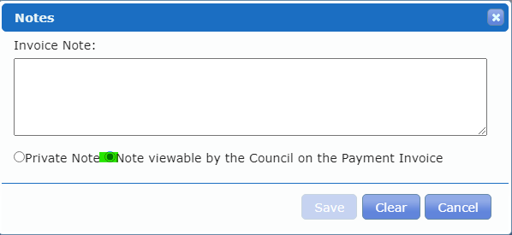

Running An Excel Report
- Why Would I Need to Run a Report
Running an Excel report from the Provider Portal can give you quick access and an overview of any information you like given the filters selected.
You can use the running of Excel reports to give you a more detailed overview of accounts and what has been processed, it is essentially the in-system remittance that you can convert into an easy to read Excel report.

- How to I Produce an Excel Report
In order to produce a report, go to the Payment Enquiry page.
From there use the left-hand panel to select what information you would like captured on the report. All options are highlighted below, so you could have it showing all processed invoices for a specific Service User, you could set it to show which invoices are Suspended, you could filter it to show specific invoicing periods, or if the box right the bottom is unticked any retracted invoices will be shown.
Or if you would like an overview of everything leave all those options blank and the report will show every single invoice.
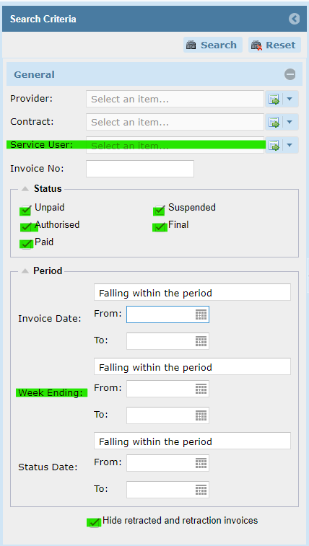

Once you have all the filters set as you would like, click the Search button at the top of the left-hand panel.
Then move across and click Export and that will put all of the information on the right-hand page into an Excel document.
If you don’t click Search the filters will not be applied and the report will show everything.
