RISK ASSESSMENT

FOR THE PROVISION OF BED RAILS

(Sometimes known as side rails, safety sides or cot sides)

Date of assessment

Name of care home

Assessor name and role

‘The MHRA continues to receive reports of adverse incidents relating to bed rails and associated equipment. The most serious of these have led to injury and death by asphyxiation after entrapment of the head, neck, or chest…. Prescribers should carefully consider the benefits and risks of bed rails before they are used for an individual bed user.’ https://www.gov.uk/guidance/bed-rails-management-and-safe-use

Part 1: Assessment of the person

Name

DOB & age

Height & weight  (Bed rails have differing minimum user’s height and weight which will need to be checked if providing) | Height | Weight

IMPORTANT: is this for a person that has a height less than 1.46m (4ft 9”)?

Yes* No (tick appropriate box)

*If yes - bar spacing and other gaps will need to be reduced to prevent entrapment (see guidance section for further details)

Is there any history of falls from bed? Yes No (tick appropriate box)
If yes, give details. If no, consider if bed rails are necessary.

What alternative methods of bed management have been considered and why are they considered inappropriate?
You may consider assistive technology, positional wedges, amendment to care plan, lowering bed and, or change of environment

Could the use of a bed rail increase risks to the occupant’s physical or clinical condition? Such as, is the person likely to try and climb over the bed rails or move down to the end of the bed?
If yes, alternative options to be considered

Has the person used bed rails before? (Why were they removed? Were there any contraindications for the person when using them?)

Why are bed rails needed? (NB Bed rails are not designed to be pulled on for rolling / independent repositioning and alternative rails should be considered)

Are bed rail bumpers being provided with the bed rails?
Yes (tick appropriate box) No (tick appropriate box)

If yes, | If no,
Will the bed rail bumpers be an entrapment and or suffocation risk?  If yes, consider alternative options | What are the reasons not to provide?  Explain why the provision of bumpers outweighs the risk not to provide
If the person can safely transfer independently from the bed is the provision of bed rails going to reduce their independence e.g., to access toilet at night?
If yes, alternative options may need to be considered

Can the person/occupant consent to the provision of bed rails? Yes No (tick appropriate box)
If no, Mental Capacity Assessment to be completed, if adult is deemed to lack capacity a decision needs to be made by Lasting Power of Attorney (Health and Welfare) or Court appointed deputy. If neither exists, the decision needs to be made in the adult’s best interest by the appropriate person leading the Mental Capacity Assessment. If no, give details as to who supported decision.

What is the person/occupants’ views on bed rails?

Does the person/occupant have any physical, sensory, or cognitive impairments or difficulties that may affect the safe use of bed rails? Yes No (tick appropriate box) If yes, list and describe the impact each has on safe use of the bed rails.

Do the risks of using bed rails outweigh the possible benefits from using them? Yes No (tick appropriate box). If yes, give details.

Part 2: Assessment of environment

Consider, what type of bed are the bed rails to be fitted to. If being attached to a profiling bed compatible bed rails should be used (check manufacturers and MHRA guidance). Most injuries occur with the use of bed rails on standard type domestic beds.

What type of mattress is to be used and what is its uncompressed depth?
Top surface of the bed rail must be at least 220mm from the top of the uncompressed mattress. Consideration required as to light weight mattresses as may not hold down bed rails. If a mattress is being provided by someone else, type and measurement details need to obtained by person assessing for and providing bed rails.

Does the mattress edge compress easily?
If yes, review is needed to confirm the gap between the bottom of the bed rail and mattress will not cause an entrapment risk.

Has interaction with other equipment and the environment been considered? If yes, how will this be managed?
Consider hoists, access to both sides of the bed etc.

If bed rails are deemed suitable, are they compliant with MHRA bed safety guidance detailed in part 3 of this risk assessment?
Yes No (tick appropriate box) If no, please detail what action will be taken to ensure safety of adult whilst compliant rails are sourced

Part 3: Measurements and equipment details
Once bed rails have been installed, measurements must be obtained before use and checked with MHRA bed safety guidance in subsequent pages below:
*Please note: for children and adults smaller than 1.46m, please use table at the end of this form
Bed details | Bed description: divan / manual hi-low / powered hi-low / fully powered profiling & hi-low
Bed details | Bed manufacturer:
Bed details | Bed product name:
Bed rail details | Bed rail product name:
Bed rail details | Bed rail bumper manufacturer:
Bed rail details | Bed rail bumper product name:
Measurement
 | Description of measurement |  | Actual measurement (mm)
1 | Height to top of side rail from uncompressed mattress
2 | Gaps between rails
3 | Gap between headboard and end of side rail
4 | Gap between footboard and end of side rail
5 | Distance from open end of side rail and mattress platform
6 | Gaps between split side rails
7 | Gaps between side rail and mattress in plan elevation

END OF RISK ASSESSMENT

MHRA BED SAFETY GUIDANCE

Refer to table 1 for measurements:

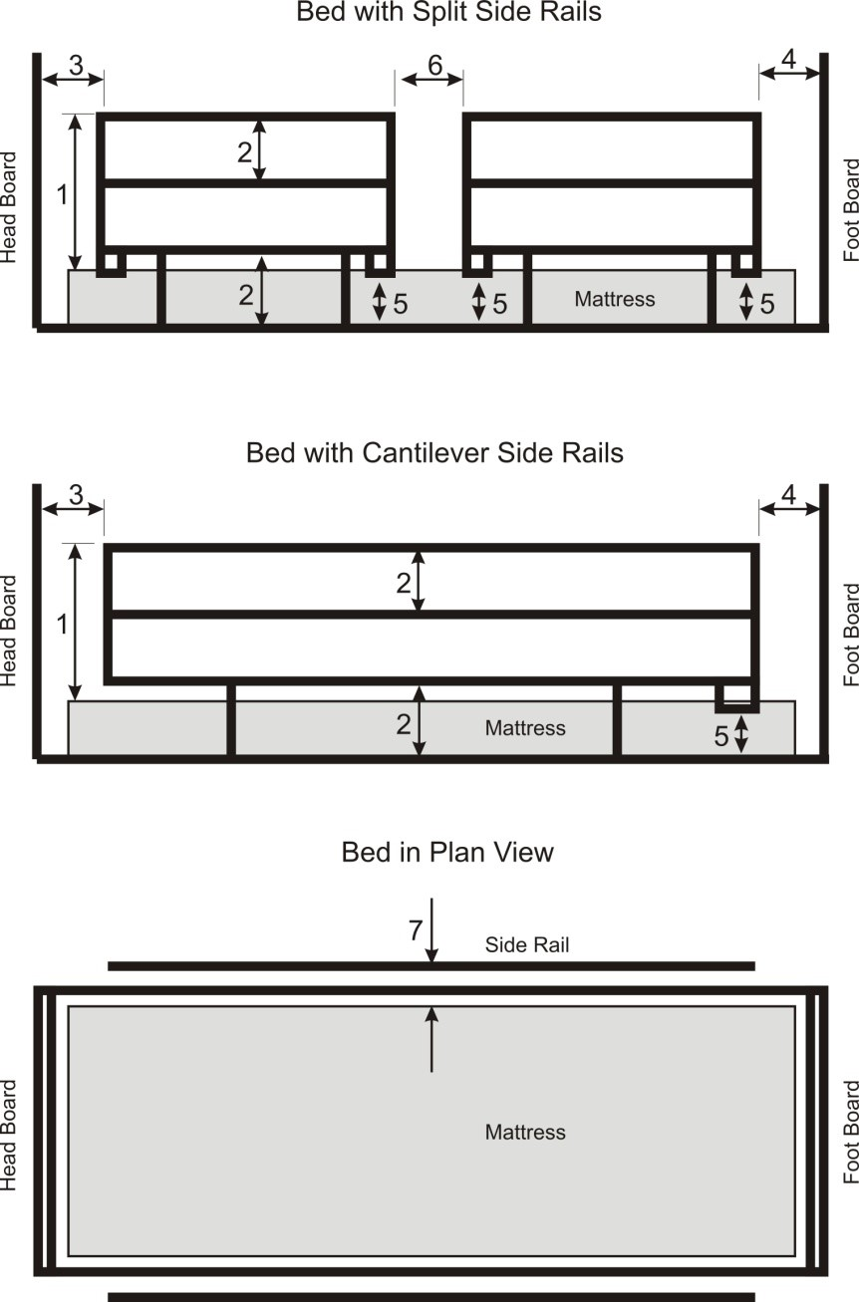
Table 1

Number | Description | Measurement | Notes
1 | Height of the top edge of the side rail above the mattress without compression | ≥ 220mm | Where a speciality mattress or mattress overlay is used and the side rail does not meet ≥ 220mm a risk assessment shall be performed to assure equivalent safety
2 | Gaps between elements within the perimeter of the side rail and between the side rail and mattress platform | < 120mm
3 | Gap between headboard and end of side rail | < 60mm | Most disadvantageous angle between headboard and side rail
4 | Gap between foot board and end of side rail | < 60mm OR > 318mm | Most disadvantageous angle between headboard and side rail
5 | Distance between open end of side rail(s) and mattress platform | < 60mm | The gap between the open end of the side rail and headboard is not relevant to this position reference
6 | Gap between split side rails | < 60mm OR > 318mm | When in most disadvantageous position
7 | Gap between side rail and mattress in ‘plan’ elevation | Perform test | 120mm aluminium cone is positioned between mattress and side rail to determine if gap is acceptable or not.

*Beds for children and smaller adults (height less than 1.46m or 4ft 9”) – refer to table 2 for measurements

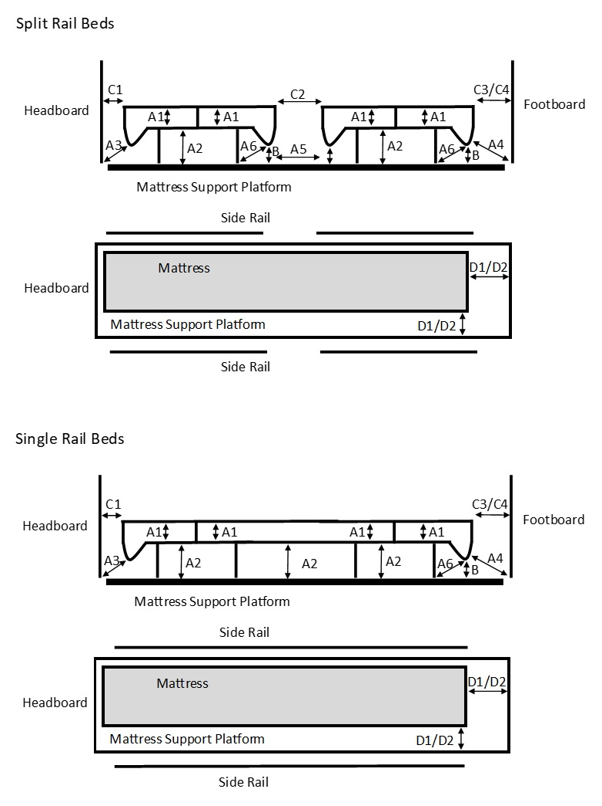
table 2
Code | Description | Measurement | Notes
A1 | Fully enclosed openings within a side rail, head/foot board, mattress support platform | < 60mm
A2 | Fully enclosed opening defined by the side rail, its supports and the mattress support platform | < 60mm
A3 | Partially enclosed opening defined by the head board, mattress support platform and side rail | < 60mm
A4 | Partially enclosed opening defined by the foot board, mattress support platform and side rail | < 60mm | Except when gap between side rail and foot board is >300mm
A5 | Partially enclosed opening between segmented or split side rail and the mattress support | < 60mm | Except when gap between side rails is >300mm
A6 | Partially enclosed opening defined by lowest point of a side rail, the adjacent side rail support and mattress support platform, to the outside of the side rail supports | < 60mm
A | Other openings defined by accessories (e.g. IV poles, fracture frames) and side rails, head or foot boards and or mattress support platform. Not shown in figures. | < 60mm
B | Distance between mattress support platform and the lowest point of the side rail outside the side rail support AND The angle between the side rail and mattress support platform at the range of the mattress height defined by the manufacturer ± 2 cm | < 40mm AND Angle between mattress support and platform side rail interface >75° over the entire range of mattress heights from minimum recommended height minus 2 cm to the maximum recommended mattress height plus 2 cm.
C1 | Gap between head board and adjacent side rail | <40mm

Continued on next page
Code | Description | Measurement | Notes
C2 | Gap between segmented or split side rails with both side rails raised  For a gap >300mm: the gap shall be >300mm or <400mm for the entire vertical distance | <40mm or >300mm
C3 | For all medical beds except junior beds: gap between side rail and foot board. Other openings defined by accessories (e.g. IV poles, fracture frames etc.) and side rails, head board, foot board, and or mattress platform | < 40mm
C4 | For junior beds: gap between side rail and foot board. Other openings defined by accessories (e.g. IV poles, fracture frames etc.) and side rails, head board, foot board, and or mattress platform  For a gap >300mm: the gap shall be >300mm or <400mm for the entire vertical distance | <40mm or >300mm
D1 | Region defined by side rail/head board/foot board and the mattress for cribs and cots | Perform test | Cone tool does not sink below the mattress surface by 50% or more of its 60mm diameter.
D2 | Region defined by the side rail/head/foot board and the mattress for junior beds and oversize cots  Cone tool does not sink below the mattress surface by 50% or more of its 60mm diameter. | Perform test OR Gap between side rail/head/foot board and mattress <300mm

Part 3 (for children and smaller adults): Measurements & equipment details
Once bed rails have been installed, measurements must be obtained before use and checked with MHRA bed safety guidance below:
Bed details | Bed description: divan / manual hi-low / powered hi-low / fully powered profiling & hi-low
Bed details | Bed manufacturer:
Bed details | Bed product name:
Bed rail details | Bed rail product name:
Bed rail details | Bed rail bumper manufacturer:
Bed rail details | Bed rail bumper product name:
Measurement
 | Description of measurement |  | Actual measurement (mm)
A1 | Fully enclosed openings within side rail, head/foot board, mattress platform
A2 | Fully enclosed opening defined by side rail and mattress platform
A3 | Partially enclosed opening – headboard, mattress support platform and side rail
A4 | Partially enclosed opening – footboard, mattress support platform and side rail
A5 | Partially enclosed opening between split rail and mattress support
A6 | Partially enclosed opening defined by lowest point of side rail
A | Other openings defined by accessories
B | Distance between mattress support platform and lowest point of the side rail
C1 | Gap between headboard and adjacent side rail
C2 | Gap between segmented or split side rails when both rails are raised
C3 | Medical beds not junior – gap between side rail and footboard
C4 | For junior beds: gap between side rail and footboard
D1 | Region defined by side rail/head/foot board for cribs and cots
D2 | Region defined by side rail/head/foot board for oversized cots

END OF RISK ASSESSMENT

