**The Homepage**

1. **System Updates**

When you first login to the Portal and are taken to the homepage one of the main features to pay attention to is the **Provider Notices section.**

**This will advise you when the system will be offline and you will not be able to login or when updates are happening and the system shouldn’t be used otherwise any changes made, i.e. invoices you submit, may not be saved once the update is complete.**

Therefore, if you use the system during Downtime, you may think you have submitted an invoice but once the update is complete its still waiting to be submitted again.

Also, if you try to login during downtime, it may say your system is blocked, it says this for everyone that’s because we are not allowed to be logging on during that notified time.

**Take note of downtime and only try to login after the estimated completion time.**

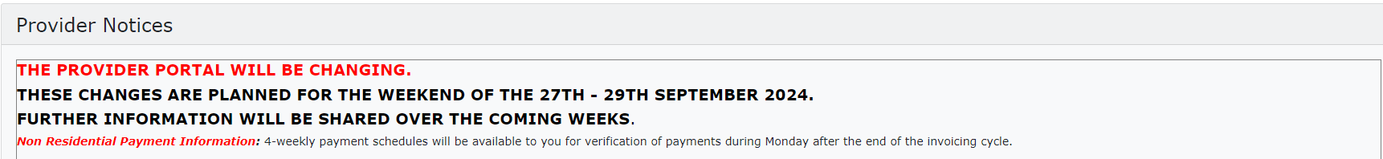

1. **Contact Details**

Below Provider Notices is a table, on the left is every team you may need to contact, their contact details and a brief reason as to why you may need to contact them so you can ensure your query is being sent to the right team.

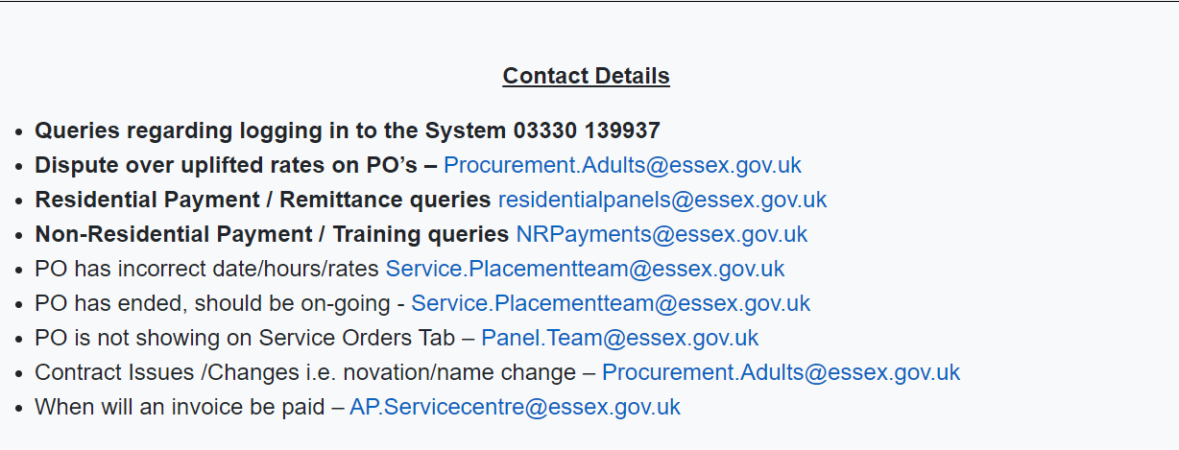

On the right-hand side of the table are links to any extra information you require, i.e. the invoicing period schedule with the start and end dates of each period, the system manuals for further guidance and instruction. Please see next page.

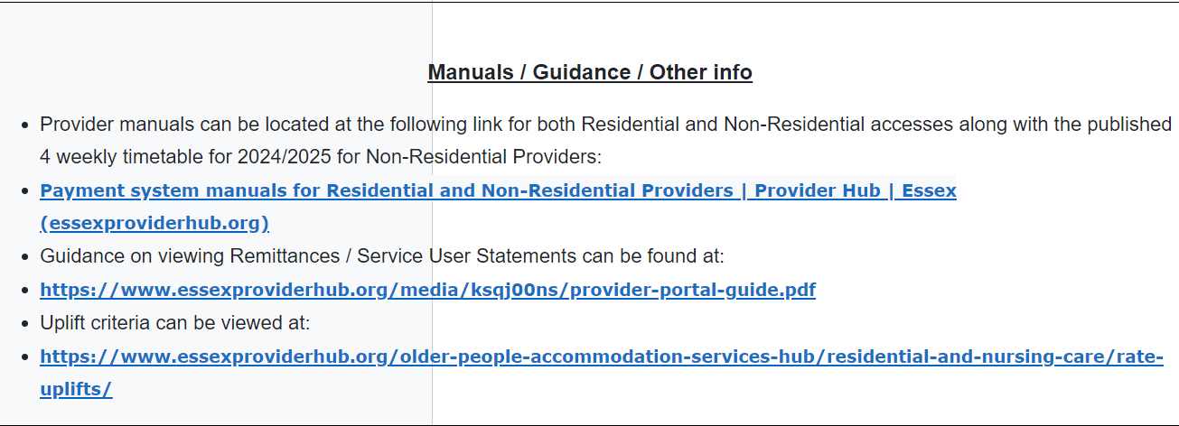

1. **Navigation**

The homepage is also where you can access all other pages and features of the Portal. Below is a list of where you can go, what information is held there and how to find that page:

* Service Orders – List of all contracts ongoing and closed, for every service user.
* Payment Schedules – Where all the contracts are held, where the invoices are submitted from.
* Payment Enquiry – Online remittance, list of every invoice processed, those that are paid, retracted, and suspended.
* House Icon – This takes you back to the main page.
* Arrow – This is how you log out of the system.