Provider Payment Enquiry

- What is this used for?

This process allows you to be able to review payments against your provider account either paid, unpaid or retracted by individual service user, or when reconciling remittance advices received from ECC for multiple service users. It is always advisable to use your own sequential invoice numbering process when verifying invoices as it will be easier and quicker to reconcile your remittance advice rather than relying on the system generated invoice number printed on your remittance advice.

- How do I find it?

Log into the Provider Portal
At the top centre of the page there are three options – Select Payments
Select Non-Residential
Select Payment Enquiry

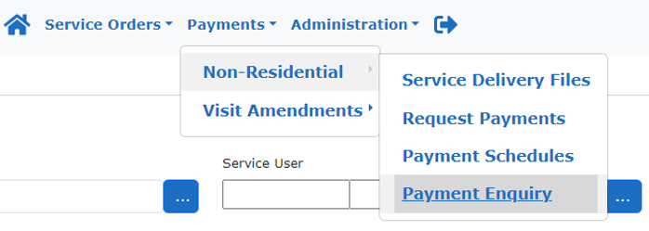

- How do I find out if an invoice has been paid against an individual adult?
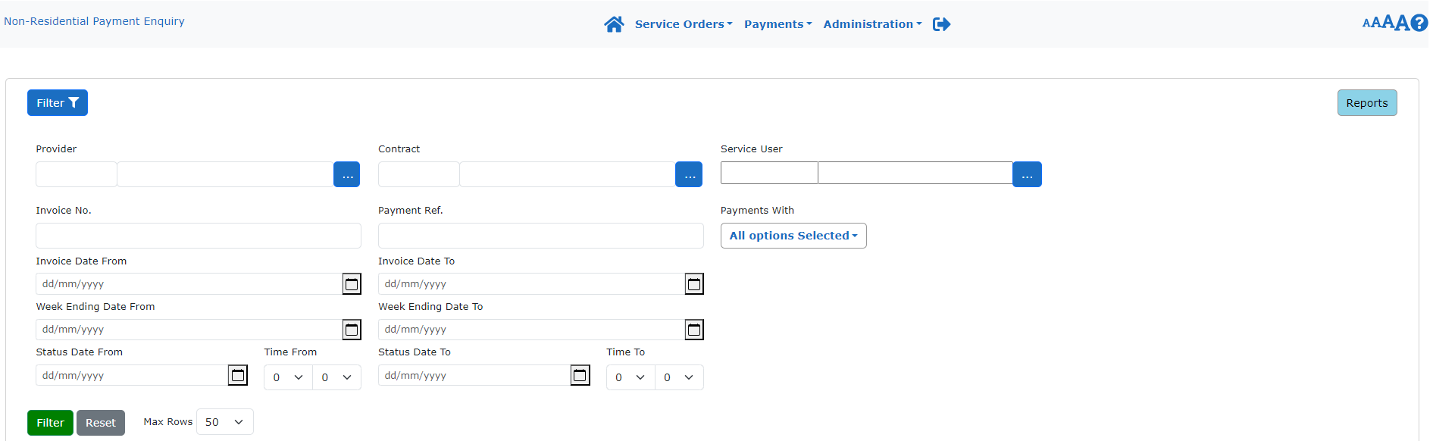

- 1) Ensure that your Provider Name is visible in the ‘Provider’ field.
- 2) Click on ‘Service User’ Filter to produce the list of service users to select from. Enter in either your service user full name, surname first followed by first name and * or Mosaic ID followed by *. Click on Apply. Mosaic ID’s can be located on your Purchase Order provided by Service Placement Team. Even if the information is redacted and shows as such you can still type in the service user’s name as above to locate the name, or Mosaic ID.
3) Delete the dates held within ‘Week Ending Date From’ and leave blank.
4) Click on “Payments With”
4) Click the arrow to reveal the pick list and untick “Hide Retracted and
Retraction Invoices”. This will ensure that the report picks up the transaction history of the adult including invoices and retracted invoices (credits)

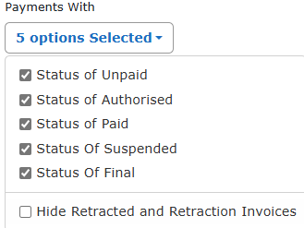

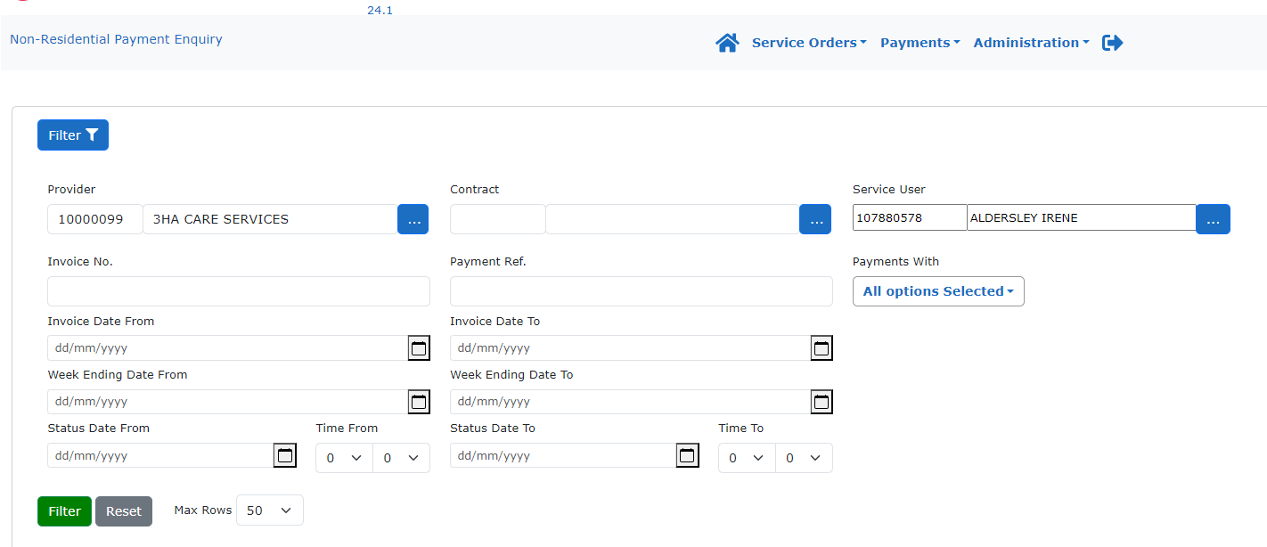

- Change ‘Max Rows’ from 50 to the maximum of 200 by clicking on the down arrow
- Click on the green ‘Filter’ button and wait for the invoices to show in the grid on the lower part of the screen.
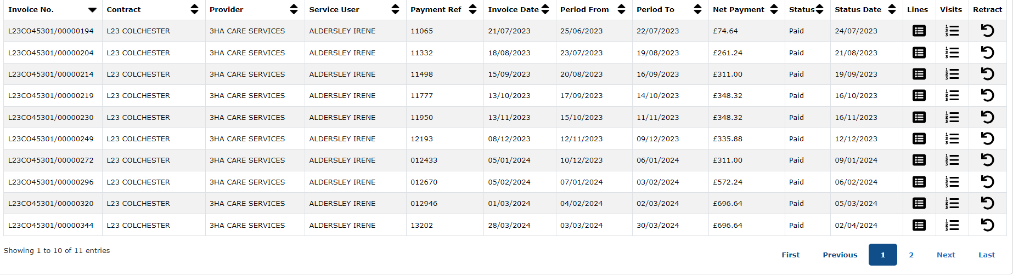

- To sort invoices into a descending order so that the newest invoicing periods are first, click the down arrow twice on the ‘Period To’ column as highlighted. The manual invoice reference you have free typed will show under column header ‘Payment Reference’, or the system generated invoice number if no manual invoice number is entered, will be shown under column header ‘Invoice No.’ This process can be repeated for each individual adult. Click on lines to open each invoice of review if required.

- When would I need to run a report and how?

Running a system report is advisable for example if you are needing to reconcile several payments for various service users or confirm how many suspended invoices you have within the Provider Portal.

There are several pre-programmed Reports to assist you in query resolution.
These are as follows and contain a brief description of what information is held within them.

Non-Residential Payments Detail Invoice Lines – Line by line invoice information including Contracted Units, Delivered Units, Non-Delivered Units, Contracted Costs, Actual Costs
List of Costed Visits – Includes basic information Service From, Service To, Invoice Number (System Generated Invoice Number), Payment Reference (Provider generated invoice number), Invoice Date, Date Received
Payment Reconciliation – Includes but is not limited to Service From, Service To, Invoice Number (System Generated Invoice Number), Invoice Date, Date Received, Contract Cost, Actual Cost, Net, VAT, Total Cost, Status, Payment Reference (Provider Generated invoice number)
Non-Residential Payment Summary – Includes but is not limited to Service From, Service To, Invoice Number (System Generated Invoice Number), Payment Reference (Provider Generated Invoice Number), Invoice Date, Date Received, Contracted Cost, Actual Cost, Net, VAT, Total Cost.
Suspension Detail Report - Payment Reference, Service User, Service From, Service To, Service Type, Contracted Units, Contracted Unit Cost, Contracted Cost, Week Ending, Invoice number, Invoice Units, Invoice Unit Cost, Invoice Value, Excess over Contracted Units, Excess Over Contracted Costs, Contract Number, Provider Notes

Ensure that your Provider Name is visible in the ‘Provider’ field.
Click on the top right-hand corner, blue box 

The below list of reports will appear: -
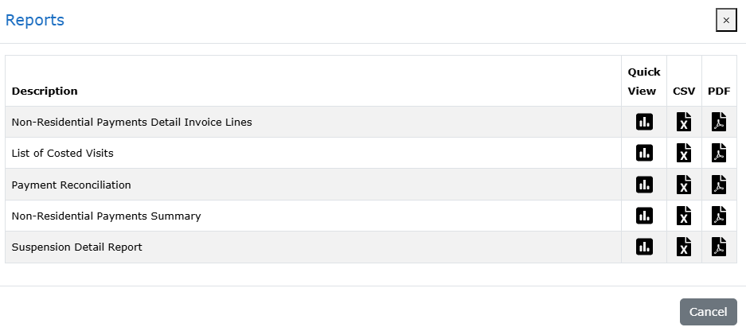

Select Type of Report required then Click on CSV. This will output the requested data and is the equivalent of Excel. Once the report is run you can delete columns, move data around to suit own requirements, highlight entries and when complete just delete the report until the next time you require the next up to date information.

All reports contain both system and manually generated invoices numbers for each of reconciliation and review purposes.

