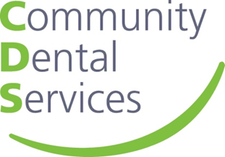
Oral Health Quiz

- What is Xerostomia?

- After how long should you get an unchanging ulcer checked?

- At what time of day should teeth be brushed?

- How quickly after eating should you brush your teeth?

- What toothpaste is the best?

