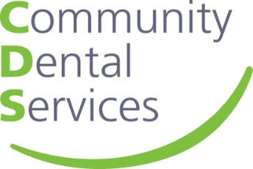

Oral Health Training Dates

Oral Health training hosted by Toyah Khan- Care homes teams/Older people- Friday 14th May @ 10:30 am
https://teams.microsoft.com/l/meetup-join/19%3ameeting_MmM2Yjg4MTAtYzg0Mi00YTdiLWFkZTEtNzk1ZmYyMmQ3YjJj%40thread.v2/0?context=%7b%22Tid%22%3a%226fd56404-8d57-4b76-a17a-22c41f0eae3d%22%2c%22Oid%22%3a%22e2d2a3e9-2187-43a0-9cef-8d8a0571dd16%22%7d

Oral Health training hosted by Claire Hobbs- Early years and child care teams- Monday 17th May @ 10:30 am
https://teams.microsoft.com/l/meetup-join/19%3ameeting_OTk1NzIyMGMtMjQxNC00MTI4LTg5MDEtOTU5YWM3MjgyZDI4%40thread.v2/0?context=%7b%22Tid%22%3a%226fd56404-8d57-4b76-a17a-22c41f0eae3d%22%2c%22Oid%22%3a%22e2d2a3e9-2187-43a0-9cef-8d8a0571dd16%22%7d

Oral Health training hosted by Claire Hobbs- Adults with additional needs- Wednesday 26th May @ 10:30 am
https://teams.microsoft.com/l/meetup-join/19%3ameeting_NjQ1MDU5NjYtZTI1Mi00YTVkLTg2YmQtNzUzYWMwMzQ1NjNh%40thread.v2/0?context=%7b%22Tid%22%3a%226fd56404-8d57-4b76-a17a-22c41f0eae3d%22%2c%22Oid%22%3a%22e2d2a3e9-2187-43a0-9cef-8d8a0571dd16%22%7d
Oral Health training hosted by Toyah Khan- Children with additional needs- Friday 28th May @ 10:30 am
https://teams.microsoft.com/l/meetup-join/19%3ameeting_OGUwMDRlYTAtMjI3ZS00NGUwLTlmYzctNWY2MzA2YzkwZGI4%40thread.v2/0?context=%7b%22Tid%22%3a%226fd56404-8d57-4b76-a17a-22c41f0eae3d%22%2c%22Oid%22%3a%22e2d2a3e9-2187-43a0-9cef-8d8a0571dd16%22%7d

