**Essex County Council**

**Total Facilities Management**

**Market Engagement**

**Request for Information**

**April 2025**



**Background**

Essex County Council (ECC) seeks input from the market to inform the design of a procurement opportunity concerning its future Facilities Management solution. ECC has had a Total Facilities Management Contract in place since 2011, expiring in 2026, encompassing a very broad range of facilities management services across a vast estate. We are keen to get further insight from the market into the areas in this RFI to help with the design and specification of our contract documents.

More information about the Procurement and previously published resources can be found on the Essex Provider Hub <https://www.essexproviderhub.org/facilities-management-and-property-re-procurement/introduction/>.

**How to respond to this RFI**

For this RFI we are seeking to engage with suppliers with the ability to deliver a total facilities management contract consisting of Hard and Soft FM services as well as project and programme work

Please respond to the questions in this document and return it to us using the message portal in Proactis ProContract. The Pro Contract reference for this project is: **DN710367.**

The page limit for the response to each question is 2 A4 pages in Arial 11 font.

Please include your company name in the filename for your returned document, as this will help us to manage responses.

Please complete and **return this RFI by Wednesday 23rd April 2025**

This market engagement exercise is not linked to a specific tender opportunity. **Suppliers who do not respond or who are not selected for engagement will not be precluded from any future tender opportunity**.

**Information about the respondent:**

Company / organisation name:

Contact name and role in the organisation:

Contact email address:

Contact telephone number:

**Q1 – Local Government Reform**

Background: During the contract term the political landscape in Greater Essex will change. As part of this process Essex County Council will be dissolved along with all current districts and unitary bodies in Essex. New Unitary Councils will be formed and will continue to deliver services. This contract will transition as part of the process and will be delivered via 2 potential routes:

1; One Unitary Council will hold the contract and deliver services on behalf of all newly created authorities

Or

2; The contract will split and each Unitary Councils will hold their own contract, each will retain the same terms and conditions and requirements as the original contract

The desire would be in either scenario to retain a central management function & shared resource within the contract rather than duplicate any functions.

The process for transition will be mapped as far as possible in the contract via specific change control mechanisms linked to Local Government Reform (LGR).

Question:

What do ECC need to consider when drafting provision for Local Government Reform? Please advise where you believe there may be legitimate need to increase costs due to the change in client structure and why these would be necessary.

Please advise anything you feel needs to be included in the provisions to limit risk pricing related to LGR.

Please also think about the possibility of the contract growing significantly in size as buildings from other authorities could potentially be pulled into scope. What notice might you need to scale up provisions and what are any impacts ECC may not anticipate?

Response:

**Q2 – Limit on Liability**

Background: Liability Caps have been raised as an area of risk as part of previous market engagement exercises. ECC is looking at putting different liability caps into the contract depending on the service being provided. It is anticipated we will have a liability cap covering the main services section (Hard & Soft FM & Business Services) and then liability caps linked to works split into 3 categories:

**Minor Works** –works up to the value of £25K, requested through the helpdesk (with a budget code for each), including without limitation:

Installation of a new kitchen

Landscaping of a garden area

Installation of a domestic boiler

**Intermediate Works**  - capital works with a design element identified in the Forward Maintenance plan including without limitation:

Roof replacement

Full heating replacement

Window replacement

Car park re-surfacing

Fire alarm upgrade and/or replacement

Replacement wiring

**Major Works** –ad hoc projects in excess of £1M instructed on an individual basis including without limitation:

School extensions

New builds

High value refurbishments with full design package

Question: Please provide what you feel would be correct Liability Limits for each of the above areas. Works liability limits will be applicable per project not as an overall cap.

Response:

**Q3 – APRS**

Background: Essex County Council offers an Accelerated Payment Rebate Scheme (APRS). This scheme offers the ability for suppliers to be paid earlier than the standard 30 day payment terms in return for a small rebate against the total invoice value. The opt in for this scheme is offered at tender stage and taken into account during our financial evaluation.

Question: Currently APRS is applied as opt in or out across the entire contract at a single rate. Are there any areas of the contract that bidders feel would not be suitable for APRS and should be excluded or any considerations ECC need to be aware of when structuring what elements of the contract APRS can apply to?

Response:

**Q4 – Mobilisation**

Background: ECC would like to amortise the mobilisation costs over the first part of term of the contract.

Question: Can you confirm the amortisation of costs over the first 5 years of the contract would be an acceptable position to bidders. Please advise if there are any concerns or provisions that need to be added to enable this?

Response:

**Q5 – Data management**

Background: ECC has a requirement for data and reports to be shared by the provider on a regular basis (generally monthly). Data and reporting cover a number of topics such as KPIs, volume and spend by service, building, cost centres, etc…

ECC operate a ‘data first contracts’ model that ensures connectivity via API by design. This means that we require our suppliers to flow data from their solutions to our data architecture using one of a number of mapped and established routes described below:

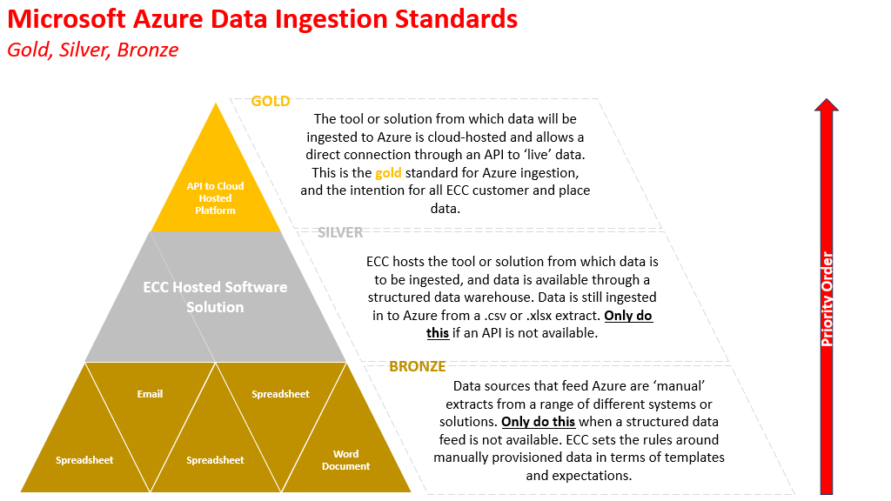

Question: please tell us how you would typically exchange data with your clients on large TFM contracts. Please explain what each solution represents for you pros and cons and what each could mean in terms of mobilisation and ongoing costs.

Response:

All communications, enquiries, questions or requests for clarification by suppliers should be addressed in writing using the secure messaging system in ECC’s procurement portal, Proactis Source-to-Contract under **DN710367**. Suppliers should note that the Authority will not respond to any enquiry, question or request not submitted in this manner.

Any queries pertaining to access to, or registration with, the Proactis sourcing portal should be addressed to Proactis in the first instance:

<https://www.proactis.com/uk/support-login/support/>

If access or registration issues remain unresolved by Proactis, please inform:

[callum.brooks@essex.gov.uk](mailto:callum.brooks@essex.gov.uk)