EXAMPLE
My Future Plan for Ageing well

My name: (INSERT PHOTO )

Date my Future Plan was completed:

Names of the people who helped me with this plan:

Date to review what I put in my Future Plan:

……………………….
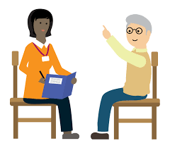

Things that may affect me as I grow older
Housing and where I live
Does my home meet my current needs? How could it be adapted for the future? What help can my landlord give? What other type of places could I live in? What can I do now to help me stay living in the same place?

What I might need in the future:

Things for me to do:

Health and Wellbeing
What general Health Checks do I need as I age? What might change for me with my health as I get older? What checks do other people have as they age? Does everyone know what a ‘good day’ looks like for me so they can tell when something is changing?

My diagnoses and illnesses:

Things for me to do:

Support networks and relationships
Who provides emotional and practical help? Who are the important people in my life? What friends and social contacts do I have? What is likely to change within my family and friends? What plans are in place if things change? How will I be supported to make new friends and not become lonely?
What I might need in the future:

Things for me to do:

Money and legal issues
Who helps me now with managing my money? What things might I like to buy now or in the future, that could help me to age well? What help might I need in the future? Have I appointed anyone to have lasting power of attorney? Am I likely to inherit? Is there a trust fund? Do I need information about wills, trusts or benefits?

What I might need in the future:

Things for me to do:

Preparing for Crises and unexpected events
What might happen? (Bereavements, change in needs, housing no longer able to meet my needs?) What would I want to do and who would I want to involve in helping me?

What might happen in the future:

Things for me to do:

Technology
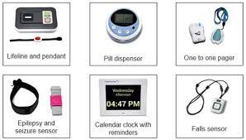
What TEC do I have/use now? How can I find out more about new Apps and equipment that could help me stay independent? What do other people that I live with use? Could any new developments (such as telehealth) help the person as they grow older?

What I might need in the future:

Things for me to do:

Making decisions and deprivation of liberty
My capacity to make decisions may change with age. How can I be supported to maintain as much choice as possible, if future changes to support mean that I may have less freedom? What views do I have about my future support and care that I’d like people to know now, before things change? What are my views and wishes about my future care and support that can be recorded now?

What are my views now, about my future care?

Things for me to do:

Giving support to others
Is there anyone that I live with or who lives somewhere else, that I help or give support to? As my own needs change, what support might I need to carry on doing this? Will I have to start looking after someone else as they age? How might my own health and wellbeing be affected by this?

What I might need in the future:

Things for me to do:

End of life
Is there a funeral plan that says who I would like to have my things when I die? what type of celebration of my life would I like there to be? Who could help make these decisions if I am unable to? What are my views about where I’d like to be cared for or where I would prefer to die? Who might help me think and talk about this if I find it difficult? Who could be involved to help make these decisions if I can’t do it for myself?

What I might need in the future:

Things for me to do:

Date Reviewed ……………………………

Who was involved in helping me review my plan?
………………………………………. ……………………………………….

