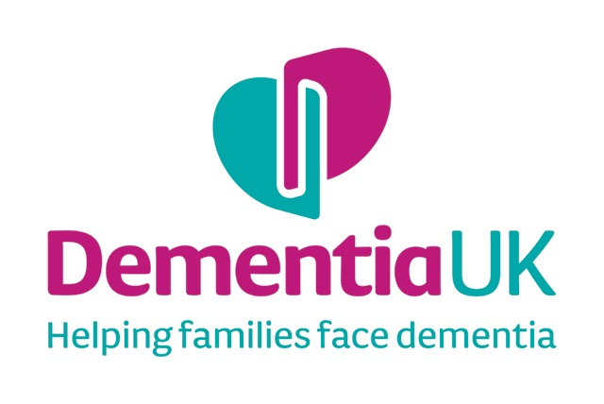

Insert PHOTO

MY LIFE STORY

Name:

I like to be called:

Introduction to my Life:

Date of Birth:

Place of Birth:

Family:

Mother’s name and occupation:

Father’s name and occupation:

Position in family: (i.e. oldest, youngest etc.)

Names of sisters and brothers: (eldest first)

Grandparents or other family members such as aunts or uncles:

My Childhood

Write down any significant memories from your childhood Examples may include:
Memories from early childhood e.g. home life, parents, grandparents & siblings, games/ toys, friends etc.
Memories from school e.g. favourite lessons, teachers, friends etc. (Include any photos)

My Working Life

Write down any significant memories about work
Examples may include:
First job, place of work (including work in the home)
Other jobs and/or favourite job
If you had your time again, would you do the same job or something else? (Include any photos)

Significant relationships

This may include significant people in your life i.e. friends/ family, long-term partner, husband or wife.
Memories of your wedding day- the place, the dress, weather etc.
Names of children if relevant
Any favourite pets? (Include any photos)

Significant Places

This may include:
Memories of the place you lived the longest or spent your happiest times? i.e. the buildings, shops, countryside, local people and community?
Other places that were and are particularly important to you e.g. holiday places, places where significant things took place etc.?
(Include any photos/ pictures/postcards)

Social Activities and Interests

Write down any significant memories about your social activities, interests or hobbies
Examples may include things you liked to do in your spare time/ interests?
Include anything that was important i.e. significant places, regular activities/outings, favourite music etc.

(Include any photos/pictures)

Significant Life Events

This may include significant things or events that had a significant impact on your life e.g. war, travel, loss of a loved one etc.
(N.B only include things that you are comfortable with sharing)

Later life/retirement

Think about highs and lows of getting older?
e.g. grandchildren, travel or time to pursue interests?
Write down anything that influenced you in your retirement i.e. events, people, illness etc.

My Life Now

What is important to me now?

Food and Drink

Please write down any particular preferences about mealtimes, favourite foods, things you dislike
Include any support needed with eating/drinking

Things I like:

Things I don’t like:

My Appearance

Please include anything that is important to you about your appearance e.g. clothes, hair, nails etc.
Include any support needed with dressing/personal care and how would you prefer to be supported?
Include any preferences for bathing /personal care e.g. baths/showers, soap, favourite perfume/aftershave etc.
Routines that you would like people to know about

Interests and Hobbies

Music

Please include types of music you like to listen to?
Include some favourite songs/ pieces of music

Television/Radio

Please write down any favourite radio channels or television programmes.

Other Hobbies and Interests

Please write down any other particular interests or hobbies e.g. books/magazines, walking, sport, art etc

My Likes and Dislikes

This may include anything that you particularly like or dislike (e.g. food/ dress/ activities/ smells, being touched etc.)
Examples may include things you like to talk about and topics to avoid or that upset you?
Please include things that help you relax

People who are important to me now

Please write down who the important people in your life are at the moment?
Please state name and relationship to you

(Include photos)

Wishes for future care

Please write down any specific wishes for your future care
This includes what is important to you that will help others understand how best to care for and communicate with you.
Include any advance care plans for end of life care. specific medical advance directives and/or preferred priorities for care
Identify who you would like to make decisions for you and if you have a Lasting Power of Attorney?

“My Life Story”, The Life Story Book Template is copyright to Dementia UK

Registered charity number: 1039404

