People with learning disabilities are often denied the opportunity to consider who they are and how life events affect their identity. This is even more important where people are faced with many transitions in their lives which can lead to a lack of continuity, and even a loss of identity, if a person's past experiences are not acknowledged. A life story book is an account of a person's life, including stories and memories of past events and relationships - all the kinds of experiences that make us who we are. In addition to helping the person with learning disabilities, these books also enable others to see beyond the 'client' identity and appreciate that each person has a unique life history that sets them apart from other people.
https://www.scie-socialcareonline.org.uk/life-story-books-for-people-with-learning-disabilities-a-practical-guide/r/a11G00000017tOAIAY

Memory boxes have been used successfully with people who have dementia. The objects within help with rekindling memories and staff can use them to generate conversations.
It does not have to be a special box and indeed a strong shoe box will do the job. As part of the process the adult might want to decorate the outside of the box with pictures that represent their character, for instance they might be a lifelong football fan and want to cover the box with pictures of their team etc.
The box can contain anything that holds a special memory. The advantage over a life story book is that the objects are tactile. For instance, it may contain photographs, programmes or tickets from concerts, football matches etc, favourite CD’s, old pop posters, old cuddly toys, copies of favourite books, old perfume or after shave bottles with the scent still detectable.
In order to help and maybe prompt the person it is an idea to attach a luggage label or a sticker to the item with some basic details written on so that the member of staff has an idea of the memory attached to the object. For example, the football programme might be a special one and the label might contain evidence that this was the last match they attended with their dad. Or an old watch might have been a gift for a special birthday and the label would identify this.
Memory boxes can be started and added to at any time.
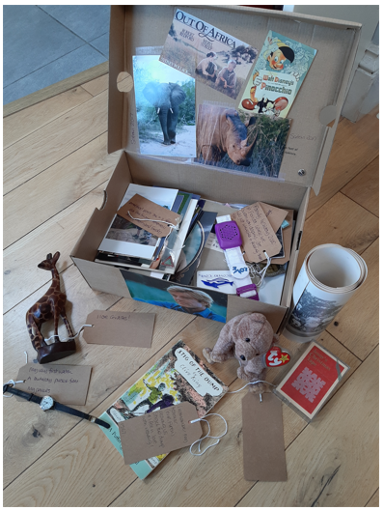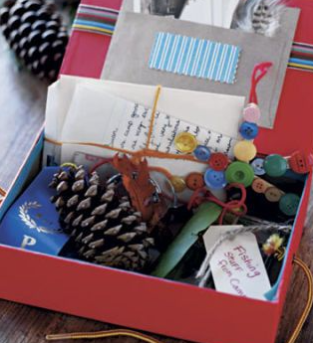

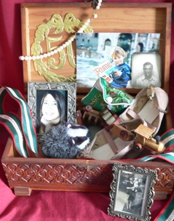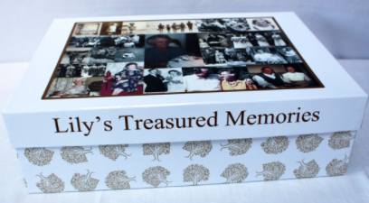
Talking memory book

