Stonecroft – Market Engagement

ECC are considering options for the development of an existing residential home and/or the site that it is on.

We want to test the market and the interest in the proposals to help us develop the most suitable commercial approach to the project, and would welcome feedback from providers through the questionnaire enclosed.

We are open to all possibilities on the use of the land for providing services to people with learning disabilities and autism, and will look over any proposal. Please note there is no capital funding available in regards to this.

Please see Appendix A for more details on the property itself in its current form.

Completion and Return

At this stage ECC are only looking to carry out soft market testing to understand potential interest and uses for the site. Proposals do not need to be costed or fully formed at this stage but should be realistic and achievable based on the building and land available.

Interested providers should complete the below questionnaire and return to Nick.Green@Essex.gov.uk not later than 26th June 2020.

Commercial and Development

No. | Question
1. | What sort of service do you think you could develop on this site and what would be the target user group?
 | Response to Question 1:
2. | What would you need to do to carry this out? (e.g. demolish the site, renovate the building etc.)
 | Response to Question 2:
3. | Are you able to develop the property and deliver the services directly or would you be seeking a partnership arrangement with another organisation?
 | Response to Question 3:
4. | What would you require from Essex County Council in order to do this? For example lease length, lease cost, type of contract for delivering the support etc
 | Response to Question 4:
5. | Would it be preferred to design the building yourself or to have a fully designed scheme provided as part of the tender?
 | Response to Question 5:
6. | What would make this opportunity most attractive to you as a provider? Are there other delivery models that you think ECC could explore?
 | Response to Question 6:

Stonecroft
Overview of Property

June 2020

Property Details
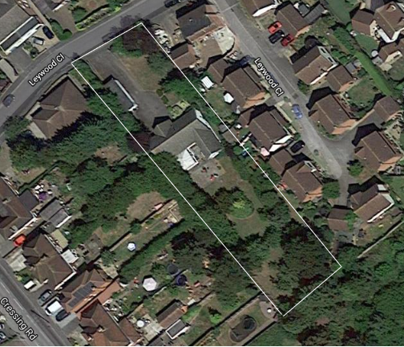
Property Address | Stonecroft, 5 Leywood Close, Braintree, CM7 3NP
Total site size | 0.41 acres
Google street view link | Google street view
Google map link | Google maps link

Property freehold owned by | Essex County Council
Issues with current property | Severe subsidence, see below document for full information:
Property Description | - c1600 sq ft with garaging  - 4-bedroom property (3 adult + 1 staff)  - Kitchen  - Single bathroom with adapted bath (no shower or wet room)  - Utility room  - Lounge/Dining Room  - Conservatory  - Office

Images
