


This is my voting passport 2026

For people with a learning disability and/or other disabilities who may need support at the polling station

My name is:

I have a learning disability and/or other disability.
I need reasonable adjustments to support me to vote in this election.

The support I need is: |  |  |   Put a tick in the boxes that are right for you
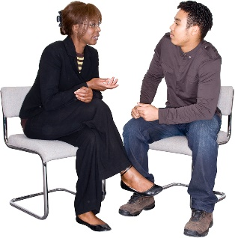 | To stay with my support worker
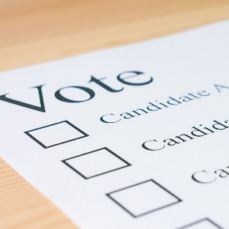 | Someone to show me a large print ballot paper
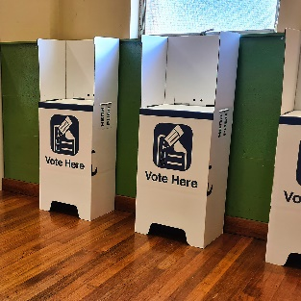 | Someone to go into the polling booth with me
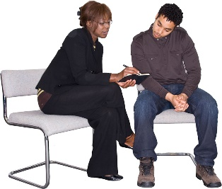 | Someone to read out the candidates on the ballot paper
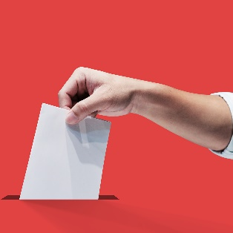 | Someone to show me where to put my ballot paper
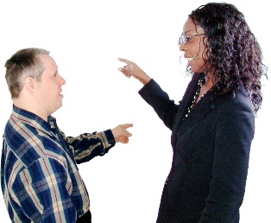 | I need things explained in a slow, clear way

List any other support you may need to help you vote:

I would like the above support from:
My companion, whose name is:
A member of the polling station staff
My companion is eligible to vote in the UK
My companion is not eligible to vote in the UK and will need to work with the Presiding Officer to support me

