**[Submitting VAT Invoices](file:///C:\\Users\\laura.franklin\\Downloads\\provider-portal-manual-2%20(14).docx" \l "Heading_Getting_Started)**

1. **Do I Need to Submit VAT Separately**

If you need to separately claim for the VAT when submitting an invoice this will have been discussed when setting up your contract, if in doubt check your contract or contact: [Procurement.Adults@essex.gov.uk](mailto:Procurement.Adults@essex.gov.uk)

1. **How to Submit VAT Invoices**

The invoice still needs to go through the same procedure as outlined in the second section titled Submitting an Invoice chapter.

Once the invoice hours have been checked, a reference number added, and the invoice date entered and **before clicking verify you need to click the box and the far left end of the invoice row so that it turns blue and there is a tick in it.**

Next go to the bottom of the page and click Submit VAT.

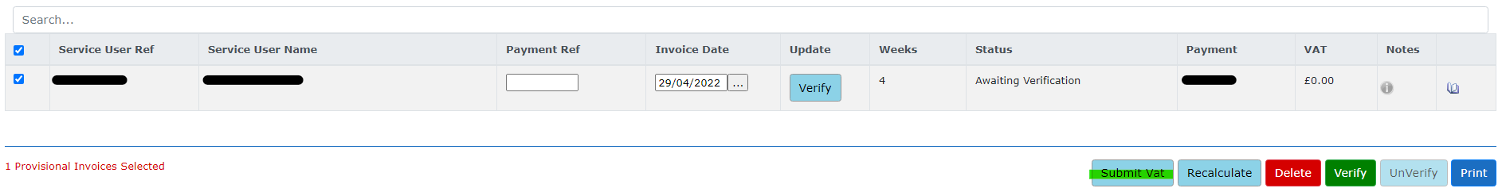

The below screen will appear and will have all the invoices available showing on it. You need to enter the VAT amount for each invoice and then click save.

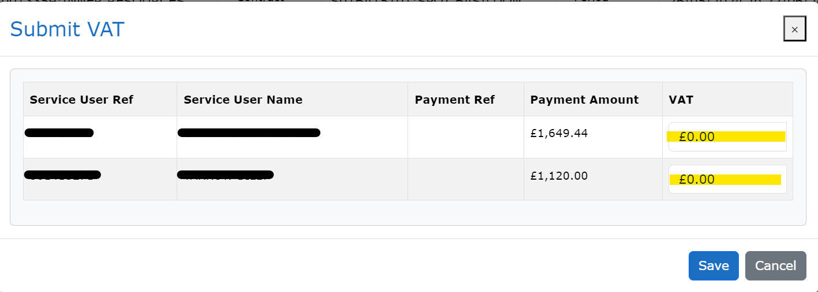

**The VAT cannot be submitted if the Verify button has already been clicked. If this is done accidentally refresh the page until the button is showing as Unverify, then click it, submit the VAT and then click Verify again. Once verified please submit a VAT invoice for this period of care directly to nrpayments@essex.gov.uk.**