**Essex County Council**

**Estate Management**

**Market Engagement**

**Request for Information**

**January 2025**



**Background**

Essex County Council's (the Council) current Estate Management Contract ends on the 30th of September 2026. The Council has started on our journey of discovery, regarding how the Estate Management provision could evolve and innovate beyond this date and would like to engage with the Estate Management Industry as part of this approach.

This RFI contains a range of themes which the Council is keen to hear from the market on to best shape our future Estate Management Provision.

The Council’s current scope includes both Core and Call off services as well as Property Projects.

The majority of the Essex County Council estate is freehold, and the core scope covers areas including lease events, leasehold transactions, rent reviews, estate finance accounting, rent arrears, inspections, plans and licenses. The call off scope is wide ranging including acquisitions, disposals, rent reviews, valuations, rates appeals and dilapidations although the above is not exhaustive list of the core and call off services required by ECC.

Within the Property Projects section, the Council seeks strategic advice on areas such as compulsory purchase orders and Part 1 Claims, planning applications and projects, property review and appraisal and development consultancy advice.

To be notified of our upcoming events please visit the Essex Provider Hub and complete the form on the Introduction tab <https://www.essexproviderhub.org/facilities-management-and-property-re-procurement/introduction/>. The Council uses the Provider Hub to release updates of our latest events and all resources relating to the project. Please also ensure you are signed up on our project dashboard Project **DN760459** on Pro Contract, the Councils eSourcing portal.

**How to respond to this RFI**

For this RFI, we are keen to hear from providers who can provide a large range of Estate Management services, covering the Council’s core, call off and property projects scope and who have experience delivering these services on contracts similar to the size and breadth of Essex County Council’s across a diverse range of property types and tenures.

Please respond to the questions in this document and return it to us using the message portal in Proactis ProContract. The Pro Contract reference for this project is: **DN760459.**

The page limit for the response to each question is 2 A4 pages in Arial 11 font.

Please include your company name in the filename for your returned document, as this will help us to manage responses.

Please complete and **return this RFI by 17th February 2025.**

Company / organisation name:

Contact name and role in the organisation:

Contact email address:

Contact telephone number:

**Q1 – Relevant experience**

Background: ECC’s current Estate Management contract covers an estate of around 350 properties with a diverse range of property types and tenures. The total spend per annum is approximately £1.1m with £0.6m or core spend and £0.5m on call off services.

Question: Please provide a description of your companies’ previous experience working on Estate Management contracts comparable to the size and breadth of ECC’s contract.

Response:

**Q2 – Contract type**

Background: ECC’s current Estate Management service sits as part of the Facilities Management contract which is currently using an NEC contract. As the Estate management provision will become its own separate contract, ECC are keen to understand which type of contracts are best suited to Estate Management, and whether an ECC bespoke contract could be suitable.

Question: Please outline the types of contracts that would be most suited to Estate Management and whether an ECC bespoke contract could be suitable.

Response:

**Q3 – Tender Timelines**

Background: Below is a Gantt Chart of ECC’s current expected timelines. We are keen to receive feedback on whether these are suitable for each stage of the process and if you foresee any challenges with these, for example we are aware that due to delays to PA 2023 several other significant tenders may be operating on very similar timescales, so please highlight any risks or issues with these timelines so we can make adjustments if necessary.

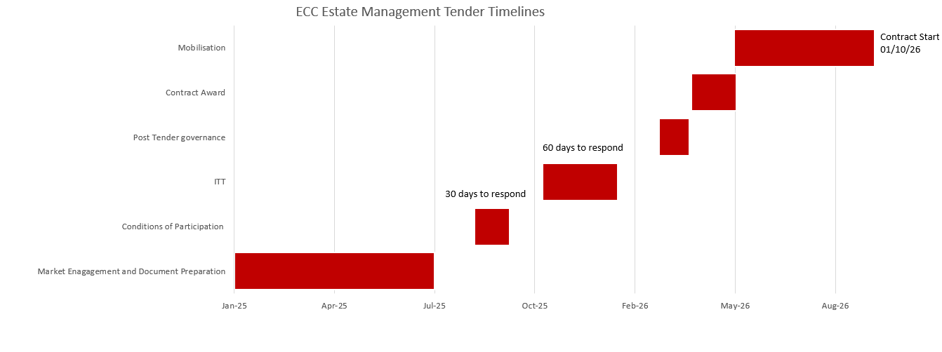

Question: Please outline your thoughts on the tender timelines in the Gantt chart above, whether you think we have allowed a suitable amount of time for each stage of the process and please highlight any risks or issues you foresee with these current tender timelines.

Response:

**Q4 – Local Government Reform and Contract Duration**

Background: In the context of the recently announced Local Government reform, ECC is keen to engage with the Estate Management market at an early stage. It is likely to result in the creation of 3 or 4 unitary councils that will go live in April 2028. ECC properties in scope for the future Estate Management contract(s) should be transferred to the newly created authorities and will increase their current estate portfolio.

However, it is anticipated that a transition period will be required for the new councils to run their operations. Therefore, ECC is looking at the optimal duration and contract arrangements for the new Estate Management contract(s) in order to support the implementation of LGR and operational transition to the unitary councils.

More detail about Local Government Reform in Essex can be found in the link, and in the slides on Local Government Reform on the Provider Hub.

[**Devolution and Local Government Reorganisation: Local Government Reorganisation (LGR) | Essex County Council**](https://www.essex.gov.uk/about-council/plans-and-strategies/our-vision-essex/devolution-and-local-government-1#:~:text=Reorganisation%20would%20see%20all%2015,authority%20services%20in%20their%20area.)

The future contract(s) are due to start in October 2026, that is 17 months before the new unitary councils go live date.

ECC are currently considering 2 options for the duration of an Essex wide Estate Management Contract:

1. An initial term of 5 years with extension period of 5 additional years; each unitary council would have the possibility to use the extension option. At the point LGR occurs, the contract will either novate to each unitary authority or novate to one singular unitary authority to manage services on behalf of the other authorities.
2. A fixed term of 17 months terminating when LGR goes live

Question: Please explain:

* the risks and opportunities that you foresee in each of the options described above
* how could those risks be mitigated
* what your preferred option would be why

Response:

**Q5 – Incentive mechanism**

Background: ECC is keen to drive continuous improvement and savings as well as innovation from the future contract to ensure our contract remains as up to date as possible with changing market trends.

Question: Please provide your companies view on how ECC can best create incentivisation within the contract to deliver above and beyond on the contract, and drive continuous improvement, innovation, and savings for ECC? Please provide examples of where this has worked effectively.

Response:

**Q6- Indexation**

Background: As Estate Management has been part of the Facilities Management Contract, it has received an annual uplift of CPI on the Core Part of the contract. ECC are keen to understand if CPI is the most suitable index to apply to the future Estate Management contract. In addition, ECC are keen to understand the most suitable method for uplifting hourly rates on the variable part of the contract to ensure these remain in line with market rates.

Question: Please explain which indices would be most suitable to apply on the Core part of the Estate Management contract and how ECC can best ensure hourly rates remain in line with market rates.

Response:

**Q7- Social Value and Climate**

Background: Due to the age of the current Estate Management contract, there are no contractual obligations on the current provider in terms of social value. ECC’s standard approach to social value is to use an adapted version of the national TOMs (the ECC TOMs). We are keen to gauge the familiarity of the Estate Management market is with the TOMs.

ECC are also keen to understand the maturity of the Estate Management market in terms of climate, and how an Estate Management Provider can best support ECC’s wider climate ambitions, including achieving Net Zero.

Question: Please outline your familiarity with the National TOMs. In addition, please outline how in your companies view, an Estate Management Provider could help ECC achieve its broader climate ambitions.

Response:

**Q8- Helpdesk Provision**

Background: As the current Estate Management provision is part of the Facilities Management contract, the Facilities Management provider manages the initial helpdesk services for Estate Management. For the new contract ECC are keen to understand how an Estate Management provider manages helpdesk services.

Question: Please explain your companies preferred arrangements for helpdesk provision for an Estates Management service?

Response:

All communications, enquiries, questions or requests for clarification by suppliers should be addressed in writing using the secure messaging system in ECC’s procurement portal, Proactis Pro Contract under **DN760459**. Suppliers should note that the Authority will not respond to any enquiry, question or request not submitted in this manner.

Any queries pertaining to access to, or registration with, the Proactis sourcing portal should be addressed to Proactis in the first instance: <https://www.proactis.com/uk/support-login/support/>

If access or registration issues remain unresolved by Proactis, please inform: [callum.brooks@essex.gov.uk](mailto:callum.brooks@essex.gov.uk)