***Private and Confidential***



**When I Die**

***My End of Life Care Plan***

**Photo of me**

This plan states the choices that I,

………………………………………………………………………

have made for my end of life care.

This plan is for me to state my wishes and plans for my end of life care. It will also help people who are caring for me to know what my wishes are.

Please treat my personal wishes and care plan with respect.

The person that I chose to help me to complete this is…………...........................They are my………………………….

**What’s in my book?**

|  |  |
| --- | --- |
| **What’s in my book** | **Page Number** |
| **A bit about me** | **3.** |
| **The people who help me** | **4/5.** |
| **About my care** | **6.** |
| **The health professionals involved in my care** | **7.** |
| **My funeral wishes** | **8/10.** |
| **My wishes about my things**  **when I die** | **11.** |
| **Other things important to me which I can add to my plan at anytime** | **12.** |
| **My review of my plan** | **13.** |
| **Additional page (if needed)**  **The people closet to me** | **14.** |

|  |  |
| --- | --- |
| I agree to share this plan with these people: | |
| Name: | They are my: |
| Name: | They are my: |
| Name: | They are my: |
| Name: | They are my: |
| Anyone else: | |



My end of life care plan was started on,

date:……………………

A Bit About Me

My Name is

\_\_\_\_\_\_\_\_\_\_\_\_\_\_\_\_\_\_\_\_\_\_

I live at



\_\_\_\_\_\_\_\_\_\_\_\_\_\_\_\_\_\_\_\_\_\_\_\_\_\_\_\_\_\_\_\_\_\_

I live with\_\_\_\_\_\_\_\_\_\_\_\_\_\_\_\_\_\_\_\_\_\_\_\_\_\_\_



­­­­­­­­­­­­­­­­­­­­­­­­­­­­­­­­­­­­­­­­­­­­­­­­­­­­­­­­­­­­\_\_\_\_ Tel:\_\_\_\_\_\_\_\_\_\_\_\_\_\_\_\_\_\_\_\_\_\_\_\_\_

[](https://www.google.co.uk/url?sa=i&rct=j&q=&esrc=s&frm=1&source=images&cd=&cad=rja&uact=8&ved=0CAcQjRxqFQoTCLDk8qzgtMcCFQOrGgodoosGWw&url=https://commons.wikimedia.org/wiki/File:Religious_symbols.png&ei=k0HUVfDOHYPWaqKXmtgF&bvm=bv.99804247,d.d2s&psig=AFQjCNEIvZfrD84W53G4PhkBUrt2sUS51Q&ust=1440060176487277)

My religion is\_\_\_\_\_\_\_\_\_\_\_\_\_\_\_\_\_\_\_\_\_\_\_\_



The name of my Priest/Religious leader to /Vicar to b be contacted is\_\_\_\_\_\_\_\_\_\_\_\_\_\_\_\_\_\_\_\_\_\_

\_Tel:\_\_\_\_\_\_\_\_\_\_\_\_\_\_\_\_\_\_\_\_\_ \_\_ \_\_



I worship at:\_\_\_\_\_\_\_\_\_\_\_\_\_\_\_\_\_\_\_\_\_ \_\_\_\_

I have updated this page on:………………………

**People who are important to me**

If my conditions changes, I would like these people to be told as soon as possible.

**The People Closest to me**

|  |  |
| --- | --- |
| Name:  Address:  They are my……..  Telephone 14  Tel: | Name:  Address:  They are my……..  Telephone 14  Tel: |
|  | |
| Name:  Address:  They are my……..  Telephone 14  Tel: | Name:  Address:  They are my……..  Telephone 14  Tel: |

|  |  |
| --- | --- |
| Name:  Address:  They are my……..  Telephone 14  Tel: | Name:  Address:  They are my……..  Telephone 14  Tel: |

|  |  |
| --- | --- |
| Name:  Address:  They are my……..  Telephone 14  Tel: | Name:  Address:  They are my……..  Telephone 14  Tel: |

I have updated this page on:………………………

These are the people who helped me to talk about what is important to me when I reach the end of life



My Keywoker is\_\_\_\_\_\_\_\_\_\_\_\_\_\_\_\_\_\_\_\_\_\_\_

Tel:\_\_\_\_\_\_\_\_\_\_\_\_\_\_\_\_\_\_\_\_\_\_\_\_\_\_\_\_\_\_

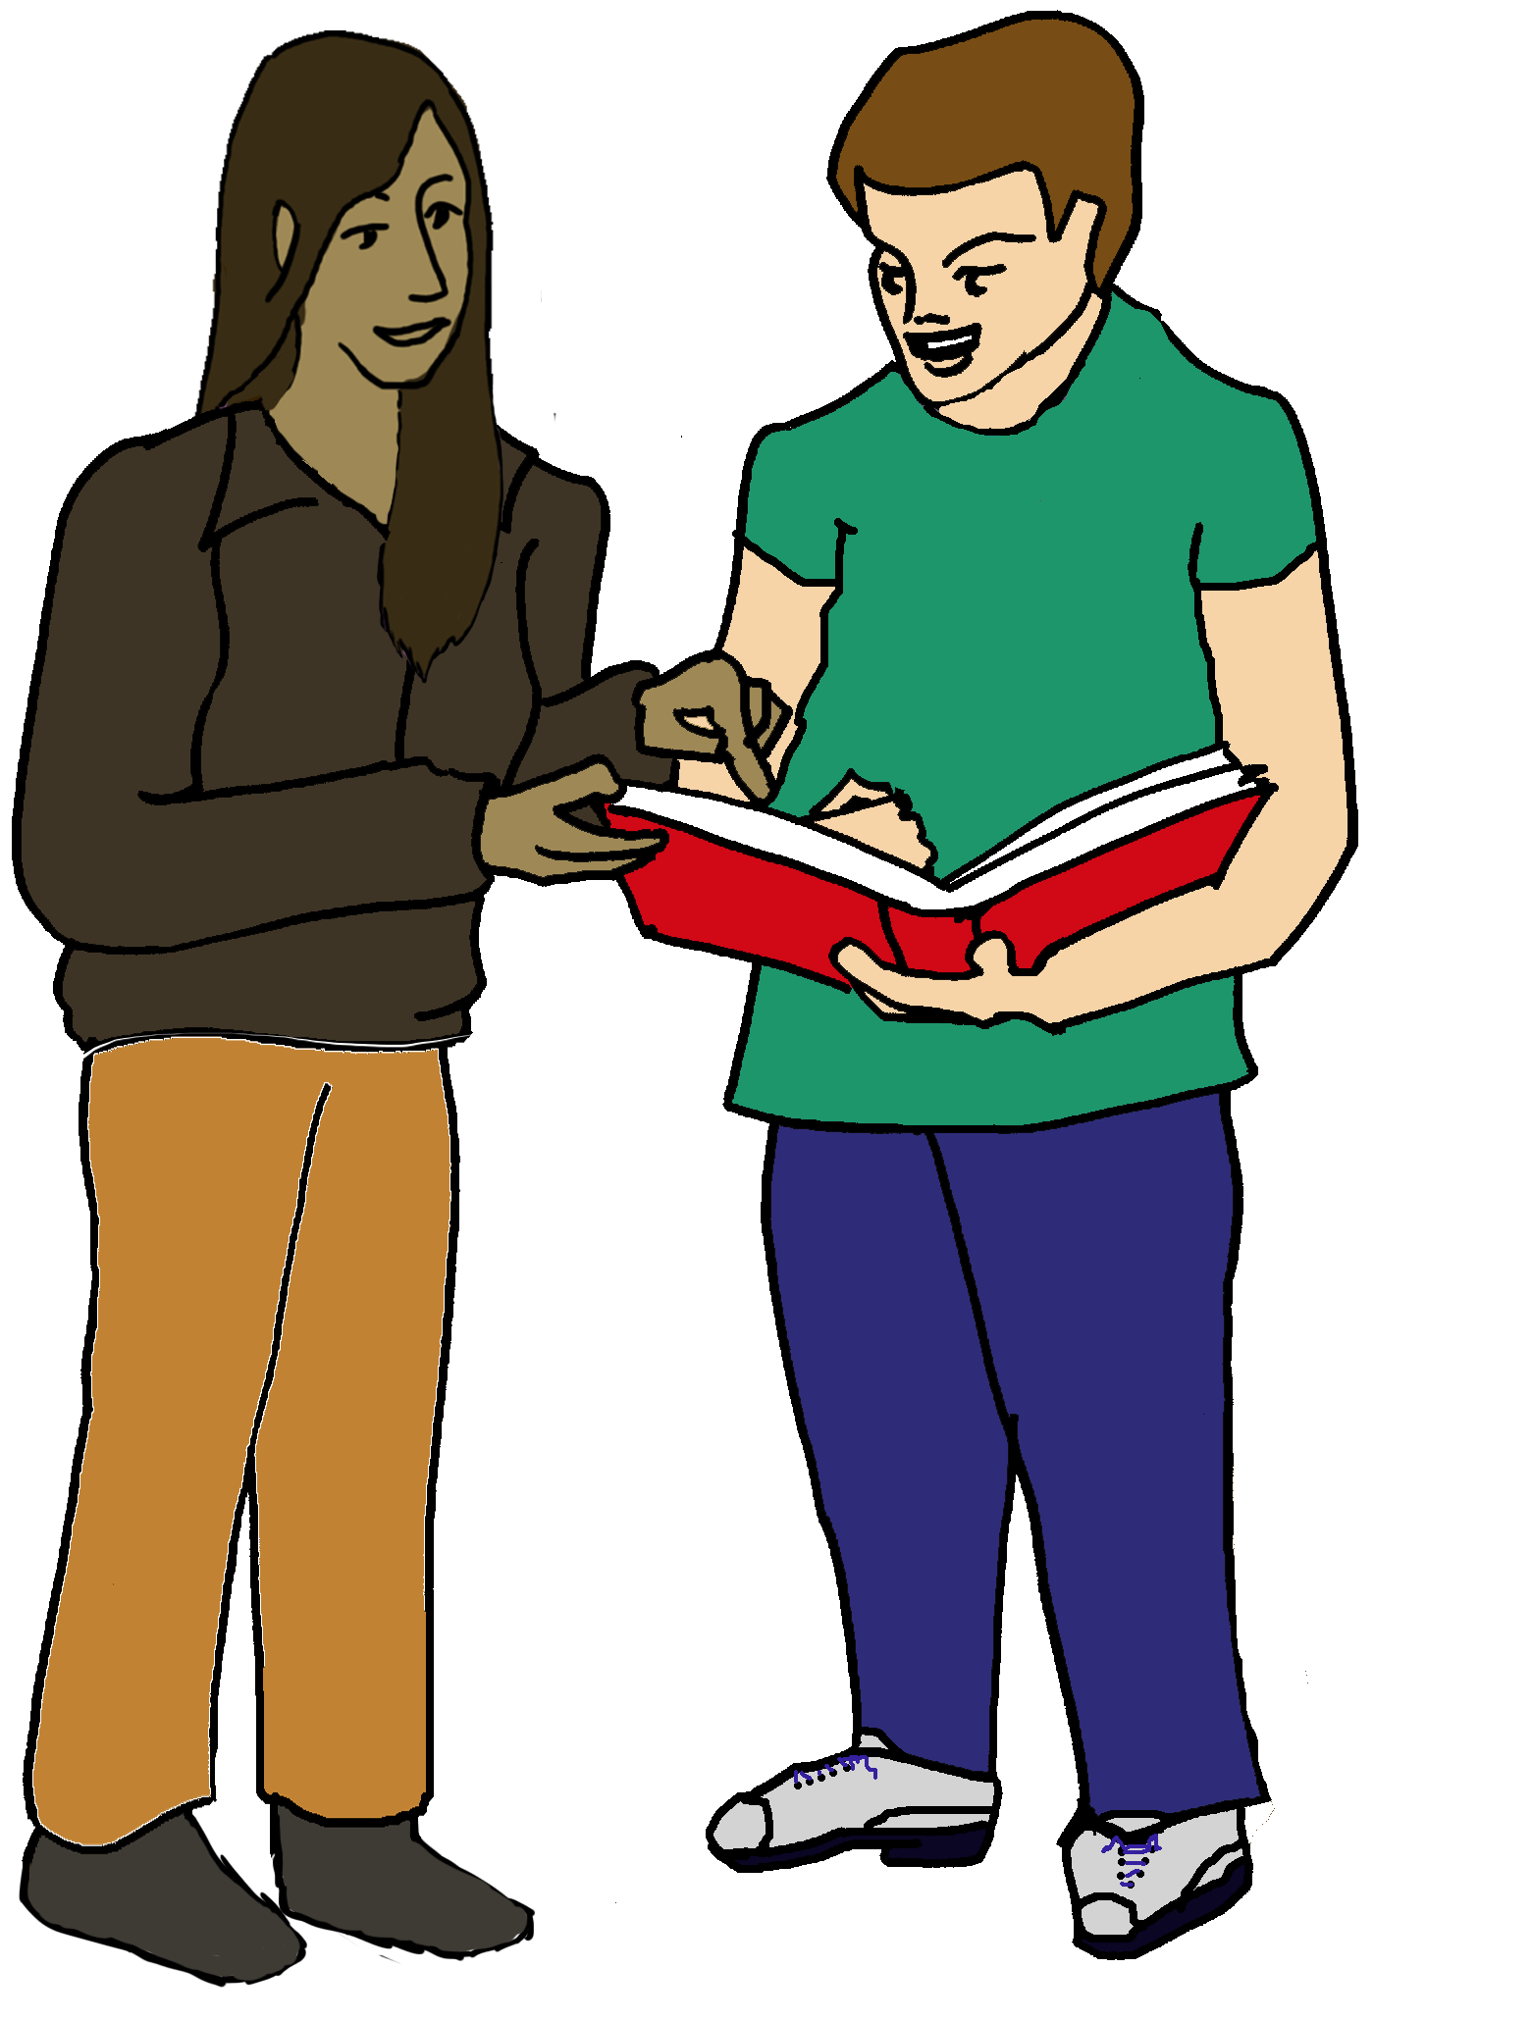

My Advocacy Worker is\_\_\_\_\_\_\_\_ \_\_ \_ \_ \_

[T  Tel:\_\_\_\_\_\_\_\_\_\_\_\_\_\_\_\_\_\_\_ \_\_\_\_\_\_\_\_](file:///\\slh1\users\CSDM\Organisation\Administration\General%20Admin\When%20I%20die%20booklet\T%20%20%20%20%20%20%20%20%20%20%20%20%20%20%20%20%20%20%20%20%20%20%20%20%20# Tel:___________________    ________)



My Next of Kin is\_\_\_\_\_\_\_\_\_\_\_\_\_\_\_­­\_\_\_\_\_\_\_\_

* Tel:\_\_\_\_\_\_\_\_\_\_\_\_\_\_\_\_\_\_\_\_\_\_\_\_\_\_\_\_\_\_



My Home Manager is\_\_\_\_\_\_\_\_\_\_\_\_\_\_\_\_\_\_

Tel:\_\_\_\_\_\_\_\_\_\_\_\_\_\_\_\_\_\_\_\_\_\_\_\_\_\_\_\_\_\_

I have chosen………………………..to be my Power of Attorney. They can make decisions on my behalf about…………………..

……………….………………………………………..….If I cannot.

I have updated this page on:………………………

**About My Care**

If I can no longer be cared for at home I would like to be

|  |  |  |  |
| --- | --- | --- | --- |
|  | In a Care Home  I made this choice on……… |  | In a Hospice  I made this choice on………… |

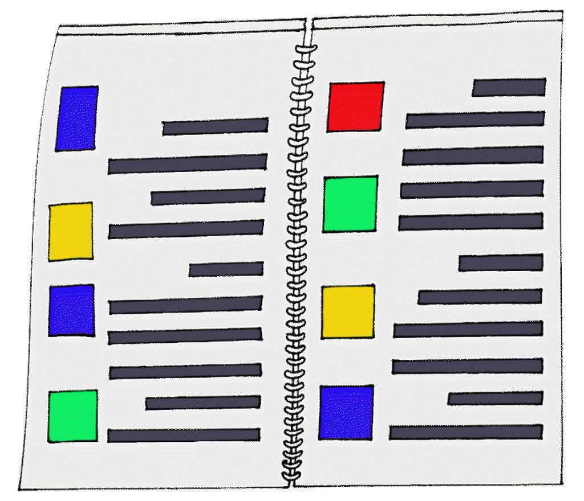**[](https://www.pinterest.com/pin/327073991665359979/)**

When I need treatment care and support,

this is what’s important to me.

\_\_\_\_\_\_\_\_\_\_\_\_\_\_\_\_\_\_\_\_\_\_\_\_\_\_\_\_\_\_\_\_\_\_\_

\_\_\_\_\_\_\_\_\_\_\_\_\_\_\_\_\_\_\_\_\_\_\_\_\_\_\_\_\_\_\_\_\_\_\_



I **do not** wish to have this treatment or care

\_\_\_\_\_\_\_\_\_\_\_\_\_\_\_\_\_\_\_\_\_\_\_\_\_\_\_\_\_\_\_\_\_\_\_

\_\_\_\_\_\_\_\_\_\_\_\_\_\_\_\_\_\_\_\_\_\_\_\_\_\_\_\_\_\_\_\_\_\_\_



What is important to me to keep me safe

and comfortable

\_\_\_\_\_\_\_\_\_\_\_\_\_\_\_\_\_\_\_\_\_\_\_\_\_\_\_\_\_\_\_\_\_\_\_

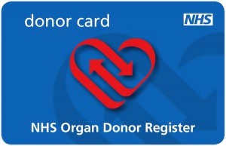

I would like to help someone to live after my

death by giving parts of my body

Yes No

I have updated this page on:………………………

**These are the health professionals involved in my care** *(these might be your GP, hospital consultant or district nurse)*

Name:

Address:

They are (job)

 Tel:

[](https://www.google.co.uk/url?sa=i&rct=j&q=&esrc=s&frm=1&source=images&cd=&ved=0ahUKEwjA1_C-o7PKAhXGqg4KHVJZAU4QjRwIBw&url=https://samdutton.wordpress.com/2009/03/09/treat-yourself-right/&psig=AFQjCNEkTwtKDu8kG3MRWk9U6h9NNU_gaA&ust=1453203606457287)

Name:

Address:

They are (job)

 Tel:

[](https://www.google.co.uk/url?sa=i&rct=j&q=&esrc=s&frm=1&source=images&cd=&ved=0ahUKEwjA1_C-o7PKAhXGqg4KHVJZAU4QjRwIBw&url=https://samdutton.wordpress.com/2009/03/09/treat-yourself-right/&psig=AFQjCNEkTwtKDu8kG3MRWk9U6h9NNU_gaA&ust=1453203606457287)

Name:

Address:

They are (job)

 Tel:

[](https://www.google.co.uk/url?sa=i&rct=j&q=&esrc=s&frm=1&source=images&cd=&ved=0ahUKEwjA1_C-o7PKAhXGqg4KHVJZAU4QjRwIBw&url=https://samdutton.wordpress.com/2009/03/09/treat-yourself-right/&psig=AFQjCNEkTwtKDu8kG3MRWk9U6h9NNU_gaA&ust=1453203606457287)

[](https://www.google.co.uk/url?sa=i&rct=j&q=&esrc=s&frm=1&source=images&cd=&ved=0ahUKEwjA1_C-o7PKAhXGqg4KHVJZAU4QjRwIBw&url=https://samdutton.wordpress.com/2009/03/09/treat-yourself-right/&psig=AFQjCNEkTwtKDu8kG3MRWk9U6h9NNU_gaA&ust=1453203606457287)

Name:

Address:

They are (job)

 Tel:

I have updated this page on:………………………

**My Funeral Wishes**

**Funeral Wishes**



I would like my coffin to be

\_\_\_\_\_\_\_\_\_\_\_\_\_\_\_\_\_\_\_\_\_\_\_\_\_\_\_\_\_\_\_\_\_\_\_\_\_\_\_\_\_\_

[](http://www.google.co.uk/url?sa=i&rct=j&q=&esrc=s&frm=1&source=images&cd=&cad=rja&uact=8&ved=0CAcQjRxqFQoTCPCEhcyAtccCFYkDGgodoVAFVg&url=http://classroomclipart.com/clipart/Clipart/Clothing.htm&ei=YmPUVfDLLImHaKGhlbAF&bvm=bv.99804247,d.d2s&psig=AFQjCNH__QP4yrI8k1fc3m5UdIpM_-nxoQ&ust=1440068761458119)[](http://www.google.co.uk/url?sa=i&rct=j&q=&esrc=s&frm=1&source=images&cd=&ved=0CAcQjRxqFQoTCIPshJjrtMcCFQPUGgodCNsPXQ&url=http://www.clipartsheep.com/spring-is-coming-free-clipart/dT1hSFIwY0RvdkwyTnZiWEJ6TG1OaGJuTjBiMk5yY0dodmRHOHVZMjl0TDJOaGJpMXpkRzlqYXkxd2FHOTBiMTlqYzNBNE9EQTRPRGt4TG1wd1p3fHc9NDUwfGg9NDcwfHQ9anBlZ3w/&ei=8EzUVYO0IIOoa4i2v-gF&psig=AFQjCNELzLfVIX-iRIkUIdz9ecnv-XWcdg&ust=1440063018824486)

When I am in my coffin I would like to be dressed in

\_\_\_\_\_\_\_\_\_\_\_\_\_\_\_\_\_\_\_\_\_\_\_\_\_\_\_\_\_\_\_\_\_\_\_\_\_\_\_\_\_\_

[](http://www.google.co.uk/url?sa=i&rct=j&q=&esrc=s&frm=1&source=images&cd=&cad=rja&uact=8&ved=0ahUKEwib_Yi7obPKAhUEFQ8KHbuYA5QQjRwIBw&url=http://www.clipartpanda.com/categories/cd-20clipart&psig=AFQjCNGIt6JBJ_8iAEO9nV_HAQa2I7y_nA&ust=1453203066712114)

[](http://www.google.co.uk/url?sa=i&rct=j&q=&esrc=s&frm=1&source=images&cd=&cad=rja&uact=8&ved=0ahUKEwjr2p2dobPKAhVBeg8KHWi4AoMQjRwIBw&url=http://www.clker.com/clipart-240906.html&psig=AFQjCNGIeK-FR9whgLNGB3sUfl19eZwlAA&ust=1453202969898110)

I would like these things to be put in my coffin with

me \_\_\_\_\_\_\_\_\_\_\_\_\_\_\_\_\_\_\_\_\_\_\_\_\_\_\_\_\_\_\_\_\_\_\_\_\_\_\_

[](http://www.google.co.uk/url?sa=i&rct=j&q=&esrc=s&frm=1&source=images&cd=&cad=rja&uact=8&ved=0ahUKEwjj3tu-orPKAhXDpQ4KHSEABTAQjRwIBw&url=http://www.cliparthut.com/aperture-clipart.html&psig=AFQjCNHknlybyggFBE_hmJE2RacQz9Fs3g&ust=1453203322717228)

[](http://www.google.co.uk/url?sa=i&rct=j&q=&esrc=s&frm=1&source=images&cd=&cad=rja&uact=8&ved=0ahUKEwjj1Z_9obPKAhXEGw8KHXJlCw0QjRwIBw&url=http://www.getdomainvids.com/keyword/jewelry%20clipart/&psig=AFQjCNFq0ff5cpArPBgzpilpMwWBAmSFUQ&ust=1453203213774632)



I have decided that I would like to be buried/cremated

\_\_\_\_\_\_\_\_\_\_\_\_\_\_\_\_\_\_\_\_\_\_\_\_\_\_\_\_\_\_\_\_\_\_\_\_\_\_\_\_\_\_



I would like the service to take place at

\_\_\_\_\_\_\_\_\_\_\_\_\_\_\_\_\_\_\_\_\_\_\_\_\_\_\_\_\_\_\_\_\_\_\_\_\_\_\_\_\_\_



I want my burial/cremation to take place at

\_\_\_\_\_\_\_\_\_\_\_\_\_\_\_\_\_\_\_\_\_\_\_\_\_\_\_\_\_\_\_\_\_\_\_\_\_\_\_\_\_\_



If cremated, I would like my ashes to be

\_\_\_\_\_\_\_\_\_\_\_\_\_\_\_\_\_\_\_\_\_\_\_\_\_\_\_\_\_\_\_\_\_\_\_\_\_\_\_\_\_\_

I have updated this page on:………………………

I would like my priest/religious leader



\_\_\_\_\_\_\_\_\_\_\_\_\_\_\_\_\_\_\_\_\_\_\_\_\_\_\_\_\_\_\_\_\_\_\_\_\_\_\_\_\_\_

to take the service

Tel:\_\_\_\_\_\_\_\_\_\_\_\_\_\_\_\_\_\_\_\_\_\_\_\_\_\_\_\_\_\_\_\_\_\_

I would like readings that I have chosen or quotes about me to be read out by these people

[](http://www.google.co.uk/url?sa=i&rct=j&q=&esrc=s&frm=1&source=images&cd=&cad=rja&uact=8&ved=0CAcQjRxqFQoTCMmH9NmJtccCFcxeGgod_rEDVw&url=http://www.andreaangella.com/&ei=72zUVYnULMy9af7jjrgF&psig=AFQjCNGk9p-WM8hB6m_QSJ1-OFZqB27eFw&ust=1440071009242666)

1.\_\_\_\_\_\_\_\_\_\_\_\_\_\_\_\_\_\_\_\_\_\_\_\_\_\_\_\_By:\_\_\_\_\_\_\_\_\_\_

2.\_\_\_\_\_\_\_\_\_\_\_\_\_\_\_\_\_\_\_\_\_\_\_\_\_\_\_\_By:\_\_\_\_\_\_\_\_\_\_

3. \_\_\_\_\_\_\_\_\_\_\_\_\_\_\_\_\_\_\_\_\_\_\_\_\_\_\_ By:\_\_\_\_\_\_\_\_\_\_

I would like the following pieces of music to be played

[](http://www.google.co.uk/url?sa=i&rct=j&q=&esrc=s&frm=1&source=images&cd=&cad=rja&uact=8&ved=0CAcQjRxqFQoTCOrJzaOHtccCFUdcGgodoqEHdA&url=http://vector-magz.com/search/google-free-music-staff-clipart/&ei=ZGrUVeqHPMe4aaLDnqAH&psig=AFQjCNGlfnKk-sbAA34wVwqDGXnhgEGnuw&ust=1440070590430520)

1.\_\_\_\_\_\_\_\_\_\_\_\_\_\_\_\_\_\_\_\_\_\_\_\_\_\_\_\_\_\_\_\_\_\_\_\_\_\_\_\_\_2.\_\_\_\_\_\_\_\_\_\_\_\_\_\_\_\_\_\_\_\_\_\_\_\_\_\_\_\_\_\_\_\_\_\_\_\_\_\_\_\_\_

3.\_\_\_\_\_\_\_\_\_\_\_\_\_\_\_\_\_\_\_\_\_\_\_\_\_\_\_\_\_\_\_\_\_\_\_\_\_\_\_\_\_

[](http://www.google.co.uk/url?sa=i&rct=j&q=&esrc=s&frm=1&source=images&cd=&cad=rja&uact=8&ved=0CAcQjRxqFQoTCPvfz__ptMcCFQO9GgodE0YBVA&url=http://cliparts.co/clipart/2394908&ei=sEvUVfvHNoP6apOMhaAF&bvm=bv.99804247,d.d2s&psig=AFQjCNEHz7M5Njje-Le3ceyyf2Ozgnnv4g&ust=1440062758082625)

I would like flowers at my funeral

Yes No

[](http://www.google.co.uk/url?sa=i&rct=j&q=&esrc=s&frm=1&source=images&cd=&cad=rja&uact=8&ved=0CAMQjRxqFQoTCICc86SjtccCFQdAGgodVzQIWQ&url=http://www.clipartbest.com/line-drawing-flowers-clip-art&ei=w4fUVcCuNoeAadfooMgF&bvm=bv.99804247,d.d2s&psig=AFQjCNE6rK76B2BW0BEltURpDvz72XzDcQ&ust=1440078147921312)

My favourite flowers are\_\_\_\_\_\_\_\_\_\_\_\_\_\_\_\_\_\_\_\_\_\_\_

?

[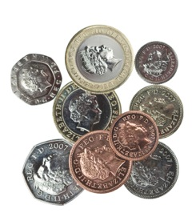](http://www.google.co.uk/url?sa=i&rct=j&q=&esrc=s&frm=1&source=images&cd=&ved=0CAcQjRxqFQoTCOWJj-eCtccCFYQDGgodhMQB1w&url=http://sixuntilme.com/highs_and_lows/&ei=tGXUVeXfF4SHaISJh7gN&bvm=bv.99804247,d.d2s&psig=AFQjCNFZnqSbtUZ6sLW-ZVmzJIq8KLDFug&ust=1440069393370413)

If people want to donate money instead of flowers

they can donate to\_\_\_\_\_\_\_\_\_\_\_\_\_\_\_\_\_\_\_\_\_\_\_\_\_\_\_

I have updated this page on:………………………

I have got a funeral plan



Yes No

My funeral plan details:

Name of plan\_\_\_\_\_\_\_\_\_\_\_\_\_\_\_\_\_\_\_\_\_\_\_\_\_\_\_

Policy number­­­­­­­­­­­­­­­­­­­­­­­­­­­­­­­­­\_\_\_\_\_\_\_\_\_\_\_\_\_\_\_\_\_\_\_\_\_\_\_\_\_\_\_

Agency address\_\_\_\_\_\_\_\_\_\_\_\_\_\_\_\_\_\_\_\_\_\_\_\_\_

Contact number\_\_\_\_\_\_\_\_\_\_\_\_\_\_\_\_\_\_\_\_\_\_\_\_\_

[](https://www.google.co.uk/url?sa=i&rct=j&q=&esrc=s&frm=1&source=images&cd=&cad=rja&uact=8&ved=0CAcQjRxqFQoTCOL9sYKetccCFYg5GgodV7wKVQ&url=https://www.taxmann.com/editorpick-iar.aspx&ei=PYLUVaLrFIjzaNf4qqgF&psig=AFQjCNGC4xNQfDqH7NTEi0FC26zskIaWSw&ust=1440076668791203)

I have a life insurance policy Yes No

Name of plan\_\_\_\_\_\_\_\_\_\_\_\_\_\_\_\_\_\_\_\_\_\_\_\_\_\_\_

Policy number\_\_\_\_\_\_\_\_\_\_\_\_\_\_\_\_\_\_\_\_\_\_\_\_\_\_\_

Contact number\_\_\_\_\_\_\_\_\_\_\_\_\_\_\_\_\_\_\_\_\_\_\_\_\_

I have made a will Yes No

[](http://www.google.co.uk/url?sa=i&rct=j&q=&esrc=s&frm=1&source=images&cd=&cad=rja&uact=8&ved=0ahUKEwjf3c7foLPKAhVDqw4KHVw9CaYQjRwIBw&url=http://www.fotosearch.com/photos-images/last-testament.html&psig=AFQjCNEaL7XaahHqYkvnzjF-wkzVlul0wg&ust=1453202882006929)

My will is kept with

Name\_\_\_\_\_\_\_\_\_\_\_\_\_\_\_\_\_\_\_\_\_\_\_\_\_\_\_\_\_\_\_\_\_\_ Address\_\_\_\_\_\_\_\_\_\_\_\_\_\_\_\_\_\_\_\_\_\_\_\_\_\_\_\_\_\_\_\_

Tel:\_\_\_\_\_\_\_\_\_\_\_\_\_\_\_\_\_\_\_\_\_\_\_\_\_\_\_\_\_\_\_\_

I have updated this page on:………………………

**My wishes about my things when I die**

I would like these people to have these things

Name\_\_\_\_\_\_\_\_\_\_\_\_\_\_\_\_\_Possession\_\_\_\_\_\_\_\_\_\_\_\_\_\_\_

Name\_\_\_\_\_\_\_\_\_\_\_\_\_\_\_\_\_Possession\_\_\_\_\_\_\_\_\_\_\_\_\_\_\_

Name\_\_\_\_\_\_\_\_\_\_\_\_\_\_\_\_\_Possession\_\_\_\_\_\_\_\_\_\_\_\_\_\_

Name\_\_\_\_\_\_\_\_\_\_\_\_\_\_\_\_\_Possession\_\_\_\_\_\_\_\_\_\_\_\_\_\_\_

I would like the rest of my things to go to

\_\_\_\_\_\_\_\_\_\_\_\_\_\_\_\_\_\_\_\_\_\_\_\_\_\_\_\_\_\_\_\_\_\_\_\_\_\_\_\_\_\_\_\_\_\_\_\_\_\_\_\_\_\_\_\_\_\_\_\_\_\_\_\_\_\_\_\_\_\_\_\_\_\_\_\_\_\_\_\_\_\_\_\_\_\_\_\_\_\_\_\_\_\_\_\_\_\_\_\_

[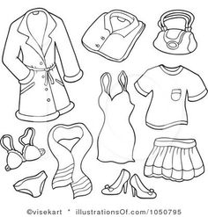](https://www.google.co.uk/url?sa=i&rct=j&q=&esrc=s&frm=1&source=images&cd=&cad=rja&uact=8&ved=0CAcQjRxqFQoTCNy0pMeOtccCFcPaGgodZMEHfA&url=https://www.pinterest.com/pin/68961438019575761/&ei=BnLUVdyZNMO1a-SCn-AH&psig=AFQjCNHoLpfwYCvmoubDOfbGw1GQtm3qOw&ust=1440072528301699)

I would like my clothes to go to

\_\_\_\_\_\_\_\_\_\_\_\_\_\_\_\_\_\_\_\_\_\_\_\_\_\_\_\_\_\_\_\_\_\_\_\_\_\_\_\_\_\_\_\_\_

\_\_\_\_\_\_\_\_\_\_\_\_\_\_\_\_\_\_\_\_\_\_\_\_\_\_\_\_\_\_\_\_\_\_\_\_\_\_\_\_\_\_\_\_\_

I have updated this page on:………………………



Other things important to me which I can add to my plan at any time if I want to:

\_\_\_\_\_\_\_\_\_\_\_\_\_\_\_\_\_\_\_\_\_\_\_\_\_\_\_\_\_\_\_\_\_\_\_\_\_\_\_\_\_\_\_\_\_\_\_\_\_\_\_\_\_\_\_\_\_\_\_\_\_\_\_\_\_\_\_\_\_\_\_\_\_\_\_\_\_\_\_\_\_\_\_\_\_\_\_\_\_\_\_\_\_\_\_\_\_\_\_\_\_\_\_\_\_\_\_\_\_\_\_\_\_\_\_\_\_\_\_\_\_\_\_\_\_\_\_\_\_\_\_\_\_\_\_\_\_\_\_\_\_\_\_\_\_\_\_\_\_\_\_\_\_\_\_\_\_\_\_\_\_\_\_\_\_\_\_\_\_\_\_\_\_\_\_\_\_\_\_\_\_\_\_\_\_\_\_\_\_\_\_\_\_\_\_\_\_\_\_\_\_\_\_\_\_\_\_\_\_\_\_\_\_\_\_\_\_\_\_\_\_\_\_\_\_\_\_\_\_\_\_\_\_\_\_\_\_\_\_\_\_\_\_\_\_\_\_\_\_\_\_\_\_\_\_\_\_\_\_\_\_\_\_\_\_\_\_\_\_\_\_\_\_\_\_\_\_\_\_\_\_\_\_\_\_\_\_\_\_\_\_\_\_\_\_\_\_\_\_\_\_\_\_\_\_\_\_\_\_\_\_\_\_\_\_\_\_\_\_\_\_\_\_\_\_\_\_\_\_\_\_\_\_\_\_\_\_\_\_\_\_\_\_\_\_\_\_\_\_\_\_\_\_\_\_\_\_\_\_\_\_\_\_\_\_\_\_\_\_\_\_\_\_\_\_\_\_\_\_\_\_\_\_\_\_\_\_\_\_\_\_\_\_\_\_\_\_\_\_\_\_\_\_\_\_\_\_\_\_\_\_\_\_\_\_\_\_\_\_\_\_\_\_\_\_\_\_\_\_\_\_\_\_\_\_\_\_\_\_\_\_\_\_\_\_\_\_\_\_\_\_\_\_\_\_\_\_\_\_\_\_\_\_\_\_\_\_\_\_\_\_\_\_\_\_\_\_\_\_\_\_\_\_\_\_\_\_\_\_\_\_\_\_\_\_\_\_\_\_\_\_\_\_\_\_\_\_\_\_\_\_\_\_\_\_\_\_\_\_\_\_\_\_\_\_\_\_\_\_\_\_\_\_\_\_\_\_\_\_\_\_\_\_\_\_\_\_\_\_\_\_\_\_\_\_\_\_\_\_\_\_\_\_\_\_\_\_\_\_\_\_\_\_\_\_\_\_\_\_\_\_\_\_\_\_\_\_\_\_\_\_\_\_\_\_\_\_\_\_\_\_\_\_\_\_\_\_\_\_\_\_\_\_\_\_\_\_\_\_\_\_\_\_\_\_\_\_\_\_\_\_\_\_\_\_\_\_\_\_\_\_\_\_\_\_\_\_\_\_\_\_\_\_\_\_\_\_\_\_\_\_\_\_\_\_\_\_\_\_\_\_\_\_\_\_\_\_\_\_\_\_\_\_\_\_\_\_\_\_\_\_\_\_\_\_\_\_\_\_\_\_\_\_\_\_\_\_\_\_\_\_\_\_\_\_\_\_\_\_\_\_\_\_\_\_\_\_\_\_\_\_\_\_\_\_\_\_\_\_\_\_\_\_\_\_\_\_\_\_\_\_\_\_\_\_\_\_\_\_\_\_\_\_\_\_\_\_\_\_\_\_\_\_\_\_\_\_\_\_\_\_\_\_\_\_\_\_\_\_\_\_\_\_\_\_\_\_\_\_\_

I have updated this page on:………………………

**My review meetings and changes to my plan**

I have changed my plan on:

|  |  |  |
| --- | --- | --- |
| Date | The changes are  [https://www.taxmann.com/TSimage/104010000000045754/51967.png](https://www.google.co.uk/url?sa=i&rct=j&q=&esrc=s&frm=1&source=images&cd=&cad=rja&uact=8&ved=0CAcQjRxqFQoTCOL9sYKetccCFYg5GgodV7wKVQ&url=https://www.taxmann.com/editorpick-iar.aspx&ei=PYLUVaLrFIjzaNf4qqgF&psig=AFQjCNGC4xNQfDqH7NTEi0FC26zskIaWSw&ust=1440076668791203) | On    Page |
|  |  |  |
|  |  |  |
|  |  |  |
|  |  |  |
|  |  |  |
|  |  |  |
|  |  |  |
|  |  |  |
|  |  |  |
|  |  |  |
|  |  |  |
|  |  |  |
|  |  |  |
|  |  |  |
|  |  |  |
|  |  |  |
|  |  |  |
|  |  |  |
|  |  |  |
|  |  |  |
|  |  |  |
|  |  |  |
|  |  |  |
|  |  |  |
|  |  |  |
|  |  |  |
|  |  |  |
|  |  |  |

**Additional page (for optional use)**

**The People Closest to me**

|  |  |
| --- | --- |
| Name:  Address:  They are my……..  Telephone 14  Tel: | Name:  Address:  They are my……..  Telephone 14  Tel: |
|  | |
| Name:  Address:  They are my……..  Telephone 14  Tel: | Name:  Address:  They are my……..  Telephone 14  Tel: |

|  |  |
| --- | --- |
| Name:  Address:  They are my……..  Telephone 14  Tel: | Name:  Address:  They are my……..  Telephone 14  Tel: |

|  |  |
| --- | --- |
| Name:  Address:  They are my……..  Telephone 14  Tel: | Name:  Address:  They are my……..  Telephone 14  Tel: |

This tool was developed by St Luke’s Hospice in consultation with Thurrock Lifestyles Solutions.

*St Luke’s Hospice, Basildon, Essex grants permission for other professionals to use the St Luke's Hospice ‘When I Die?’ tool in their practice and would be grateful that the Hospice logo is retained on all copies. For further information please contact: Supportive Care and Development manager on 01268 524973.*

[](http://www.choiceandcontrol.co.uk/)



St Luke’s Hospice Thurrock Lifestyle Solutions